Teacher Preparation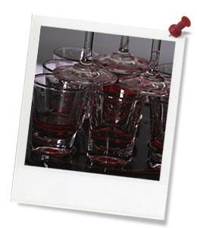

**Lesson Objectives** Students will…

* understand the limitations of the circular flow economic model
* understand the principles of the ‘doughnut’ economic model
* understand the difference between both circular flow and ‘doughnut’ economic models

By the end of the lessons students can…

* identify the principles of the circular flow economic model
* identify the importance of environmental and social wellbeing in an economic model
* identify features of an ideal economic model
* compare two economic models (circular flow and ‘doughnut’)

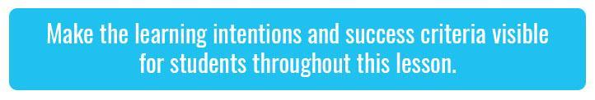

**Teacher content information:**A 2018 study by [The University of Melbourne](https://education.unimelb.edu.au/__data/assets/pdf_file/0011/2887895/Most-important-issues-report-final-Sept-2018.pdf) on the thoughts and concerns of young people from Generations X and Y found the number one concern across both groups was lack of action around climate change. In particular, "Generation X worries what climate change will mean for their own children, while Generation Y is concerned about the impact on future generations" ([The Educator](https://www.theeducatoronline.com/au/news/youth-reveal-their-top-concern-in-national-survey/255130)). The report indicates that young people have a serious mistrust in the Government's ability or willingness to tackle climate change.

Tackling climate change requires large-scale, systemic changes across all aspects of society. Simply aiming to reduce our C02 emissions is not enough: we need to rapidly decarbonize our planet. While this might sound challenging, the good news is we already have the knowledge and tools to do it.

*2040* is an innovative feature documentary that looks to the future while focusing on what is happening now. Award-winning director Damon Gameau (director of [That Sugar Film](https://thatsugarmovement.com/film/)) embarks on a journey to explore what the future could look like by the year 2040 if we simply embraced the best solutions already available to us to improve our planet and shifted them into the mainstream.

The film will demonstrate to your students that we already have the solutions to climate change; we just need to take action to bring them rapidly into the mainstream. The *2040* documentary and curriculum package will support your students in turning this knowledge into positive action for a better future.

Find out how to see the film [here](https://madmanfilms.com.au/2040film/). *2040* will only be available in cinemas for the first part of 2019 and you can make a group booking for your class at your local cinema during the film’s theatrical release which starts on May 23. These lessons have been designed with a media library to support teachers. The film will be available on video-on-demand and DVD later in 2019.

The film is the entry point to a global impact campaign that seeks to mobilize audiences to learn about, contribute to, advocate for and invest in regenerative solutions that improve the wellbeing of the planet, all people and all living systems.

To join the Regeneration and share your vision for 2040, see the [website](https://whatsyour2040.com).

Watch the 2040 trailer:

[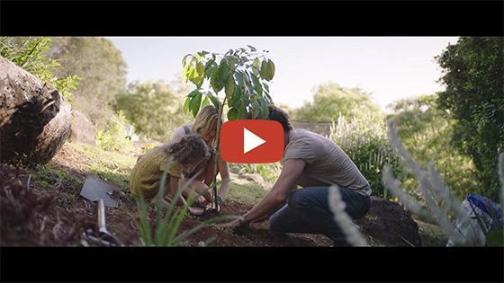](https://vimeo.com/showcase/6167669/video/325372102)

[2040 - Official Trailer](https://vimeo.com/showcase/6167669/video/325372102) **Password: 2040_EDU** (https://vimeo.com/showcase/6167669/video/325372102)

Cool Australia, GoodThing Productions and Regen Pictures would like to acknowledge the generous contributions of [Good Pitch Australia](https://goodpitch2australia.com.au/), [Shark Island Institute](https://sharkisland.com.au/shark-island-institute/), [Documentary Australia Foundation](https://www.documentaryaustralia.com.au/), [The Caledonia Foundation](https://www.caledoniafoundation.com.au/) and our philanthropic partners in the development of these teaching resources.

Teaching Sequence

**Work through this resource material in the following sequence:**

15 minutes – Part A: What Is The Economy?  
20 minutes – Part B: Looking for an Alternative  
20 minutes – Part C: What Is The Economy For?  
5 minutes – Reflection

Part A: What Is The Economy?

**Step 1.**Begin by explaining to students that during this lesson they will be drawing on their understanding of the circular flow economic model to evaluate a different economic model. The first activity will be used to highlight the key principals of the circular flow economic model before introducing an alternative model.

Provide each student with a copy of the Student Worksheet and draw their attention to the diagram titled; *Circular Flow Economic Model,* which models how the economy supposedly works.

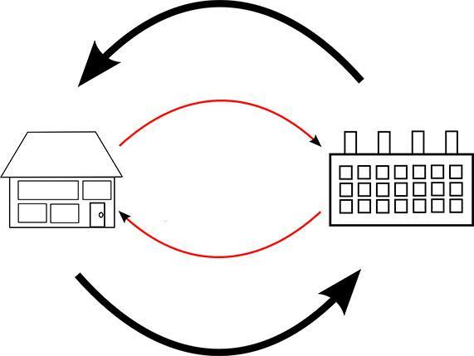

**Step 2.** Invite students to work individually to fill in the blank spaces of what they think the arrows from the firms to the households and from the household to the firms could represent. Here is the model with the correct labels:

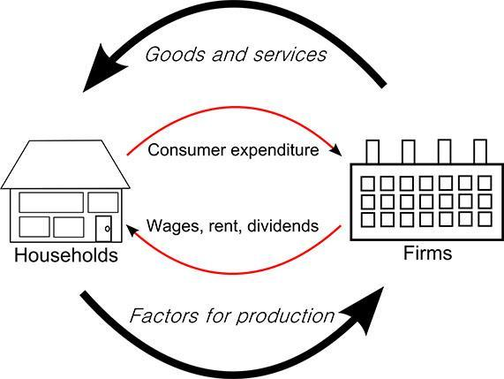

**Step 3.** Once students have filled in the blank spaces of the diagram, explain the correct labelling of the diagram, ensuring they understand the interconnection of firms and household, e.g. the circular flow of consumers spending and the firms providing income – one is dependent on the other.

Encourage students to question the simplistic nature of this model by asking prompt questions such as:

* Are there any other factors or institutions that we should consider when looking at this model?
* Do you think this represents how our economy works? Why?/Why not?
* What things are excluded when we only see the economy as firms and households spending or making money?

**Step 4.** Write the following prompt questions on the board and have students complete the Think – Pair – Share activity on the Student Worksheet:

* What problems do you see with such a simplistic economic model?
* Who and what is not being represented – what is missing?

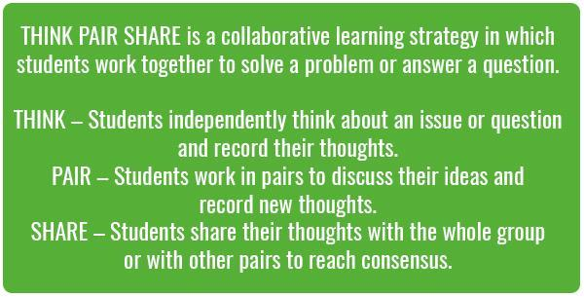

* **Column A** - Students should write their own answers to the question.
* **Column B** - Students will share their thoughts in column A with a partner and note down anything new they discover.

Once this is complete, invite them to work together to annotate the circular flow economic model or write their favourite ideas in the space provided on the Student Worksheet.

**Step 5.** Bring the class together and encourage students to share the flaws or the things that are not considered in the diagram. Record student ideas on the board.

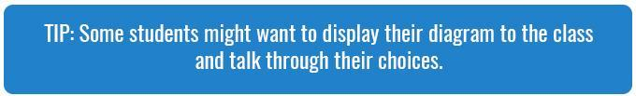

**Take it further:** Students can further their understanding of the problems of the circular flow economic model by watching Kate Raworth’s TEDxTalk (they will also have an opportunity to explore Kate Raworth's economic model later in the lesson):

[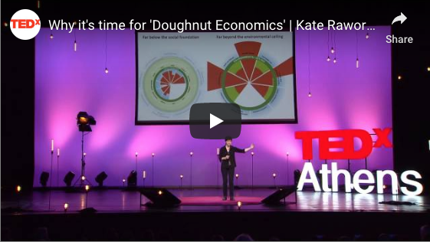](https://www.youtube.com/watch?time_continue=56&v=1BHOflzxPjI)

[Why it’s time for ‘Doughnut Economics'](https://www.youtube.com/watch?time_continue=56&v=1BHOflzxPjI) (https://www.youtube.com/watch?time_continue=56&v=1BHOflzxPjI)

You may choose to organise student ideas based on the four main problems identified by Kate Raworth. They include:

1. There is no recognition of the environment that the firms and household are embedded in, for example, energy and resources used.
2. Not all work is paid, for example, there are many people in the community that do not get paid for the work that they do to ensure society functions.
3. For something to be of value does not always have a money value – social exchange, for example, doing things for people and them doing things in return for you without money changing hands.
4. There is an imbalance between the wealth and power that a firm has compared to that of a household, for example, accumulation of wealth brings about power – there is a great divide between who is benefiting from this model.

Part B: Looking for an Alternative

**Step 1.** Using the ideas suggested in the previous activity as a foundation, invite students to participate in a *Stand on the Line* activity. This activity gives students the opportunity to consider their personal views about the circular flow economic model and expressing their reasoning for their stance.

Ask students to clear the furniture to the sides of the classroom (or go to an open space) and attach the [Agree/Disagree signs](https://prod-media.coolaustralia.org/wp-content/uploads/2018/10/21192017/2040_AgreeDisagreeSigns.pdf) to the wall or floor on opposite sides of the classroom. Invite students to imagine a line between each sign. Explain that the imaginary line is a continuum, with extremes at each end.

Inform students that you will read a statement, and they should stand in a position between the two signs that indicates their viewpoint.

**Step 2.** Read out each of the following statements, allowing students time to consider them and move to the position that indicates their view. Once students have chosen their position, invite them to turn to a person close to them, and share their view. Invite some volunteers to share their view with the class and draw out key reasons for their stance.

* This model does not take into consideration the wellbeing of the environment.
* This model impacts all people equally.
* This model is a useful tool for understanding the current economy.
* This model is valuable as we move forward into the future.
* There is no alternative to this model.

Use this opportunity to highlight to students that something can always be done to find an alternative or a solution to a problem, it just may not be identified yet and they may be the ones to make change happen.

**Take it further:** You may wish to share the following clip or [this image](https://prod-media.coolaustralia.org/wp-content/uploads/2019/05/27095038/2040_TrickleDownEconomicsImage_FINAL.pdf) (Trickle Down Economics Image) with your students to help explain the concepts of wealth and power through the exploration of ‘Trickle Down’ economics:

[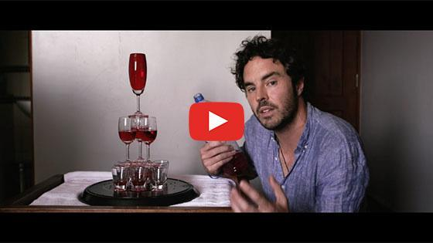](https://vimeo.com/showcase/6167669/video/336514432)

[2040 - Wealth Distribution](https://vimeo.com/showcase/6167669/video/336514432) **Password: 2040_EDU** (https://vimeo.com/showcase/6167669/video/336514432)

**Step 3.** Ask students to form small groups of 3 or 4 and provide each group with a piece of butcher's paper and some markers. In these groups, invite students to write down the features that they think are important in a future economy.

You may choose to use the following prompts to help get groups thinking:

* What would an ideal economic model include?
* What do we want as our future economy?
* What don’t you want in a future economy?

**Step 4.** Invite groups to create a statement that summarises the key features of what they think is important in a future economy and share with the class.

**Step 5.** Explain to students that these different economic models encourage us to think about the economy in different ways. In the circular flow model, the focus is largely on gross domestic product. The economic cycle just goes round and round, growing and consuming more resources from the environment. However, the circular economy operates largely on the premise of a continuous stream of resources to feed into the cycle.

Ask students to consider this premise of a circular economy continuing in perpetuity, as it has been up to this point, and to offer their opinions on the following questions:

* What does a circular economy mean for the input of resources from our environment? *Key point:* it assumes that there are infinite resources available to continue meeting the demands of consumers. As the number of consumers and goods desired by consumers grows with the growth in population, more and more resources will be required.
* What does a circular economy mean for the role of recycling resources? *Key point:* Recycling and waste reduction are essential to limiting the extent to which new resources are required from the environment. With there being a finite supply of resources available from the planet, it is unsustainable to continue drawing more and more from the environment.

These questions hit upon the fact that the current supply and demand cycle cannot continue infinitely as the resources available from the environment are finite. At some point, the cycle must end as we will have eventually depleted all of the natural resources Earth has to offer. Every year, we mark the date when humanity extracts more from nature than it is able to restore in an event known as Earth Overshoot Day. You can find out more about it here: [overshootday.org](https://www.overshootday.org/).

**Step 6.**Using a more holistic model, economist Kate Raworth has suggested that we should think about economics in a new way. Instead of treating it as a vehicle for growing gross domestic product, Raworth thinks about it in terms of a doughnut.

Invite students to predict what they think Doughnut Economics might be about.

Show the following clip to the class. As they watch, invite them to make a note of anything they find interesting or important.

[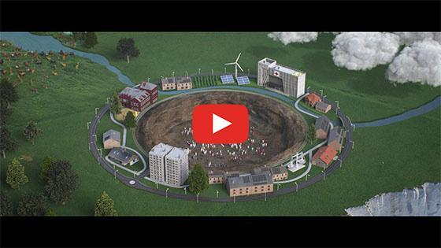](https://vimeo.com/showcase/6167669/video/293917202)

[2040 - Introducing Kate’s Doughnut](https://vimeo.com/showcase/6167669/video/293917202) **Password: 2040_EDU** (https://vimeo.com/showcase/6167669/video/293917202)

Once complete, briefly invite students to reflect on the clip by asking them to share the following:

* What this clip was about; and
* What was important or interesting about this clip.

**Step 7.** Now draw an outline of a doughnut on the board similar to that shown in the clip (also available on [The Doughnut of Social and Planetary Boundaries Worksheet](https://prod-media.coolaustralia.org/wp-content/uploads/2019/05/27103817/2040_TheDoughtnutOfSocialAndPlanetaryBoundaries_FINAL.pdf)). Use the diagram to prompt students to share what they understood about this new role for economics. You may want to use the following questions as a guide:

* Why is it shaped like a doughnut?
* What does the hole represent? What is in the hole?
* What does Kate mean by ‘planetary boundaries’? Where are they located? What are some examples?
* What are each of the arrows showing?

**Tip:** Instead of drawing the doughnut outline on the board, you could use this completed diagram to illustrate the key principals of Doughnut Economics ([Kate Raworth](https://www.kateraworth.com/doughnut/)) found at https://www.kateraworth.com/doughnut/.

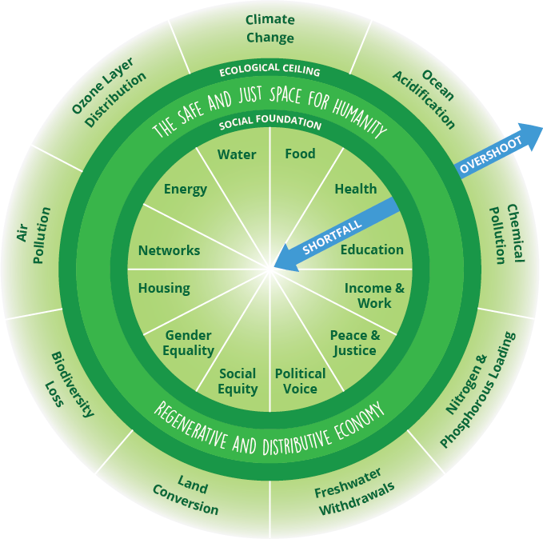

**Step 8.** Provide each student with [The Doughnut of Social and Planetary Boundaries Worksheet](https://prod-media.coolaustralia.org/wp-content/uploads/2019/05/27103817/2040_TheDoughtnutOfSocialAndPlanetaryBoundaries_FINAL.pdf) and invite them to label the diagram using the terms provided.

Ensure students are correctly identifying the factors that are outside the ecological ceiling (eg. putting too much pressure on the planet) and the social foundations (eg. people falling short on life’s essentials). Recognising where these factors are is important to understanding how environmental and social wellbeing can be achieved.

**Tip:** [Kate Raworth’s website](https://www.kateraworth.com/) (https://www.kateraworth.com) has a range of animations, clips, and articles that could be used to further support student understanding of Doughnut Economics.

Part C: What Is The Economy For?

**Step 1.** Explain to students that the model of growing GDP shows how the economy operates, but the Doughnut Model differs greatly in that it is a goal for how the economy should operate.

To further elaborate on the differences between the two models, show the students this video which starts with the supply and demand model and then introduces the missing elements provided by the doughnut model.

[Meet the Economy](https://youtu.be/ZLnAXNbtcZQ) (https://youtu.be/ZLnAXNbtcZQ)

You could also show them the following diagram (also available [here](https://prod-media.coolaustralia.org/wp-content/uploads/2019/04/24110606/2040_DoughnutEconomicsModel.pdf) to print and on the Student Worksheet):

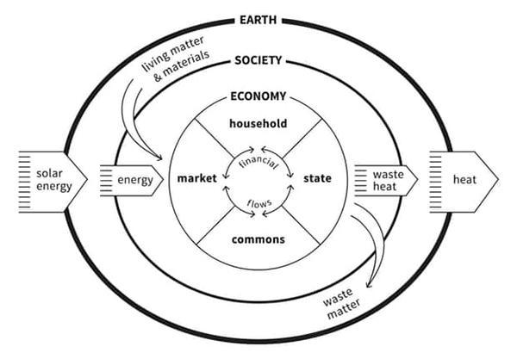

(Title: *The Embedded Economy*  
Credit: Kate Raworth and Marcia Mihotich. CC-BY-SA 4.0  
Citation: Raworth, K. (2017), *Doughnut Economics: seven ways to think like a 21st century economist*. London: Penguin Random House*.*)

**Step 2.** Ask students to work in pairs or small groups to discuss each of the models. In their discussion, students should look to critically evaluate the circular and doughnut models of the economy, highlighting the strengths and weaknesses of each and the impact they have on environmental and social wellbeing. For more information on Doughnut Economics visit [doughnuteconomics.org](https://doughnuteconomics.org/).

**Step 3.** At the end of the class discussion, ask students to work with a partner to brainstorm a list based on the following question:

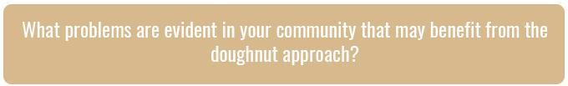

**Step 4.** Invite students to select one problem and identify a solution that could work in their community.

For example, traffic congestion around schools is a major problem for some communities. Setting up a carpooling system or a walking school bus could help reduce the congestion but also build up community relationships, reduce car emissions and pollution, encourage all students to come to school, and help children be more active.

Encourage students to think creatively about their solution write their responses in the space provided on the Student Worksheet.

**Step 5.** Invite students to share their ideas with the class and identify which actions are taking pressure off the outer rim (planetary boundaries) and the ones that are moving people out of the centre hole (social factors of wellbeing).

For example:

* To build up community relationships improves community networks
* To reduce car emissions reduces air pollution
* To encourage all students to come to school impacts education, social equality, income and work
* To help children be more active improves health

Reflection

Invite students to work independently to complete the following prompt on the Student Worksheet.

In regards to understanding economic models:

* I used to think...
* Now I think...

Differentiated Learning

**Extension -** In Part B, Step 2, use the video [Wealth Distribution](https://vimeo.com/showcase/6167669/video/336514432)**(Password: 2040_EDU** - https://vimeo.com/showcase/6167669/video/336514432) to further explain the concepts of wealth and power through the exploration of ‘Trickle Down’ economics. Encourage students to evaluate the strengths and weakness of this approach.

**Provisions for Learning Support -**Depending on the prior knowledge of the circular flow economic model, you could in Part A, Step 1, provide students with the missing terms in the diagram and work through how the model works as a class.  
OR  
In Part B, Step 6, instead of drawing the doughnut outline on the board, you could use the completed “[The Doughnut of social and planetary boundaries](https://www.kateraworth.com/doughnut/)” (https://www.kateraworth.com/doughnut/) diagram to illustrate the key principals of Doughnut Economics. Having the inner and outer factors visible may help some students understand the social and environmental impacts.

Take It Further

This lesson can be followed by the next lesson in [this unit](https://www.coolaustralia.org/unit/2040-economics-and-business-years-7-to-10/); [2040 - Doughnut Economics Case Studies - Economics - Years 9 & 10](https://www.coolaustralia.org/activity/2040-doughnut-economics-case-studies-economics-years-9-10/).

Teacher Reflection

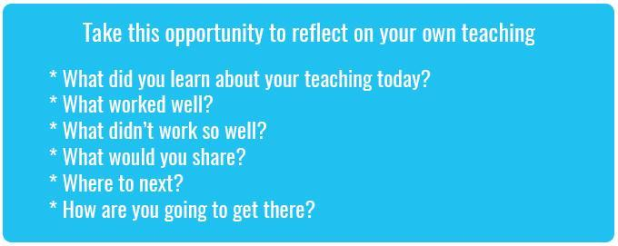

What's Your 2040?

Record your students' work in their communities with the hashtag #whatsyour2040 and share their visions in the '2040: [The Regeneration' Facebook Group](https://www.facebook.com/groups/2040TheRegeneration/).

The 2040 crew would love to see your class' work.