# Doughnut Economics Case Studies Grades 8 – 12 Teacher Worksheet

**Teacher Preparation**

**Learning intentions: Students will…**

* … understand the features of the Doughnut diagram
* … understand the pressures placed on the planet and the inequality of social wellbeing
* … understand possible solutions to an environmental and social problem.

**Success criteria: Students can…**

* … identify and label the Doughnut diagram
* … identify the environmental problems and social equalities evident in our world
* … explore and evaluate possible solutions to problems that are available today.

***Make the learning intentions and success criteria visible for students throughout this lesson.***

Tackling climate change requires large-scale, systemic changes across all aspects of society. Simply aiming to reduce our C02 emissions is not enough: we need to rapidly decarbonize our planet. While this might sound challenging, the good news is we already have the knowledge and tools to do it.

2040 is an innovative feature documentary that looks to the future while focusing on what is happening now. Award-winning director Damon Gameau (director of [That Sugar Film](https://thatsugarmovement.com/film/)) embarks on a journey to explore what the future would look like by the year 2040 if we simply embraced the best solutions already available to us to improve our planet and shifted them into the mainstream.

The film will demonstrate to your students that we already have the solutions to climate change; we just need to take action to bring them rapidly into the mainstream. The 2040 documentary and curriculum package will support your students in turning this knowledge into positive action for a better future.

Find out how to see the film [here](http://www.togetherfilms.org/2040-screenings). 2040 launched in cinemas in Nov 2019 and is now available for booking for your school. These lessons have been designed with a media library to support teachers. The film is available on video-on-demand and DVD for individual viewing.

The film is the entry point to a global impact campaign that seeks to mobilise audiences to learn about, contribute to, advocate for, and invest in regenerative solutions that improve the wellbeing of the planet, all people and all living systems. To join the Regeneration and share your vision for 2040, see the [website](https://whatsyour2040.com/).

**Watch the 2040 trailer:**

[**https://www.youtube.com/watch?v=p-rTQ443akE**](https://www.youtube.com/watch?v=p-rTQ443akE)

Cool Australia, GoodThing Productions and Regen Pictures would like to acknowledge the generous contributions of [Good Pitch Australia](http://goodpitch2australia.com.au/), [Shark Island Institute](http://sharkisland.com.au/shark-island-institute/), [Documentary Australia Foundation](https://www.documentaryaustralia.com.au/), [The Caledonia Foundation](https://www.caledoniafoundation.com.au/), [Global Health Film](https://www.globalhealthfilm.org/) and our philanthropic partners in the development of these teaching resources.

**Teaching Sequence**

Work through this resource material in the following sequence:

15 minutes – Part A: What is Doughnut Economics?

15 minutes – Part B: Doughnut Case Study

30 minutes – Part C: Exploring Economic Solutions

30 minutes – Part D: Evaluating Economic Solutions

10 minutes – Reflection

Note: This is the second lesson in the [2040 – Economics And Business – Grades 8 to 12](https://whatsyour2040.com/courses/uk-curriculum-materials/units/economics-business-years-7-10/) Unit. Ensure that this previous lesson, [2040 – Comparing Economic Models – Economics – Grades 8 to 12](https://whatsyour2040.com/courses/uk-curriculum-materials/units/economics-business-years-7-10/activities/comparing-economic-models-economics-years-9-10/), has been completed prior to starting this lesson.

### **Part A: What is Doughnut Economics**

**Step 1.** Introduce the lesson by asking students what they remember about Circular Flow and Doughnut economic models from the previous lesson. You can show them this diagram to explore the features of the Doughnut model (also available [here](https://whatsyour2040.com/wp-content/uploads/2020/11/2040_DoughnutEconomics_TheDoughnut.pdf) and on the **Student Worksheet**).

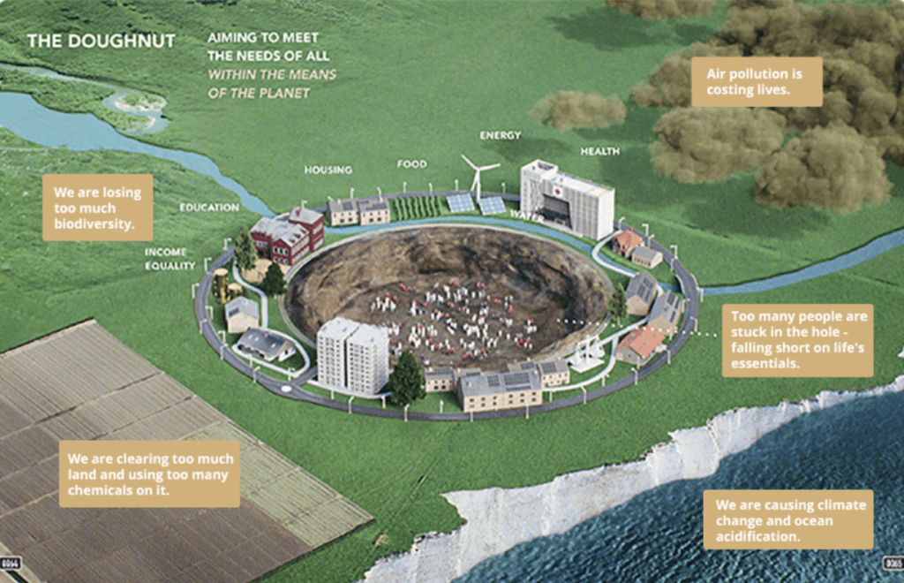

If students are struggling to articulate their ideas or cannot remember key features of either model, select one or more of the following resources to prompt their thinking.

* Basic [Circular Flow Diagram](https://commons.wikimedia.org/wiki/File:Circular_flow_of_goods_income.png), as used in the previous lesson (https://commons.wikimedia.org/wiki/File:Circular_flow_of_goods_income.png
* [Change the Goal – 1/7 Doughnut Economics](https://youtu.be/Mkg2XMTWV4g) (https://youtu.be/Mkg2XMTWV4g)
* [The Doughnut of social and planetary boundaries](https://www.kateraworth.com/doughnut/) Diagram, as used in the previous lesson (https://www.kateraworth.com/doughnut/)
* [Introducing Kate’s Doughnut](https://vimeo.com/293917202) Password: 2040_EDU (https://vimeo.com/293917202)

**Step 2**. Facilitate a brief class discussion to highlight key understandings such as:

**Circular Flow**

* Flow of money between firms and households in the form of goods and services and factors of production.
* Common understanding of how the economy runs.
* This model does not recognize the importance of the environment, unpaid work, social exchange that does not involve money, or the imbalance of power when wealth is accumulated.

**Doughnut model**

* Designed to meet the needs of all within the means of the planet – not just a model based on money but takes into consideration the pressure we are placing on the planet and the widening social inequality
* Shaped like a doughnut – the outer crust is the planetary boundaries where we are putting pressure on its survival e.g. biodiversity loss, land conversion, air pollution
* The inner hole is where people are falling short of life’s essentials e.g. housing, food, health, education, water, energy.

### **Part B: Doughnut Case Study**

**Step 1.** This activity will encourage students to make connections between the economic theory of the Doughnut model and what it looks like in action through the case study of a decentralized electricity grid in India.

Invite students to watch the following and participate in a guided discussion around the clip.

**TIP: Allow students to watch the clip through once uninterrupted. You can watch it a second time pausing at the timings shown below to engage students in the guided discussion.**

[**What’s Your 2040 – For Energy?**](https://vimeo.com/showcase/6167669/video/336504721)

**Password**: 2040_EDU (<https://vimeo.com/showcase/6167669/video/336504721>)  
**Note: You can use this same password to access all clips in the 2040 education media library.**

**Guided discussion suggested timings and topics:**

* **1:07 – Damon explores the community electricity grid as a solution. What is the problem that needs to be solved?***Suggested answer:* Not all communities are connected to traditional power grids, and the cost is very high. Having access to cheap, safe and reliable electricity can help improve the quality of life for people in the community. Eg. able to study, cook safely, connect to the media etc.
* **How does the grid work? And how do all members of the community connect to it?***Suggested answer:* Any home that has solar panels and a battery can buy a special box that connects them to the grid. If people can not afford to set this up, they can buy one of the Solboxes and load money into an account and buy other people’s energy when they need it.
* **2:09 – It is suggested that the microgrid is mimicking nature. What is meant by this? How does the grid get stronger and strong the more people that connect?***Suggested answer:* When cells divide they are creating a stronger body, the same occurs when more people connect to the network – greater supply of energy to be shared. The example of a swarm of bees working together is more effective than one bee trying to do it alone – this is the same when trying to build up an energy network. People power to make change.
* **2:32 – What is the economic benefit of creating microgrids? Why might some governments want to make them illegal?**
* *Suggested answer:* Profits from the grids stay in the local community and empower people rather than sending the profits to large companies with limited connection to the needs of the people. Some governments might want to shut down microgrids as they take away regulation and wealth from larger companies.
* **4:18 – What are the main principles of the Doughnut framework?***Suggested answer:* Designed to meet the needs of all within the means of the planet. The outer crust is the pressure on the planet, the inner hole is where society is falling short in meeting the needs of the people.
* **4:58 – How does the microgrid reduce pressure on the planet? How does it also bring people into the doughnut and out of the hole?***Suggested answer:* Solar energy is renewable, so it reduces pressure on climate change and air pollution. More people are pulled into the doughnut through improved health with less kerosene use, education, as there is light available to study, income equality, as profits stay in the local community, and networks, as the grid connects households. Solar energy also reduces pressure on deforestation, as less wood is cut and burned for fuel.

**Step 2.** After participating in the class discussion, invite students to reflect on the clip using the following questions (also available on the **Student Worksheet**):

* How did this clip make you feel and why?
* What was most interesting or inspiring about this clip?
* What were the main messages of the clip and how relevant are they to you?
* What questions do you still have about this clip?

Show students this diagram (also available to download [here](https://whatsyour2040.com/wp-content/uploads/2020/11/2040_DoughnutEconomics_TheDoughnut.pdf)) and talk through how the microgrids fit into the Doughnut model:

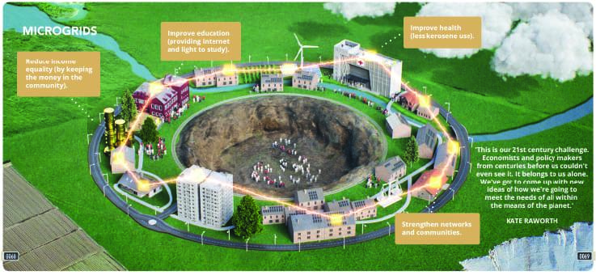

### **Part C: Exploring Economic Solutions**

**Note:** Steps 1, 2 and 3 are optional, but this activity will provide students with an opportunity to engage with the Doughnut model in a different way and may help improve understanding of the model, creating deeper learning in the following Steps.

**Step 1.** Take students to an open space, or move the tables. Use chalk, masking tape or sports markers to create a donut shape in the middle of the space.

Place student on, outside or inside the doughnut using approximately the following percentages (these are not accurate, but merely chosen to adequately demonstrate this activity):

* Outside the doughnut – 20%
* On doughnut – 30%
* Inside the doughnut – 50%

**Step 2.** Explain to students that they are configured in the hypothetical world where rich energy companies control all the fossil fuels and electricity generation. They will be given a range of scenarios that will impact on the economy, environment, and social factors. For each scenario, they have only 2 minutes to decide amongst themselves how many people should move in, off or out of the doughnut based on what they think the impact will be.

Then read out the following scenarios one at a time. After each, encourage students to negotiate between them who is going to move in, off or out of the doughnut depending on their imagined impact on the environment, economy and social factors:

* **Scenario 1.** A major car manufacturer decides to only build electric cars and drastically undercuts the prices of other car manufacturers.
* **Scenario 2.** Governments lift the ban on community-driven energy production and microgrids, while at the same time, cheap recyclable solar batteries become available worldwide.
* **Scenario 3.** After years of campaigning, women finally achieve full education and pay equality around the world.
* **Scenario 4.** Governments around the world, ban on the use of pesticides and chemicals for food production.
* **Scenario 5.** Single-use plastics are banned worldwide.

**Step 3.** Return to the classroom.

**Step 4.** Explain to students that they will be investigating, in groups, a 2040 solution like that of the decentralized electricity grid in India. Using the jigsaw technique, each member of the group will become an ‘expert’ in one of the following 2040 solutions:

**2040 – Seaweed as Food**

(<https://vimeo.com/showcase/6167669/video/304290496>)

**2040 – Aero farm**

(<https://vimeo.com/showcase/6167669/video/336498074>)

**2040 – Transport Case Study**

(<https://vimeo.com/showcase/6167669/video/336509114>)

**Empowering women and girls**

(<https://vimeo.com/showcase/6167669/video/336513493>)

**Note: Password for all clips is: 2040_EDU**

**Hot tip:** Learn more about the jigsaw technique [here](https://www.jigsaw.org/) (https://www.jigsaw.org/)

**Step 5.** Divide the class into even ‘home’ groups. For this example, four groups of five students (20 total). Tell students they will be returning to these groups after the next activity.

**Step 6.** Allocate each student in the ‘home’ group a different ***2040*** clip to become the expert for. Invite all experts for each topic to sit together (now there will be five groups with four students in each).

**Step 7.** Explain to students:

* *Your role as an expert is to investigate your solution along with the other students who have been given the same solution. Then you will report back to your ‘home’ group about what you learned. To become an expert, you will need to identify what the problem is and the possible solution, then discuss with your fellow ‘experts’ how it fits into the Doughnut framework.*

**TIP:** For smaller classes, you can make the home groups and expert equal numbers and use less clips. For larger groups, you could have more than one group study the same clip.

**Step 8.** Encourage ‘experts’ to watch their allocated ***2040*** solution clip and then work through the ***2040* Report Questions** on the **Student Worksheet.** Students can access the ***2040* Report Template** in the Student Worksheet to help guide their investigation. Questions include:

* Describe the problem:
  + What pressures are being placed on the planet (outer ring)?
  + What shortfalls are people facing (inside the hole)?
* Describe the solution:
  + How does this solution help reduce pressure on the planet?
  + How does this solution help lift people out of the hole and into the doughnut?

**Step 9.** Once all experts understand their problem, solution and how it fits within the Doughnut framework, ask them to return to their original ‘home’ groups (the original four groups of five students).

### **Part D: Exploring Economic Solutions – Shared learning**

**Step 1.** Now that all students are back in their original ‘home’ group, there should be five experts ready to share their findings from their 2040 solution. Invite each ‘expert’ to take turns to share their problem, solutions, and connection to The Doughnut. (E.g. pressures on the planet and the people).

**TIP:** You want to allocate a set time (e.g. 3 mins) to each expert to ensure all group members are given equal opportunity to share their findings.

**Step 2.** Provide each group with a printed or [digital copy](https://whatsyour2040.com/wp-content/uploads/2020/11/2040_SolutionsEvaluationTable_FINAL.pdf) of the **Solutions Evaluation Table below**. Explain to students that they now must evaluate each of the solutions that were presented by their ‘expert’ using the following criteria:

* The impact on bringing people out of the hole.
* The impact on reducing pressure on the planet.
* How realistic and achievable this solution is.

Each criterion will be rated out of five (5) and then given an overall star rating.

**Step 3.** Invite students to work together to come up with their ratings and encourage them to justify their ratings, and provide evidence where appropriate.

**TIP:** You may want to complete the decentralized electricity grid solution as a worked example or include it as one of the solutions that needs to be evaluated.

**Solutions Evaluation Table**

| **Solution Name** | **Impact on bringing people out of the hole** | **Impact on reducing pressure on the planet** | **Realistic and Achievable** | **Overall Star Rating** |
| --- | --- | --- | --- | --- |
| Decentralized Electricity Grid |  |  |  |  |
|  |  |  |  |  |
|  |  |  |  |  |

**Step 4.** Once groups have evaluated each of the solutions, invite students to share their star ratings with the class. Depending on how much time you have, you may choose to complete a class rating table that considers all groups evaluations.

Here are some diagrams to help you assist students to analyze their designated solution:

**Regenerative Agriculture and Marine Permaculture** (could also apply to Aero farming – image also available to download [here](https://whatsyour2040.com/wp-content/uploads/2020/11/2040_DoughnutEconomics_TheDoughnut.pdf)):

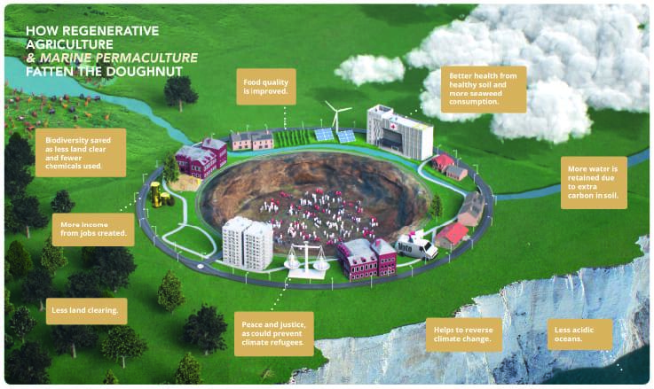

**Clean Transport** (e.g. driverless cars, electric vehicles – image also available to download [here](https://whatsyour2040.com/wp-content/uploads/2020/11/2040_DoughnutEconomics_Transport.pdf))

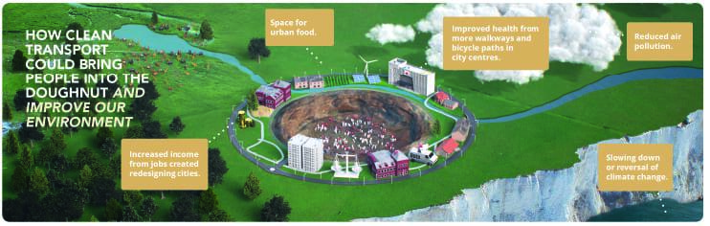

**Educating Girls** (image also available to download [here](https://whatsyour2040.com/wp-content/uploads/2020/11/2040_DoughnutEconomics_EducatingGirls.pdf))

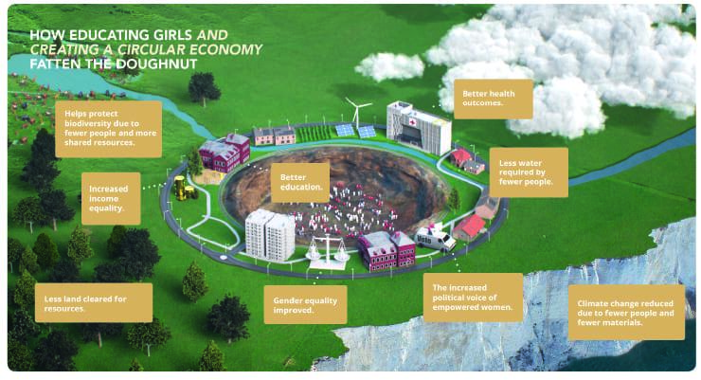

**Reflection**

Invite students to work independently to complete the following reflection questions on the Student Worksheet:

Identify and justify which solution you felt…

* … had the biggest impact on the wellbeing of people
* … has the biggest impact on the wellbeing of the planet
* … is the most realistic and achievable.

**Differentiated Learning**

**Extension** – Students can select one of the ***2040*** solutions that they found interesting and conduct further research about the impact that it can have on the local, national and global economies.

**Provisions for Learning Support** – Students who require additional support can be placed in groups of an odd number (for example, one group may need six students when there are only five solutions to investigate) and be an extra ‘expert’. This will ensure that they have someone from their home group to support them when presenting the solution. Alternatively, you may include the worked example as one of the solutions that need an expert for.

#### **Teacher Reflection**

Take this opportunity to reflect on your own teaching

* What did you learn about your teaching today?
* What worked well?
* What didn’t work so well?
* What would you share?
* Where to next?
* How are you going to get there?

**What’s Your 2040?**

Record your students’ work in their communities with the hashtag #whatsyour2040 and share their visions in the ‘2040: [The Regeneration’ Facebook Group](https://www.facebook.com/groups/2040TheRegeneration/). The 2040 crew would love to see your class’ work.