Empowering Women And Girls English Grades 10 & 11 Student Worksheet
Name: …………………………………. Class: …………..

Thought starter: What could you do to meet the challenge of climate change?

Climate Change Solutions
What do you think are the TOP FIVE most effective solutions to address climate change? Record them below:
1.
2.
3.
4.
5.

Women, Girls And Climate Change
You will be now watching a clip from the film 2040 that explains more about this topic that explores the topic of women, girls and climate change. Once complete, you will be reflecting on the clip using a SEE THINK WONDER routine. As you watch, pay attention to how you might complete this routine once the clip is complete.
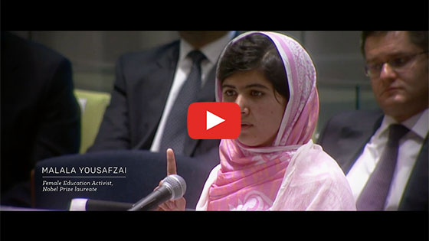
2040 – Empowering Women and Girls
Password: 2040_EDU
(https://vimeo.com/showcase/6167669/video/336513493)
SEE – What did you SEE in this clip? | THINK – What does this clip make you THINK about? | WONDER – What does this clip make you WONDER? What questions does it leave you with?

The Role of Community
1. Many different community members and groups have a role to play in addressing climate change. You will be assigned to a group that will have a specific role in the community. Here are the different community ‘roles’:
- Educators: your role is to give people important information and teach them (could be at school, or for adults)
- Creatives: your role is to get people excited about making changes (you could think of ad campaigns, art, films etc)
- Activist: your role is to raise awareness about issues in the community. You can also put pressure on government or businesses (you might organise campaigns, protests etc)
- Government: your role is to make laws – rules for everyone to follow
- Businesses: your role is to make products and services that help people and the planet. You can also raise money.
Fill in the table below, from the perspective of your group’s ‘role’ in the community. You must address this question:
How can we empower women and girls to address some of the challenges of climate change?
Your role
What parts of society will your group focus on?
What are some of the challenges that women and girls face in getting educated? How could you help?
What solutions could you create? (Write down every idea your group thinks of)
2. In your group, select one solution to focus on. Explain the idea in 2-3 sentences:

Working in your groups you then need to complete this SWOT analysis of your solution. This will help you to analyse your idea.
You should first fill out the ‘strengths’ and ‘weaknesses’. In these two areas, you should focus on the idea itself and what your group/community can do.
Then, move onto the opportunities and threats, which are ways that people outside of your group might help or hinder your plan.
Strengths  (positives about the idea) | Weaknesses  (drawbacks of the idea)
Opportunities  (ways other groups or people could add to this idea) | Threats  (ways other people or groups might damage this idea)

Reflection
Work independently to think about the solutions for climate change generated by your group and by your class, and answer the complete the following:
• What were the top two ideas you heard? List them here with a reason you found each interesting or important:

• How did completing the SWOT analysis affect your original idea?

• Think of a disagreement you had during the role play. How did you resolve it?

• Give an example of something that you or a peer did or said that demonstrated effective communication skills.

