Energy And Liveability Geography Years 7 & 8 Teacher Worksheet

Teacher preparation
Learning intentions: Students understand…
- … what liveability is
- … how energy affects our environment
- … how our environment affects liveability
- … the relationship between energy choices and liveability
Success criteria: Students can…
- … undertake research
- … produce a report based on criteria
- … participate in group and class discussions
- … work collaboratively and independently

Teacher content information: A 2018 study by The University of Melbourne on the thoughts and concerns of young people from Generations X and Y found the number one concern across both groups was lack of action around climate change. In particular, “Generation X worries what climate change will mean for their own children, while Generation Y is concerned about the impact on future generations” (The Educator). The report indicates that young people have a serious mistrust in the Government’s ability or willingness to tackle climate change.
Tackling climate change requires large-scale, systemic changes across all aspects of society. Simply aiming to reduce our C0₂ emissions is not enough: we need to rapidly decarbonise our planet. While this might sound challenging, the good news is we already have the knowledge and tools to do it.
2040 is an innovative feature documentary that looks to the future while focusing on what is happening now. Award-winning director Damon Gameau (director of That Sugar Film) embarks on a journey to explore what the future would look like by the year 2040 if we simply embraced the best solutions already available to us to improve our planet and shifted them into the mainstream.
The film will demonstrate to your students that we already have the solutions to climate change; we just need to take action to bring them rapidly into the mainstream. The 2040 documentary and curriculum package will support your students in turning this knowledge into positive action for a better future.
Find out how to see the film here. 2040 will only be available in cinemas for the first part of 2019 and you can make a group booking for your class at your local cinema during the film’s theatrical release which starts on May 23. These lessons have been designed with a media library to support teachers. The film will be available on video-on-demand and DVD later in 2019.
The film is the entry point to a global impact campaign that seeks to mobilise audiences to learn about, contribute to, advocate for and invest in regenerative solutions that improve the wellbeing of the planet, all people and all living systems.
To join the Regeneration and share your vision for 2040, see the website.
Watch the 2040 trailer:
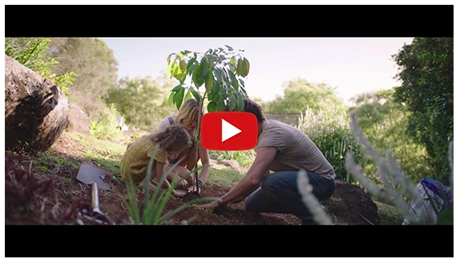
https://youtu.be/sR51ZDNSRFQ
Cool Australia, GoodThing Productions and Regen Pictures would like to acknowledge the generous contributions of Good Pitch Australia, Shark Island Institute, Documentary Australia Foundation, The Caledonia Foundation and our philanthropic partners in the development of these teaching resources.

Teaching sequence
Work through this resource material in the following sequence:
20 minutes – Part A: Activating Prior Knowledge
15 minutes – Part B: Exploring Liveability & our Environment Through Energy
20+ minutes – Part C: Improving our Environment and Liveability Through our Energy Choices
5 minutes – Reflection

Part A: Activating Prior Knowledge
Preparation: Print a copy of the AGREE/DISAGREE signs to use in the barometer activity (Step 1.)
Step 1. Begin this lesson by explaining to students that they will participate in a stand on the line activity around the concept of liveability.
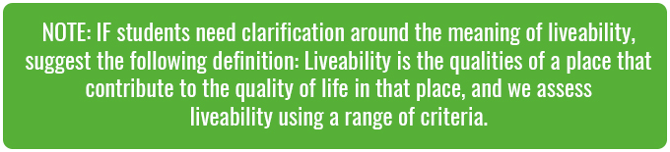
Explain to students that different aspects of liveability are important to different people in different ways. Students may not recognise it but we all make assessments about liveability based on the things that are important to us, such as “I’d love to live near the sea” or “I couldn’t live on that street. it’s too busy”. To find out what aspects of liveability are important to students, invite them to participate in the following barometer activity:
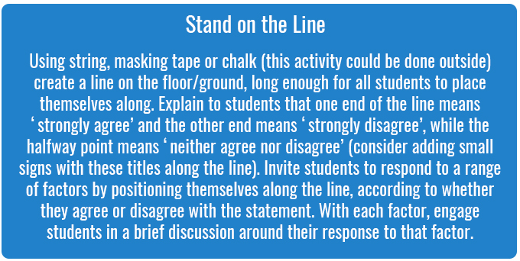
Read the following factors out to students one at a time and invite students to position themselves along the line based on how important each factor is to them:
- Access to nature
- Shops
- Cafes and restaurants
- Good neighbours
- Parks
- Sports centre
- Peace and quiet
Once complete, explain to students that when considering opportunities for urban development, town planners and decision makers don’t just think about appearance; they also need to need to consider making the area liveable. We assess the liveability of a place using a range of factors, including those included in the barometer activity.
Step 2. Explain to students that they will be watching and reflecting on a clip about what one Danish company thinks about liveability. Students will be watching the video through once uninterrupted, and then watching it again and taking notes using the questions below (also available on the Student Worksheet).
Now show students the following clip:
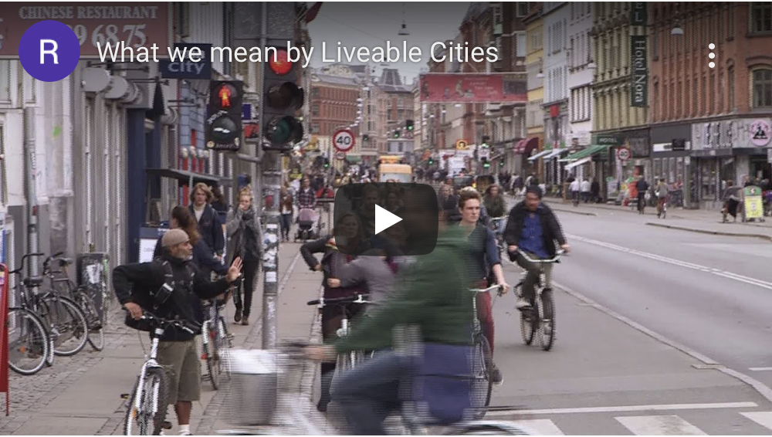What we mean by Liveable Cities
(https://www.youtube.com/watch?v=ziuKfCtXgSk)
Step 3. Once complete, invite students to work as a class to share their responses. Suggested answers and points for further discussion point are included above.
- What points does Herbert raise about the physical aspects of a city?
Suggested answers: Mobility (how people can move around), transportation, energy, food systems, waste management.
Further discussion points: What other points would students add?
- What points does Herbert raise about the social components of a city?
Suggested answers: Equity, no corruption, everyone has access to decision-making.
Further discussion points: Are these important to students? Why or why not? What would they add instead?
- What does Herbert say about the cultural aspects of a place?
Suggested answers: What people believe in, the values we share, identity, genius loci (the general atmosphere or sense of place).
Further discussion points: Which of these are important to students? How do we experience these factors?
- What are the ‘ingredients’ for a liveable city?
Suggested answers: This image has been taken from the clip and can be found at 1:16 on the clip. You can use it to guide further discussion about the ingredients for a liveable city. Further discussion points: Work with students to clarify any points in the image and discuss any points which are particularly interesting or relevant to students.

Part B: Exploring Liveability and our Environment Through Energy
Step 1. Explain to students that in the rest of this lesson they will be looking at:
- Some of the human-induced challenges affecting our environment; and
- How our environment affects the liveability of the places we live.
Through this, students will look at how we can take actions for our environment that will consequently improve the liveability of the places we live in.
Step 2. Explain to students that they will now be investigating how energy – one of the physical factors of liveability included in the clip watched earlier – affects how we live.
Break the class into pairs or small groups. Give each group a piece of butchers paper and ensure each student has a pen or pencil. Each group needs to conduct a brainstorm in response to the following question:
- What things in our daily lives do we need electricity for?
Allow students one or two minutes to record their ideas.
Once complete, invite each group to then think about the following:
- How would having no access to electricity in our homes or schools affect our daily lives?
Students should consider all the points they raised in response to the first question and then add further notes to show how having no access to electricity would affect this point (i.e. how would you keep food cool or how would you charge your phone?).
Once complete, invite students to share key points with the class. Through your discussion suggest to students that having no access to electricity would have a dramatic effect on their lives, and could ultimately affect them in terms of nutrition, health, and eduction. Having no or limited access to electricity is known as ‘energy poverty’, and is a situation facing many people in Australia and around the world.
Step 3. Now explain the following to students (also available on the Student Worksheet):
From the time of the Industrial Revolution, most energy generation relied on fossil fuels (fossil fuels are natural fuels that were formed in the geological past from the remains of living organisms). The role that energy generation from fossil fuels has played in our modern lives should not be understated; almost all of the things we do and use have their roots in energy sourced from fossil fuels. The problem is, burning fossil fuels to power our modern lives has a range of environmental impacts.
Then break the class into pairs or small groups. Each group needs to undertake research to find out:
- Two different types of fossil fuel
- At least one environmental impact for each fossil fuel, either in sourcing the fuel, transportation or energy production
- One way each of the environmental impacts may affect liveability.
Allow students time to conduct their research.
Learning Support: You might like to ask the school librarian to collate some relevant resources or direct students towards these websites if you think they require some extra support/structure, for example Fossil Fuel – Britannica Kids and Climate Kids NASA – Energy.
Step 4. Once complete, invite pairs or groups to pair up with other groups to share the results of their research. Alternatively, you could invite students to share the results of their research through class discussion. The teacher could use the following points to clarify key issues, either by moving between groups or through your class discussion:
- There are three different types of fossil fuel: coal, natural gas, and oil.
- An environmental impact for all fossil fuels includes the release of Carbon Dioxide (CO₂) into the atmosphere, contributing to global warming and climate change.
NOTE: If students need clarification around the chemical processes and causes of climate change, consider sharing this clip from the 2040 documentary; 2040 – Exploring the Themes (Password 2040_EDU)
- Specific impacts for coal include: Biodiversity loss and landscape disturbances from mining, groundwater contamination, air pollution from mining and burning coal.
- Specific impacts for natural gas include: Natural gas emits methane which is a far more potent greenhouse gas than CO₂. One method of sourcing natural gas – fracking – causes methane to be released into the atmosphere.
- Specific impacts for oil include: Oil spills cause environmental damage on a massive scale, air pollution from burning oil, biodiversity loss and landscape disturbances from oil drilling.
- Liveability can be affected in multiple ways: all living things (including humans) rely on a healthy environment for our basic needs including fresh air, water, shelter and food. Humans also benefit from a healthy environment on a mental health level; being in healthy and diverse green spaces improves our mental health and feelings of wellbeing.
Tip: The following clip can be used to get students thinking about the future challenges as well as the future opportunities for our energy future:
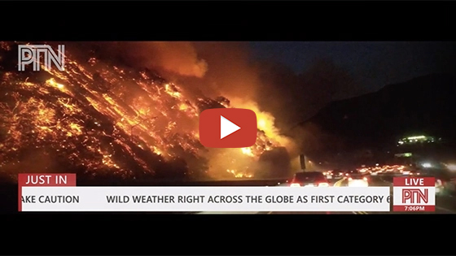
2040 – Energy News Report
Password: 2040_EDU (https://vimeo.com/showcase/6167669/video/336506016)
Note: You can use this same password to access all clips in the 2040 education media library.

Part C: Improving our Environment and Liveability Through our Energy Choices
Step 1. Explain to students that they will now be looking at how different approaches to energy generation can help to improve our environment and the liveability of the places we live.
Explain that they will begin by watching a clip (link below) about decentralised energy from the 2040 documentary and responding to a series of questions (provided below) through class discussion. Explain to students that the community presented in this clip is from Bangladesh, a country of around 160 million people, 70 million of whom do not have access to grid electricity with another 60 million having unreliable grid connections (Source: Lighting Global).
NOTE: This clip deals with solar energy; if students are unfamiliar with solar energy you could read through the following information before watching the clip (information also available on the Student Worksheet):Solar is the Latin word for ‘sun’, so when we talk about solar energy, we are talking about the energy that comes from the sun. We already use the energy from the sun for light and warmth – in fact, without the sun the earth would be completely dark, freezing and lifeless.But we can also use photovoltaic (PV) cells to capture the sun’s energy and convert it into electricity. Photovoltaic cells are found in solar panels. The sun shines onto the solar panel, and the photovoltaic cells generate “DC” (Direct Current) electricity. This electricity is then fed into a solar inverter that converts into “AC” (Alternating Current) electricity. You can then use AC electricity to power appliances in your home or school. Any power that is ‘left over’ gets directed into the mains power grid for others to use.The best part about solar energy is that it creates almost no pollution (some pollution may be generated in building and transporting the solar panels). And because the sun’s energy is totally renewable it will never run out (well, it will in around 4 billion years but that means we’ve got a bit of time to prepare). On top of that, the Earth receives more energy from the sun in an hour than is used in the entire world in one year.

Share one of the following clips with students:
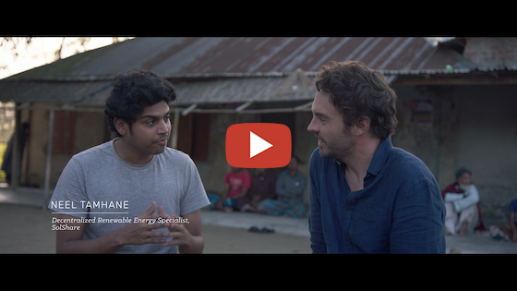
2040 – Decentralised Energy
Password: 2040_EDU
(https://vimeo.com/showcase/6167669/video/336499398)
OR
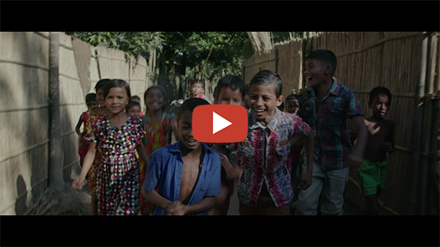
What’s Your 2040 – For Energy?
Password: 2040_EDU
(https://vimeo.com/showcase/6167669/video/336504721)
Once complete, engage students in a class discussion around their answers to the following questions
- What is happening in this clip? What did you see?
- What was interesting or surprising about this clip?
- How might the energy system in this case study affect liveability in this area?
Suggested answer: In terms of the environment, solar energy is a source of renewable energy which has little environmental impact. In terms of community, many communities in developing countries struggle to access energy which limits educational and employment opportunities (it’s very hard to study or run a business in the dark). In this case study, people can buy energy when they need it, meaning they have more control over their energy use and expenses. It also means all people have access to a clean form of energy; energy from fossil fuels can create pollution that impacts both environmental and human health.
- What questions does this clip leave you with? What do you want to know more about?
Step 2. Once complete, invite students to form pairs or small groups (not the same ones they were in earlier). Each group needs to compare solar power with coal power according to different factors. They can record their assessment on the table on the Student Worksheet, rating each factor for each energy type out of 10 (with 1 being ‘poor’ and 10 being ‘excellent’). Students should also add notes to each point to justify the rating given.

Factor | Solar | Coal
Liveability
Sustainability
Accessibility
Cost
Your choice…
Step 3. Once complete, students need to work in their groups to create a report around the results of their assessment. The report can be in a written format or in a video format. Reports need to include supporting images (students can use images from the Cool Australia Digital Library, or can take their own photos or create their own graphics – remind students that images online are often subject to copyright).
Give students the following structure for their report (also available on the Student Worksheet):
- Introduction – What are you investigating and describing in this report?
- Key terms – What is meant by the key terms you use in this report (e.g. liveability, energy, energy choices, sustainability, accessibility etc.)?
- Body of the report – Present the details of your assessment and justify your ratings.
- Conclusion – Summarise key points and recommendations.
Students may need to conduct additional research in support of their report. When conducting research online, remind students of the Search Strategies for Googling.
Allow students the time to research and create their reports.
Step 4. Invite students to share their reports with other students. This could be done by having groups share with the whole class or with another group. Once complete, invite students to think about the similarities and differences between the information included in their reports.

Reflection
Invite students to work independently to answer the following (also available on the Student Worksheet):
- I used to think…
- But now I think…

Take It Further
To expand on student’s learning in this lesson, consider following up with this lesson; 2040 Vision For Your Community. The class could also explore energy solutions (https://whatsyour2040.com/regenerative-agriculture/) in more detail using the 2040 website.
The 2040 team have created a range of clips specifically for use in geography classrooms. Access the whole package of 2040 Geography clips at the following link, Secondary GEOGRAPHY Portfolio Password: 2040_GEO
Teacher Reflection
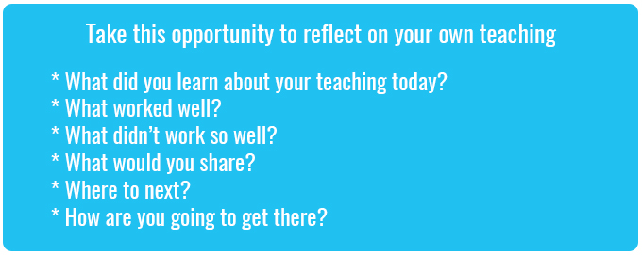

What’s Your 2040?
Record your students’ work in their communities with the hashtag #whatsyour2040 and share their visions in the ‘2040: The Regeneration’ Facebook Group.
The 2040 crew would love to see your class’ work.

