Energy And Sustainability Science Grades 7 & 8 Teacher Worksheet

Teacher preparation
Learning intentions: Students will …
- … understand what sustainability is and how it relates to energy
- … recognise the key features of renewable energy and the different types of renewable energy that currently exist
- … understand different energy efficiency practices and why we might use these (year 8)
Success criteria: Students can …
- … create a presentation
- … create a scientific poster
- … conduct research
- … work collaboratively
- … participate in group and class discussions

Teacher content information: A 2018 study by The University of Melbourne on the thoughts and concerns of young people from Generations X and Y found the number one concern across both groups was lack of action around climate change. In particular, “Generation X worries what climate change will mean for their own children, while Generation Y is concerned about the impact on future generations” (The Educator). The report indicates that young people have a serious mistrust in the Government’s ability or willingness to tackle climate change.
Tackling climate change requires large-scale, systemic changes across all aspects of society. Simply aiming to reduce our C0₂ emissions is not enough: we need to rapidly decarbonise our planet. While this might sound challenging, the good news is we already have the knowledge and tools to do it.
2040 is an innovative feature documentary that looks to the future, while focusing on what is happening now. Award-winning director Damon Gameau (director of That Sugar Film) embarks on a journey to explore what the future could look like by the year 2040 if we simply embraced the best solutions already available to us to improve our planet and shifted them into the mainstream.
The film will demonstrate to your students that we already have the solutions to climate change; we just need to take action to bring them rapidly into the mainstream. The 2040 documentary and curriculum package will support your students in turning this knowledge into positive action for a better future.
Find out how to see the film here. 2040 will only be available in cinemas for the first part of 2019 and you can make a group booking for your class at your local cinema during the film’s theatrical release which starts on May 23. These lessons have been designed with a media library to support teachers. The film will be available on video-on-demand and DVD later in 2019.
The film is the entry point to a global impact campaign that seeks to mobilise audiences to learn about, contribute to, advocate for and invest in regenerative solutions that improve the well-being of the planet, all people and all living systems.
To join the Regeneration and share your vision for 2040, see the website.
Watch the 2040 trailer:
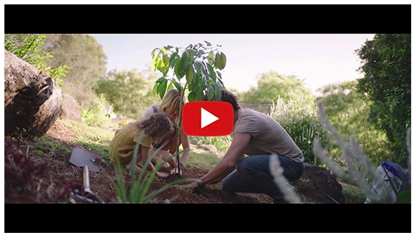
Cool Australia, GoodThing Productions and Regen Pictures would like to acknowledge the generous contributions of Good Pitch Australia, Shark Island Institute, Documentary Australia Foundation, The Caledonia Foundation and our philanthropic partners in the development of these teaching resources.
Additional resources:
- Definitions of Sustainability Factsheet

Teaching sequence
Work through this resource material in the following sequence:
20 minutes – Part A: Activating Prior Knowledge
30 minutes – Part B: Energy and Sustainability
40 minutes – Part C: Energy in our Community
10 minutes – Reflection

Part A: Activating Prior Knowledge
Step 1. Begin this lesson by distributing a copy of the Student Worksheet to each student. Ask them to navigate to the first activity; Defining Sustainability. Invite students to think about and respond to the following question (also available on the Student Worksheet):
- What does sustainability mean to me?
Students can record their responses in full sentences, bullet points or keywords.
Once complete, invite students to team up with a classmate to share their ideas, looking at the differences and similarities between their ideas and explaining their responses.
Step 2. Now, explain to students that they will continue working in their pairs to try to create a definition of sustainability. They could start their definition with:
- Sustainability is…
Allow students several minutes to attempt a definition. If students are struggling, suggest that they focus on keywords rather than full sentences; what words do they think should be included in a definition of sustainability?
Then invite students to share their definitions with the class. It may be that your students have generated vastly different definitions; reassure students that this is perfectly fine. Sustainability is a difficult topic that can be hard to put your finger on, especially as it often means different things to different people in different situations.
Through your discussion, explain to students that sustainability is widely considered to be made up of three elements. The three elements are:
- Environment – How is the natural environment affected?
- Society – What are the costs or benefits to society?
- Economy – Will this make or lose money?
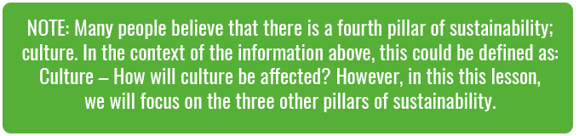
Sustainability will only be achieved when there is a balance between all three elements. To help explain this to students you could project the following image (which can be downloaded here):
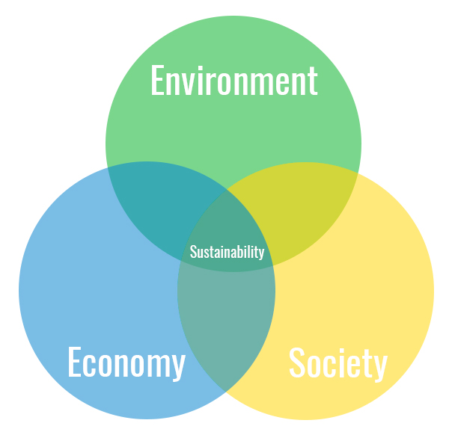
If one or more of the factors experience significant negative changes then sustainability will fail.
Step 3. Spend several minutes working with students to develop a class definition for sustainability, based on students’ earlier attempts and the information you just provided about the three factors of sustainability. The following definition might be helpful in guiding students:
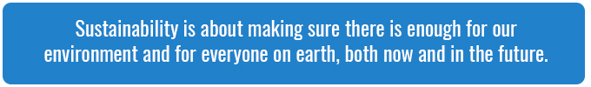
NOTE: The Definitions of Sustainability factsheet contains several more definitions for sustainability which might be useful.

Part B: Energy and Sustainability
Step 1. Explain to students that they will be exploring the concept of sustainable energy. Project the following image on the board:
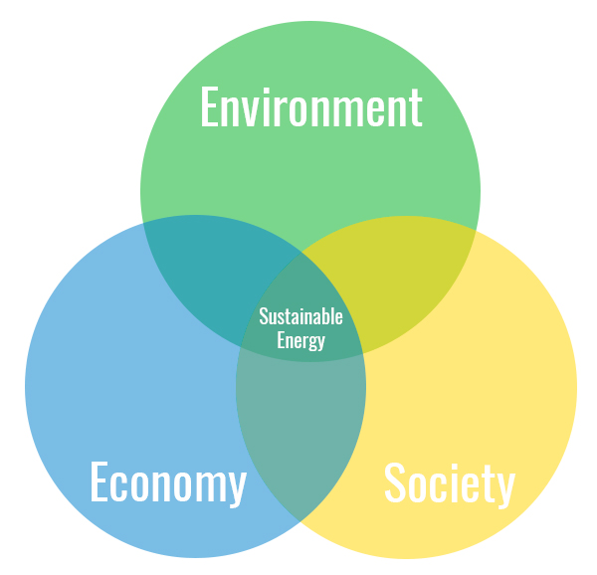
Invite students to suggest what the three factors in this Venn diagram might refer to in the context of sustainable energy. Through your discussion, suggest to students the following:
- Environment – This refers to the need for cleaner sources of energy with lower environmental impacts and energy conservation.
- Society – This refers to ensuring all people have access to affordable energy. Energy poverty refers to a situation where a household does not have access or cannot afford to have the basic energy or energy services to achieve day to day living requirements. In countries like Australia this can mean that energy prices are too high, and people can’t afford to pay their energy bills. In developing countries, many people are negatively affected because their very low use of or access to modern energy requires that they use dirty or polluting fuels or requires them to spend excessive time spent collecting fuel to meet their basic needs.
- Economy – This refers to ensuring that clean energy sources are economically viable in both the short and long term.
When combined, the three factors of sustainability create a complex picture of sustainable energy. Explain to students that in the rest of this lesson they will be focusing on the Environment factor.
Step 2. Explain to students that when it comes to energy, the most sustainable forms are those that are from renewable resources.
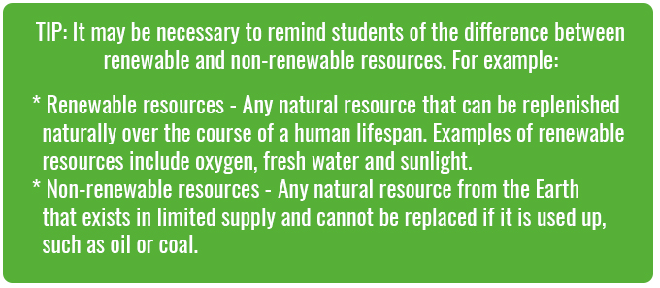
There are a range of different types of renewable energy that are available to us and that we have the technology to harness. Explain to students that they will now work collaboratively to research these.
Year 8 students will also look at energy efficiency as an aspect of sustainable energy.
Differentiation
Year 7 – Break the class into five groups and assign each group with one of the following types of renewable energy:
- Solar
- Wind
- Hydropower
- Biomass
- Geothermal
Each group needs to conduct the research necessary to answer the following questions about their type of energy (questions also available on the Student Worksheet):
- How does this type of energy work? What resource does it use?
- Is this a renewable resource? Why or why not?
- Is this a clean source of energy? Why or why not?
- Does this source of energy have any environmental impacts? If so, what are they and what could be done to address these impacts?
- Where is this type of energy used? Is this type of energy used in Australia and how much of our energy comes from this source? (E.g. Live Australian Electricity Generation Source Statistics)
Each group needs to create a presentation to describe the type of energy they investigated and to communicate their answers to the questions above. You could provide students with the Presentation Assessment Rubric to help them understand what is expected of them.
Year 8 – Break the class into eight groups and assign each group with one of the following:
- Energy source – solar
- Energy source – wind
- Energy source – hydropower
- Energy source – biomass
- Energy source – geothermal
- Energy conservation – buildings
- Energy conservation – energy efficient products
- Energy conservation – transport
Each group needs to conduct the research necessary to answer the following questions about the topic they have been assigned (questions also available on the Student Worksheet):
- What are the key points about your topic? What is it about?
- What do you think is most interesting or important about this topic?
- How does your topic relate to sustainable energy? How does this topic help us achieve sustainable energy?
- Where do we use this? Is this used in your country or the area you live in?
Each group needs to create a presentation to describe the type of energy they investigated and to communicate their answers to the questions above. You could provide students with the Presentation Assessment Rubric to help them understand what is expected of them.
Step 3. Invite each group to share their presentations with the class. You can use the Presentation Assessment Rubric to assess students work.

Part C: Energy in our Community
Step 1. Explain to students that they will now think about how sustainable energy might be used to address one of the other factors of sustainability; society.
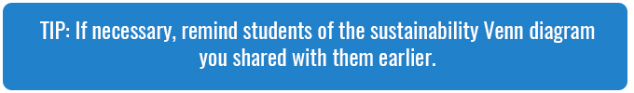
Explain to students that they will be watching a clip from the 2040 documentary. As they watch, invite them to record anything that they think relates to the environment and society factors of sustainability. Share the following clip with students:
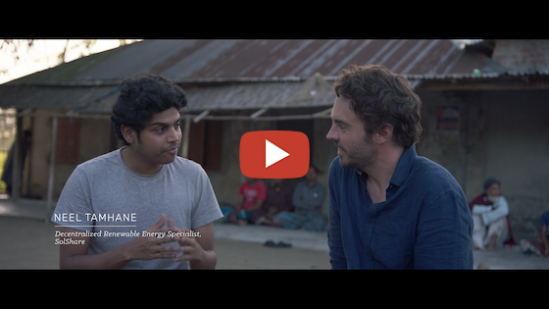
2040 – Decentralised Energy Password: 2040_EDU (https://vimeo.com/showcase/6167669/video/336499398)
Once complete, invite students to participate in a class discussion around the clip. Consider the following questions in your discussion:
- What is this clip about?
- What sort of energy is this clip about?
- How does this clip relate to the ‘environment’ factor of sustainability?
- How does this clip relate to the ‘society’ factor of sustainability?
- What else stood out for you in this clip? What did you find interesting or inspiring?
Step 2. Now explain to students that they will be thinking about their community and what could be done to help their community become more sustainable in terms of energy. Invite students to imagine that they need to present their ideas to a community meeting where many different people from the community will be present. Some of these people will have little knowledge about the impacts of energy on our environment, and some may be wary of change. Others may have family or friends who work for renewable energy or conventional energy providers. It is important that students present a balanced argument and that they justify any proposals they make.
Differentiation –
- Year 7 – Students should focus on what type of energy would be most suited to their area. Students should consider the social and environmental benefits of their idea. Students need to justify their choice.
- Year 8 – Students can suggest either a type of energy or an energy conservation action for their area. Students should consider the social and environmental benefits of their idea. Students need to justify their choice.
Students can work in pairs or groups and each group should produce a scientific poster that describes their suggestion, includes justifications, maps and diagrams (where necessary).
You can use the Scientific Poster Rubric to assess the work of students.

Reflection
Invite students to work independently to think about this lesson and complete the CONNECT EXTEND CHALLENGE activity on the Student Worksheet.

Take It Further
To expand on student’s learning in this activity, consider following up with this lesson; 2040 Vision For Your Community.

Teacher Reflection

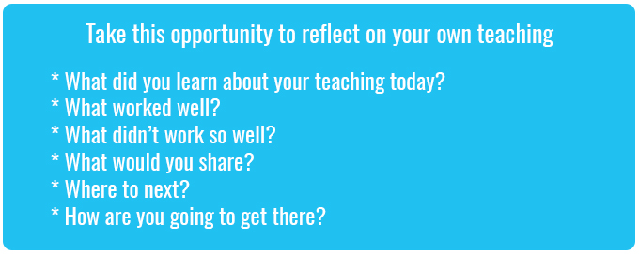

What’s Your 2040?
Record your students’ work in their communities with the hashtag #whatsyour2040 and share their visions in the ‘2040: The Regeneration’ Facebook Group.
The 2040 crew would love to see your class’ work.

