# Energy And Sustainability Science Years 7 & 8 Student Worksheet

**Name: ………………………………….  Class: …………..**

#### Thought Starter: What does a sustainable energy future look like?

### **Defining Sustainability**

**1.** Work independently to think about and record your responses to the following question:

What does sustainability mean to me?

**2.** Now work collaboratively to come up with a definition of sustainability. You could start your definition with:

Sustainability is…

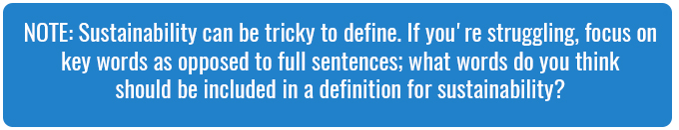

Be prepared to share your definition or keywords with the class.

### **Energy and Sustainability**

**Year 7**

Work in your groups to research the answers to the following questions about the type of energy your teacher has assigned you. Record your notes below:

What type of energy has our group been assigned?

How does this type of energy work? What resource does it use?

Is this a renewable resource? Why or why not?

Is this a clean source of energy? Why or why not?

Does this source of energy have any environmental impacts? If so, what are they and what could be done to address these impacts?

Where is this type of energy used? Is this type of energy used in Australia and how much of our energy comes from this source?

Each group needs to create a presentation to describe the type of energy they have investigated and to communicate their answers to the questions above.

**Year 8**

Work in your groups to research the answers to the following questions about the energy source or type of energy conservation your teacher has assigned you. Record your notes below:

What topic is our group investigating?

What are the key points about your topic? What is it about?

What do you think is most interesting or important about this topic?

How does your topic relate to sustainable energy? How does this topic help us achieve sustainable energy?

Where do we use this? Is this used in your country or the area you live in?

Each group needs to create a presentation to describe the topic they investigated and to communicate their answers to the questions above.

### **Reflection**

Think about what you looked at in this lesson and answer the questions below:

How was the information you covered in this lesson CONNECTED to what you already knew?

What new ideas did you get that EXTENDED or pushed your thinking in new directions?

What do you still find CHALLENGING or confusing? What questions do you now have?