# Applying Point Of View – English – Years 7 & 8 – Student Worksheet

## Thought starter: What’s the point of Point of View?

### **Understanding Point of View**

**1.** In the table below, draw three pictures. Each picture should represent ONE of the statements:

|  |  |  |
| --- | --- | --- |
| I stole the jewellery. | That woman stole the jewellery. | You stole the jewellery! |
|  |  |  |

Once complete, team up with a partner to share your drawings and discuss your answers to the following questions:

* How are the statements different?
* What did you include in each picture to show the difference between the statements?
* What did you find challenging about visually depicting these statements? How did you attempt to address these challenges?

Record any important points raised in your discussion here:

**2.**What keywords we might look for to find the point of view? Think of some examples and record these in the table below:

|  |  |  |  |
| --- | --- | --- | --- |
|  | **First Person** | **Second Person** | **Third Person** |
| **Examples** |  |  |  |
| **Keywords** |  |  |  |

### **Applying Knowledge to Written Text**

You will now explore point of view through the lens of climate change. Read each of these real news headlines and identify which point of view is being used. Use the guide below to help you. After you’ve identified the point of view (Column B), make a prediction about the type of story you think the headline would be about (Column C).

|  |  |  |
| --- | --- | --- |
| **Column A. Headline** | **Column B. Point of View** | **Column C. Predict the type of story and information included** |
| Climate change: yes, your individual action does make a difference |  |  |
| Climate change activists prepare traffic blockades across London |  |  |
| Is eating vegan really the best diet for the planet? I tried it for a month |  |  |

Once complete, turn to a partner and compare your answers, making amendments where necessary.

### **Pros and Cons of POVs**

**1.** You will now be watching some clips about climate change that use different points of view at different times. As you watch pay attention to the point of view being used in the clip. Often they use multiple points of view.

You will record your observations in the table below. To help get you started, some of the first table has been filled out for you.

Watch this clip first:

**2040 – Children’s Solutions**

[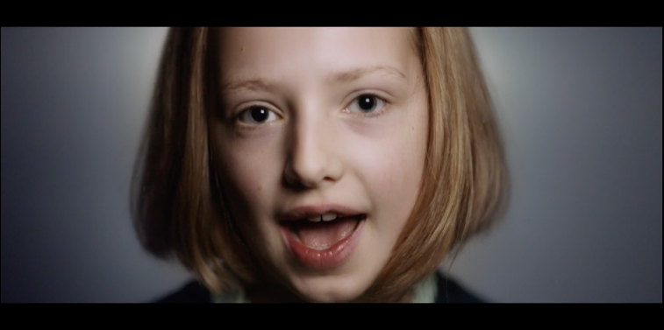](https://vimeo.com/showcase/6167669/video/334806925)

**Password: 2040_EDU** (<https://vimeo.com/showcase/6167669/video/334806925>)

|  |  |  |
| --- | --- | --- |
| **Column A. POV being used** | **Column B. First Person (1st)** | **Column C. Second Person (2nd)** |
| **When it was used** |  |  |
| **How I know (words used)** |  |  |

|  |  |  |
| --- | --- | --- |
| **Column A. POV being used** | **Column B. First Person (1st)** | **Column C. Second Person (2nd)** |
| **Strengths** |  |  |
| **Weaknesses** |  |  |

**2.** Now watch this clip, and again pay attention to the point of view being used in the clip and record your observations in the table below:

**2040 – A Vision**

[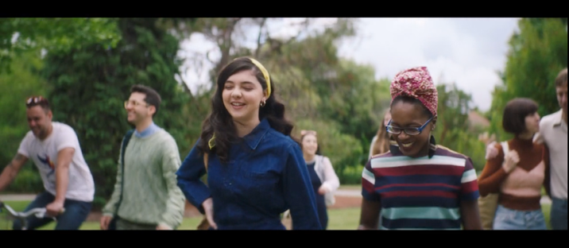](https://vimeo.com/showcase/6167669/video/336512335)

**Password: 2040_EDU**   
(<https://vimeo.com/showcase/6167669/video/336512335>)

|  |  |  |
| --- | --- | --- |
| **Column A. POV being used** | **Column B. First Person (1st)** | **Column C. Second Person (2nd)** |
| **When it was used** |  |  |
| **How I know (words used)** |  |  |

|  |  |  |
| --- | --- | --- |
| **Column A. POV being used** | **Column B. First Person (1st)** | **Column C. Second Person (2nd)** |
| **Strengths** |  |  |
| **Weaknesses** |  |  |

**3.** Reflect on the content on the videos. These videos explained what the children and Damon’s ideas of 2040 are. Which ideas did you find interesting? Note them down below:

•  Something I’d never thought about before

•  Something that would make life more fun

•  Something that would make life easier

•  Other ideas I liked

### **Your 2040 Vision**

**1.** You are now going to write about your own vision for 2040! To help get you started work independently or in pairs to brainstorm your answers to the following questions, recording your own ideas in your own words:

•  How old will you be in 2040?

•  Which point/s of view will you use?

•  What are the main experiences you will focus on?

•  What ideas will you surprise your audience with?

•  What will remain the same about life in your vision of 2040?

•  You can then start writing. You could record your work here:

**2.** Once complete, you can share your vision with a classmate. You should provide feedback on each other’s visions using the following points to guide you:

* I liked your idea of…
* I want to know more about…
* When you used the _____ person point of view, I felt….

### **Reflection**

Work independently to think about what you looked at in this lesson and answer the following questions:

•  What was challenging about using different points of view?

•  Which idea do you most hope to see happen in 2040?