# Making Persuasive Speeches English Years 9 & 10 Student Worksheet

**Name: ………………………………….  Class: …………..**

#### Thought starter: Do girls and women in Australia have challenges getting access to education and family planning support?

### **Generating Challenges and Solutions**

Lack of access to education and family planning are two challenges that girls and women around the world currently face.

Working in groups, you need to focus on either education or family planning, and consider the reasons why girls or women may lack access to these rights, both in Australia and around the world. You should consider social, economic, political, medical and religious reasons. Discuss your ideas in your groups and record your responses in your own words in the table below:

|  |  |
| --- | --- |
| **Reason** | **Solution** |
| Lack of access to school due to menstruation | e.g. Toilets and sanitary products provided |
|  |  |
|  |  |
|  |  |

**Extend yourself:** Put a star next to the challenges you believe are only found in developing countries.

### **Monroe’s Motivated Sequence**

Many persuasive texts follow a sequence known as Monroe’s Motivated Sequence. Keep in mind that not all texts follow the exact order – sometimes they can flow back and forth between steps.



You will now watch the following clip then use the table below to consider how Damon’s text is structured and the impact on the audience. Once complete, you will need to respond to the questions in the table below. It would be useful to read the questions prior to watching, and then pay attention to these points within the clip. Remember that most texts do not perfectly fit any given structure and areas of both fitting the structure and deviating from it are of interest.

[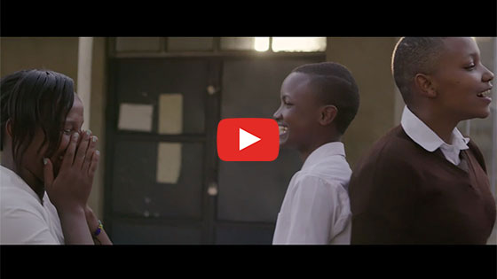](https://vimeo.com/336513493)

[Empowering Women and Girls](https://vimeo.com/336513493)   
**Password: 2040_EDU** (<https://vimeo.com/336513493>)

Complete this table:

|  |  |
| --- | --- |
| **Stage One: Attention** How does Damon grab our attention? What information or persuasive techniques does he include? |  |
| **Stage Two: Problem/Challenge** What challenges does Damon describe? |  |
| **Stage Three: Solution** What solutions does Damon include? |  |
| **Stage Four: Visualise the solution** How does Damon help us visualise the solution? What images do we see? What do the speakers describe? |  |
| **Stage Five: Action**  Does Damon leave us with an action to take? Why/why not? |  |

**Step 3.** Now watch Katharine Wilkinson’s TED talk and do the same again. How does she use this sequence? How does she stray from it?

[How empowering women and girls can help stop global warming](https://www.youtube.com/watch?v=vXlJEcrinwg)   
(<https://www.youtube.com/watch?v=vXlJEcrinwg>)

|  |  |
| --- | --- |
| **Stage One: Attention** How does Katharine grab our attention? What information or persuasive techniques does she include? |  |
| **Stage Two: Problem/Challenge** What challenges does Katharine describe? |  |
| **Stage Three: Solution** What solutions does Katharine include? |  |
| **Stage Four: Visualise the solution** How does Katharine help us visualise the solution? |  |
| **Action:** Does Katharine leave us with an action to take? Why/why not? |  |

### **Persuasive Speech Writing**

You will now write a persuasive speech about a solution that will empower women and girls and help to address climate change. Use the planner below to ensure you have followed Monroe’s Motivated Sequence.

The problem you are addressing:

The solution you are proposing:

|  |  |
| --- | --- |
| **Stage One: Attention** How will you grab the audience’s attention? |  |
| **Stage Two: Problem/Challenge** What problem will you focus on? What details will you include? |  |
| **Stage Three: Solution** What is the solution? |  |
| **Stage Four: Visualise the solution** What is the solution? How will you help the audience imagine the solution in action? |  |
| **Action:** What steps do you want the audience to take at the end of your speech? |  |

Now, write your speech:

You are going to perform your speech to a small group. Nominate someone in the group to be a scribe, and provide you with feedback below:

Step by step feedback:

* Did the opening lines catch your attention? Why/why not?
* Was the ‘need’ or ‘problem’ described clearly? Did it seem like an important problem?
* Was the solution clear? Why/why not?
* Did the visualisation help you imagine the solution? Why/why not?
* Was the action clear?

Overall feedback:

* What do you think is missing from the speech?
* What worked well?

### **Reflection**

Work independently to reflect on what you have learned, enjoyed and/or found challenging about using Monroe’s Motivated Sequence to write and to analyse texts. Use the following questions to guide your reflection:

How did Monroe’s Motivated Sequence help you to structure your work?

What parts of using the structure did you find challenging or constraining?