# Making Persuasive Speeches English Years 9 & 10 Teacher Worksheet

## Teacher Preparation

**Learning intentions:**Students will…

* … understand some of the challenges that women and girls currently face
* … understand the five stages of Monroe’s Motivational Sequence

**Success criteria:** Students can…

* … describe how a text’s structure and features impact an audience
* … apply Monroe’s Motivational Sequence to a text to explore how it fits and deviates from the structure
* … create their own persuasive text incorporating ideas from research and utilising the learnt structure



**Teacher content information:**A 2018 study by [The University of Melbourne](https://education.unimelb.edu.au/__data/assets/pdf_file/0011/2887895/Most-important-issues-report-final-Sept-2018.pdf) on the thoughts and concerns of young people from Generations X and Y found the number one concern across both groups was lack of action around climate change. In particular, “Generation X worries what climate change will mean for their own children, while Generation Y is concerned about the impact on future generations” ([The Educator](https://www.theeducatoronline.com/au/news/youth-reveal-their-top-concern-in-national-survey/255130)). The report indicates that young people have a serious mistrust in the Government’s ability or willingness to tackle climate change.

Tackling climate change requires large-scale, systemic changes across all aspects of society. Simply aiming to reduce our C02 emissions is not enough: we need to rapidly decarbonise our planet. While this might sound challenging, the good news is we already have the knowledge and tools to do it.

2040 is an innovative feature documentary that looks to the future while focusing on what is happening now. Award-winning director Damon Gameau (director of [That Sugar Film](https://thatsugarmovement.com/film/)) embarks on a journey to explore what the future could look like by the year 2040 if we simply embraced the best solutions already available to us to improve our planet and shifted them into the mainstream.

The film will demonstrate to your students that we already have the solutions to climate change; we just need to take action to bring them rapidly into the mainstream. The 2040 documentary and curriculum package will support your students in turning this knowledge into positive action for a better future.

Find out how to see the film [here](https://madmanfilms.com.au/2040film/). 2040 will only be available in cinemas for the first part of 2019 and you can make a group booking for your class at your local cinema during the film’s theatrical release which starts on May 23. These lessons have been designed with a media library to support teachers. The film will be available on video-on-demand and DVD later in 2019.

The film is the entry point to a global impact campaign that seeks to mobilise audiences to learn about, contribute to, advocate for and invest in regenerative solutions that improve the wellbeing of the planet, all people and all living systems.

To join the Regeneration and share your vision for 2040, see the [website](https://whatsyour2040.com/).

**Watch the 2040 trailer:**

[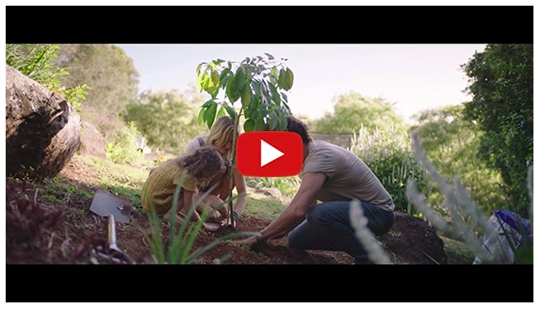](https://www.youtube.com/watch?v=sR51ZDNSRFQ&feature=emb_title)

[2040 Official Trailer](https://youtu.be/sR51ZDNSRFQ) (<https://youtu.be/sR51ZDNSRFQ>)

Cool Australia, GoodThing Productions and Regen Pictures would like to acknowledge the generous contributions of [Good Pitch Australia](https://goodpitch2australia.com.au/), [Shark Island Institute](https://sharkisland.com.au/shark-island-institute/), [Documentary Australia Foundation](https://www.documentaryaustralia.com.au/), [The Caledonia Foundation](https://www.caledoniafoundation.com.au/) and our philanthropic partners in the development of these teaching resources.

## Teaching Sequence

**Work through this resource material in the following sequence:**

10 minutes – Part A: Identifying Challenges and Generating Solutions  
40 minutes – Part B: Munroe’s Motivational Sequence  
45 minutes – Part C: Persuasive Speech Writing  
20 minutes – Part C: Performance and Feedback  
5 minutes – Reflection

### **Part A: Identifying Challenges and Generating Solutions**

**Step 1.**Begin this lesson by explaining to students that lack of access to education and family planning are two challenges that girls and women around the world currently face. To explore the relationship between climate change and empowering women and girls refer to this accompanying lesson, [2040 – Empowering Women and Girls – English – Years 9 & 10.](https://twentyfortyb.wpengine.com/activities/empowering-women-and-girls-english-years-9-10/) This lesson highlights the importance and benefits of empowering women and girls, as well as its far-reaching impacts.

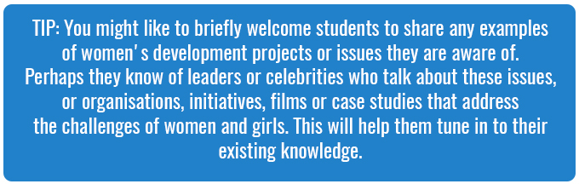

**Step 2.** Divide students into an even number of groups, and assign or allow students to choose from the two below topics, ensuring that each topic is distributed an equal number of times:

* Lack of education for women
* Lack of family planning information for women

Provide each student with a copy of the Student Worksheet.  As a small group, invite them to brainstorm using the table of reasons and solutions. Ask students to discuss and record all the reasons they believe there may be a lack of access to education or family planning (depending on their assigned group) and any solutions to those challenges. Students can discuss their ideas in their groups; however, each student is responsible for recording their ideas in their own words.

Remind students they should consider all factors – what social, economic, political, cultural and religious factors might affect each of the challenges (lack of education, lack of family planning)?



If students are struggling to think of reasons and solutions by themselves, prompt them with the information on the tables below:

|  |
| --- |
| **LACK OF ACCESS TO EDUCATION** |
| **Reason** | **Solution** |
| Water collection | Infrastructure such as wells built nearby villages, plumbing |
| Lack of access to school due to menstruation | Toilets and sanitary products provided |
| Stereotypes or social values – girls not worth educating | Campaigns, role models |

|  |
| --- |
| **LACK OF FAMILY PLANNING INFORMATION FOR WOMEN** |
| **Reason** | **Solution** |
| Religious and cultural values | Working with religious groups to find suitable solutions, education campaigns |
| Cost | Innovating for affordable contraceptives |
| Lack of education | Campaigns, role models |

You could also encourage them to research their topic using some of the following websites:

* [The World Bank](https://www.worldbank.org/en/topic/girlseducation)
* [One Girl](https://www.onegirl.org.au/our-impact/why-girls-)
* [Girl Effect](https://www.girleffect.org/)
* [2040 Solutions](https://whatsyour2040.com/educating-girls/)
* [1 Million Women](https://www.1millionwomen.com.au/blog/why-climate-change-worse-women-and-how-we-can-make-it-better/)
* Drawdown:
  + <https://drawdown.ecochallenge.org/challenges/women-and-girls>
  + <https://www.drawdown.org/solutions/health-and-education>

**Step 3.** Once students have had time to complete their tables, invite groups to share the challenges and solutions they came up with or found and record these on the board. Then pose the following question to students:

* Improving education and family planning information for women undoubtedly benefits the lives of women and girls. How might addressing these challenges also benefit communities and our environment more broadly?

Invite students to suggest answers. Through your discussion explain to students that the main benefit relates to population. By improving access to education and family planning information, women are more likely to delay marriage and have fewer children. Fewer people means fewer environmental resources being used, as well as fewer resources required for food, transport, electricity etc. Addressing a lack of education and family planning for women is an essential strategy in meeting the challenges of climate change. More information about this can be found here: <https://www.drawdown.org/solutions/women-and-girls>.

**Tip:** If you have already completed the accompanying lesson, [2040 – Empowering Women and Girls – English – Years 9 & 10](https://twentyfortyb.wpengine.com/activities/empowering-women-and-girls-english-years-9-10/), prompt students to recall how these challenges and solutions related to climate change.

### **Part B: Munroe’s Motivational Sequence**

**Step 1.**Write or display Monroe’s Motivated Sequence on the board (also available on the Student Worksheet). Explain that it is a sequence used to structure some persuasive texts. The sequence focuses on the intended impact on the audience. We may sometimes use the sequence without meaning to, as the structure has become quite commonplace.



**Step 2.** Inform students they will be viewing a clip from the documentary film, 2040. Direct students to the table on their Student Worksheet (completed version below) prior to viewing the clip. They should read the questions prior to watching, and then pay attention to the clip with the aim to answer the questions, using examples, once the clip is complete. Remind students that most texts do not perfectly fit any given structure and areas of both fitting the structure and deviating from it are of interest. You may need to play the video twice and stop in sections.

**Tip:** If you have already completed the accompanying lesson[, 2040 – Empowering Women and Girls – English – Years 9 & 10](https://twentyfortyb.wpengine.com/activities/empowering-women-and-girls-english-years-9-10/), tell students that they will be watching the same video as they did previously. Rather than thinking about content, students should be focusing on craft – how does Damon position the viewer?

[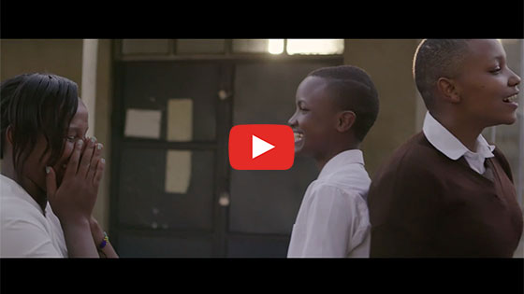](https://vimeo.com/showcase/6167669/video/336513493)

[2040 – Empowering Women and Girls](https://vimeo.com/showcase/6167669/video/336513493)   
**Password: 2040_EDU** (<https://vimeo.com/336513493>)

Once complete, allow students time to reflect on the clip and answer the questions. If students need assistance, use the following timings and examples of quotes and images from the film to guide them:

|  |  |
| --- | --- |
| **Stage One: Attention** How does Damon grab our attention? What information or persuasive techniques does he include? | **0.00 – 0.20** “Probably our biggest surprise… The number one solution” Images of young girls smiling |
| **Stage Two: Problem/Challenge** What challenges does Damon describe? | **0.37 – 1.01**“I completely take for granted that she will get to complete her education.” ”There are 65 million girls around the world that don’t get that opportunity…” “They have 5 or more children…” |
| **Stage Three: Solution** What solutions does Damon include? | **1.03 – 1.34**“When girls stay in school for longer… women will tend to delay having children.” They choose to have fewer children |
| **Stage Four: Visualise the solution** How does Damon help us visualise the solution? What images do we see? What do the speakers describe? | **1.25-1.50**Images of smiling children, girls running, girls talking, women and children together. Description of a solution by experts. |
| **Stage Five: Action**  Does Damon leave us with an action to take? Why/why not? | Malala speech ‘one teacher, one student’ OR could argue he doesn’t explicitly leave us with an action |

Once complete, invite students to share some of their ideas with the class. Through this discussion ask students to share whether they thought this clip followed the sequence or not. You can collect some examples from them, but keep this discussion brief.

**Step 3. OPTIONAL (this could be used as an extension activity).**

Show students Katharine Wilkinson’s TED talk:

[How empowering women and girls can help stop global warming](https://www.youtube.com/watch?v=vXlJEcrinwg)   
(https://www.youtube.com/watch?v=vXlJEcrinwg)

Explain that in Katharine’s speech, she often moves back and forth between the problem and solution stages. Students should be allowed to move non-chronologically through these stages.

|  |  |
| --- | --- |
| **Stage One: Attention** How does Katharine grab our attention? What information or persuasive techniques does she include? | **0 – 0.34** Introduces that “ gender equity is a key answer to our planetary challenge.” |
| **Stage Two: Problem/Challenge** What challenges does Katharine describe? | **1.50** Explains that climate change is a: “situation of urgency, severity, and scope never before faced by humankind. So far, our response isn’t anywhere close to adequate.” Another possible answer is her description of gender inequality |
| **Stage Three: Solution** What solutions does Katharine include? | **4.29** “If we gain ground on gender equity, we also gain ground on addressing global warming.” |
| **Stage Four: Visualise the solution** How does Katharine help us visualise the solution? | **8.04** Describes education’s results. Describes family planning results |
| **Action:** Does Katharine leave us with an action to take? Why/why not? | **11.49** Explains that we each need to use our skills to take action **12.21** Asks everyone to play the role of messenger. |

Once complete invite student volunteers to share with the class how they thought this speech was similar to or different from the 2040 clip in form and structure, using Munroe’s Motivational Sequence to guide their responses.

### **Part C: Persuasive Speech Writing**

**Step 1.**Remind students of the problems (that women and girls face) and solutions discussed at the start of the lesson and those raised by Damon in the 2040 clip. Ask students to choose ONE problem and solution to explore. Students may wish to undertake more research on these problems and solutions, or if you completed the role-play lesson in the accompanying lesson ([2040 – Empowering Women and Girls – English – Years 9 & 10](https://twentyfortyb.wpengine.com/activities/empowering-women-and-girls-english-years-9-10/)), they may wish to expand upon the problem and solution they focused on in that activity.

If students wish to undertake research, they could visit websites such as

* [One Girl](https://www.onegirl.org.au/our-impact/why-girls-) (https://www.onegirl.org.au/)
* [Girl Effect](https://www.girleffect.org/) (https://www.girleffect.org/)
* Article: [Why Climate Change is not Gender Neutral](https://unfccc.int/news/climate-action-needs-gender-action) (https://unfccc.int/news/climate-action-needs-gender-action)

They could also use search terms such as

* Empowering women climate change
* Gender equality climate change

**Step 2.**Inform students they will be writing a speech on their chosen problem and solution. They will need to design their speech using the general structure of Munroe’s Motivational Sequence. Students can plan using the blank version of this table available on the Student Worksheet.

|  |  |
| --- | --- |
| **Steps of the sequence** | **Suggestions for information to include** |
| **Stage One: Attention** How will you grab the audience’s attention? | Statistics. Interesting facts. Anecdotes |
| **Stage Two: Problem/Challenge** What problem will you focus on? What details will you include? | Statistics about the extent of the problem. Explanation of why it’s a problem |
| **Stage Three: Solution** What is the solution? | Statistics about the effectiveness of the solution |
| **Stage Four: Visualise the solution** What is the solution? How will you help the audience imagine the solution in action? | Explanation of the effects of solution. Description and evocative language about the solution’s benefits |
| **Action:** What steps do you want the audience to take at the end of your speech? | Short call to action |

**Step 3.** When planning is complete, ask students to begin writing their speeches. Tell students to aim for a 2-3 minute speech. (You may wish to shorten or extend this time to support different student needs.)

### **Part D: Performance and Feedback**

**Step 1.** When students’ drafted speeches are complete, invite them to perform them in small groups. Ask their peers to provide each person with feedback, linking back to Monroe’s Motivational Sequence. The students have the below prompts on the Student Worksheet to guide them:

Step by step feedback:

* Did the opening lines catch your attention? Why/why not?
* Was the ‘need’ or ‘problem’ described clearly? Did it seem like an important problem?
* Was the solution clear? Why/why not?
* Did the visualisation help you imagine the solution? Why/why not?
* Was the action clear?

Overall feedback:

* What do you think is missing from the speech?
* What worked well?

**Step 3.**Direct all students to read their peers’ feedback and apply it to their speeches.

**Step 2.** Ask each group to nominate one speaker, whom they believe has the best speech. These speeches will then be performed for the class.

## Reflection

Invite students to work independently to reflect on what they have learnt about Monroe’s Motivated Sequence. You may wish to provide them with these questions to scaffold their reflection (also available on the Student Worksheet):

* How did Monroe’s Motivated Sequence help you to structure your work?
* What parts of using the structure did you find challenging or constraining?

## Differentiated Learning

**Extension –**

* Students could be asked to include an array of persuasive techniques in their speeches.
* Students could submit their speeches to a public speaking competition or present in a public forum such as assembly or at a town meeting.
* They could also develop a campaign to support their solution and create marketing/social media materials to support it.

**Provisions for Learning Support –**

* Students could use phones or devices to record their speech, rather than writing it or performing it live.
* Students could also be provided with suggestions for what to include in each section (at Part C, Step 2).
* Not all students will find it useful to view Katharine Wilkinson’s TED talk. Make a judgement as to whether this will engage your class or not.

## Teacher Reflection

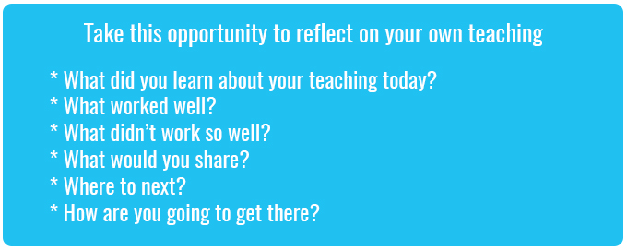

## What’s Your 2040?

Record your students’ work in their communities with the hashtag #whatsyour2040 and share their visions in the ‘2040: [The Regeneration’ Facebook Group](https://www.facebook.com/groups/2040TheRegeneration/).

The 2040 crew would love to see your class’ work.