# The Tone Of Climate Change English Years 7 & 8 Student Worksheet

**Name: ………………………………….  Class: …………..**

#### Thought starter: How does tone affect an audience?

### **Examining Tone**

**1.** Climate change is a very emotive issue. Many people feel very strongly about it, but many of us feel different emotions.

You will now watch a clip from the 2040 documentary that explains more about climate change and which may help you to connect with your emotions around this topic:

[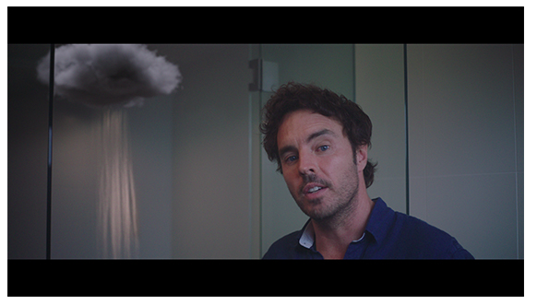](https://vimeo.com/showcase/6167669/video/336503936)

[2040 - Exploring the Themes](https://vimeo.com/336503936) **Password: 2040\_EDU (**<https://vimeo.com/336503936>)

Once complete, reflect on your experience of this clip by completing the table below:

|  |  |  |
| --- | --- | --- |
| **THINK – *What does the clip make***  ***you THINK about?*** | **FEEL – *How do you FEEL about this clip?*** | **WONDER – *What do you WONDER about the clip? What questions does this clip leave you with?*** |
|  |  |  |

**2.**Write down your definition of ‘tone’:

Tone is …

Can you think of a sentence where a ‘tone’ is used?

**3.** Have a look at the table below. Write down what tone you think the author is using in each headline in the table below. Record your responses in Column C. In Column B, underline the words that you think give them that tone.

**For example:** ALJAZEERA – Climate change threatens 19 Million Bangladeshi Children – **negative**

|  |  |  |
| --- | --- | --- |
| **Column A. Source** | **Column B. Headline** | **Column C. Suggested answers** |
| ABC NEWS | Will climate change be devastating for Kakadu National Park? |  |
| THE CONVERSATION UK | Climate change: Yes, your individual action does make a difference |  |
| FOREIGN POLICY | The kids are taking charge of climate policy |  |
| ALJAZEERA | Europe set to suffer as climate change brings mosquito threat |  |
| UNSW NEWSROOM | The future for climate change action is in good hands |  |
| NEW SCIENTIST | Climate change is making the seas rise even faster, UN Warns |  |
| POPULAR SCIENTISTS | Small shifts can stop climate change – if they happen in the right places |  |

### **Climate Change Trailers**

1. You will now watch the trailer for the film ‘An Inconvenient Truth’. As you watch, pay attention to the tone and images or words that convey that tone, and record your responses in the table below:

[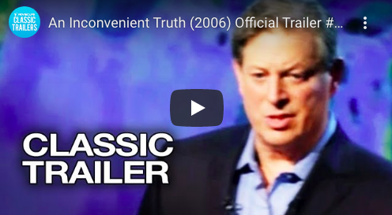](https://www.youtube.com/watch?v=Bu6SE5TYrCM)

[An Inconvenient Truth – Offical Trailer](https://www.youtube.com/watch?v=Bu6SE5TYrCM" \t "_blank) (https://www.youtube.com/watch?v=Bu6SE5TYrCM)

|  |  |  |
| --- | --- | --- |
| **I saw or heard…** | **Tone (This made them sound/seem…)** | **This made me feel/think…** |
|  |  |  |
|  |  |  |

2.You will now watch the trailer for the film ‘2040’. Again, as you watch, pay attention to the tone and images or words that convey that tone, and record your responses in the table below.

[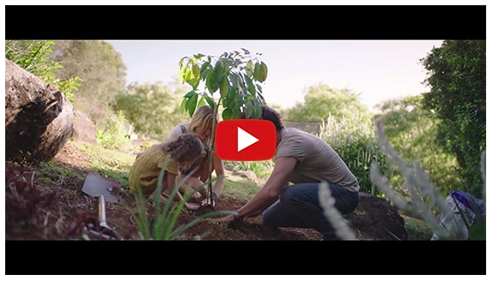](https://www.youtube.com/watch?v=sR51ZDNSRFQ&feature=emb_title)

[2040 Official Trailer](file:///Users/kimingles/Desktop/Worksheets/2040 Official Trailer) (<https://youtu.be/sR51ZDNSRFQ>)

|  |  |  |
| --- | --- | --- |
| **I saw or heard…** | **Tone (This made them sound/seem…)** | **This made me feel/think…** |
|  |  |  |
|  |  |  |

**3.**Think about the two clips you just watched and complete the table below. Begin by working independently to record your own responses in Column B. You can then team up with a partner to share and discuss your answers before adding any new thoughts or ideas to Column C.

|  |  |  |
| --- | --- | --- |
| **Column A. Questions** | **Column B. What do you think?** | **Column C. What does your partner think?** |
| What types of words and images created a more negative tone? |  |  |
| What types of words and images created a more positive tone? |  |  |
| What are the benefits and drawbacks of a negative tone? |  |  |
| What are the benefits and drawbacks of a positive tone? |  |  |
| What types of tone do you feel are more commonly used in the media? Why? |  |  |
| What types of tone do you think should be used more often? |  |  |

### **Testing out Tone**

You are now going to create a climate change message to be placed around the school. You might want to warn students about the dangers, give them actions to take, or include other information. It’s up to you. You simply need to create 3 messages with 3 differing tones.

First, move into your groups and brainstorm what the tones and messages will be.

Now, turn those tones and messages into 3 short texts. You should include more details and information to support your message. Add your final messages to the following table:

|  |  |  |
| --- | --- | --- |
|  | **Intended Tone** | **Main Message** |
| ***Example*** | Angry | Adults are ruining the world that we have to grow up in. Act now! |
| **One** |  |  |
| **Two** |  |  |
| **Three** |  |  |

Survey your classmates about your messages and record the results in the table below.

|  |  |
| --- | --- |
|  | **Votes for Most Effective** |
| **Message One** |  |
| **Message Two** |  |
| **Message Three** |  |

You will then present your most effective/popular message to your class who will offer feedback and suggestions for improvement. You can then incorporate this feedback into your message, recording the final version of your message below.

Our final message:

### **Reflection**

Work independently to reflect on your classmates’ opinions:

1. What kind of feedback did you receive for the message you presented to the class? Why do you think this feedback was given and what did you do to address it?
2. Did your group agree, or disagree, with the opinions of your classmates (survey results)? Why do you agree/disagree?
3. What tones were commonly used by your classmates? Which tended to be more effective?
4. What was your favourite message presented by your classmates and why? How was tone used in this message?