# The Tone Of Climate Change English Years 7 & 8 Teacher Worksheet

## Teacher Preparation

**Learning intentions:**Students will…

* … understand how tone is created through author choices
* … understand that tone impacts on audiences in different ways

**Success criteria:**Students can…

* … identify tone in written and multi-modal texts
* … identify examples of author’s choices that create or contribute to the tone
* … evaluate the varying effect of differing tones
* … create their own messaging with a variety of tones

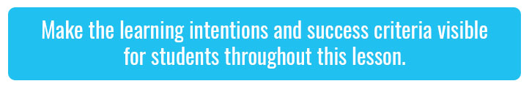**Teacher content information:**A 2018 study by [The University of Melbourne](https://education.unimelb.edu.au/__data/assets/pdf_file/0011/2887895/Most-important-issues-report-final-Sept-2018.pdf) on the thoughts and concerns of young people from Generations X and Y found the number one concern across both groups was lack of action around climate change. In particular, “Generation X worries what climate change will mean for their own children, while Generation Y is concerned about the impact on future generations” ([The Educator](https://www.theeducatoronline.com/au/news/youth-reveal-their-top-concern-in-national-survey/255130)). The report indicates that young people have a serious mistrust in the Government’s ability or willingness to tackle climate change.

Tackling climate change requires large-scale, systemic changes across all aspects of society. Simply aiming to reduce our C02 emissions is not enough: we need to rapidly decarbonise our planet. While this might sound challenging, the good news is we already have the knowledge and tools to do it.

2040 is an innovative feature documentary that looks to the future while focusing on what is happening now. Award-winning director Damon Gameau (director of [That Sugar Film](https://thatsugarmovement.com/film/)) embarks on a journey to explore what the future would look like by the year 2040 if we simply embraced the best solutions already available to us to improve our planet and shifted them into the mainstream.

The film will demonstrate to your students that we already have the solutions to climate change; we just need to take action to bring them rapidly into the mainstream. The 2040 documentary and curriculum package will support your students in turning this knowledge into positive action for a better future.

Find out how to see the film [here](https://madmanfilms.com.au/2040film/). 2040 will only be available in cinemas for the first part of 2019 and you can make a group booking for your class at your local cinema during the film’s theatrical release which starts on May 23. These lessons have been designed with a media library to support teachers. The film will be available on video-on-demand and DVD later in 2019.

The film is the entry point to a global impact campaign that seeks to mobilise audiences to learn about, contribute to, advocate for and invest in regenerative solutions that improve the wellbeing of the planet, all people and all living systems. To join the Regeneration and share your vision for 2040, see the [website](https://whatsyour2040.com/).

**Watch the 2040 trailer:**

[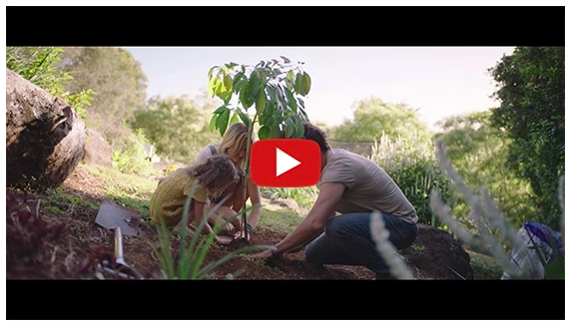](https://www.youtube.com/watch?v=sR51ZDNSRFQ&feature=emb_title)

[2040 Official Trailer](https://youtu.be/sR51ZDNSRFQ) (<https://youtu.be/sR51ZDNSRFQ>)

Cool Australia, GoodThing Productions and Regen Pictures would like to acknowledge the generous contributions of [Good Pitch Australia](https://goodpitch2australia.com.au/), [Shark Island Institute](https://sharkisland.com.au/shark-island-institute/), [Documentary Australia Foundation](https://www.documentaryaustralia.com.au/), [The Caledonia Foundation](https://www.caledoniafoundation.com.au/) and our philanthropic partners in the development of these teaching resources.

## Teaching Sequence

**Work through this resource material in the following sequence:**

15 minutes – Part A: Examining Tone  
30 minutes – Part B: Climate Change Trailers  
25 minutes – Part C: Testing out Tone  
5 minutes – Reflection

### **Part A: Examining Tone**

**Step 1.**Begin this lesson by writing the words ‘climate change’ on the board. Explain to students that climate change is an emotive issue. Many people feel very strongly about it, but many of us feel different emotions. Explain that you will show them a clip from the 2040 documentary that explains more about climate change which may help them to connect with their emotions around this topic.

Show students this clip:

[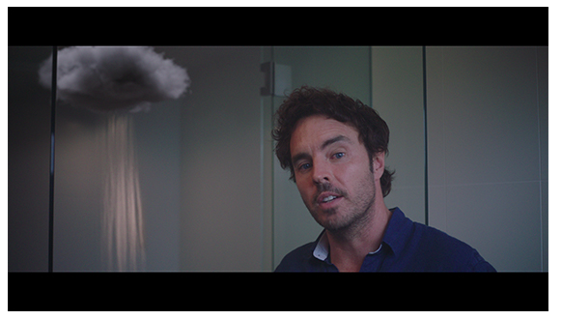](https://vimeo.com/showcase/6167669/video/336503936)

[2040 - Exploring the Themes](https://vimeo.com/336503936)

**Password: 2040\_EDU (**<https://vimeo.com/336503936>)

*Note: You can use this same password to access all clips in the 2040 education media library.*

Once complete, provide each student with a copy of the Student Worksheet. Invite them to reflect on their feelings around this clip by completing the ‘Think, Feel, Wonder’ table (available on the Student Worksheet).

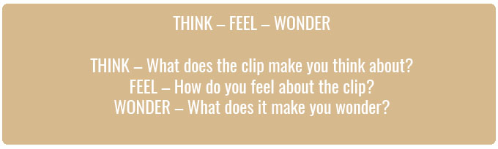

You could then invite students to share some of their answers with their a partner.

**Step 2.** Now write the word ‘tone’ on the board and invite students to team up with a classmate. Working in their pairs, tell students they will have one minute to write down what they think ‘tone’ means, recording their ideas on the Student Worksheet. If they finish early, they can try to use ‘tone’ in a sentence.

Once complete, invite students to share their responses with the class, looking for correct answers. Correct answers should explain that tone is the attitude an author has toward a topic. For example, an author may sound negative when they describe a topic. Ask students with correct, but perhaps differing answers, to share them with the class and write these on the board. Students can add new information to their answers or alter their own definitions.

**Step 3.** Next read out the following eight headlines from newspaper articles (also available on the Student Worksheet). Explain that these use a range of positive, neutral and negative tones. Working independently or in their pairs, ask students to classify the headlines by writing a ‘tone’ word next to each headline on the Student Worksheet. Suggested answers are included below. Ask them to underline any words they feel contribute to creating the tone (suggestions below).

|  |  |  |
| --- | --- | --- |
| **Source** | **Headline** | **Suggested Answer** |
| ABC NEWS | Will climate change be devastating for Kakadu National Park? | negative, uncertain |
| THE CONVERSATION UK | Climate change: Yes, your individual action does make a difference | positive, confident |
| FOREIGN POLICY | The kids are taking charge of  climate policy | positive |
| ALJAZEERA | Climate change threatens 19 million Bangladeshi Children | negative, authoritative |
| ALJAZEERA | Europe set to suffer as climate change brings mosquito threat | fatalistic, negative, certain, concerned |
| UNSW NEWSROOM | The future for climate change action is in good hands | positive, optimistic, certain |
| NEW SCIENTIST | Climate change is making the seas rise even faster, UN Warns | negative, certain, foreboding |
| POPULAR SCIENTISTS | Small shifts can stop climate change – if they happen in the right places | positive, instructive |

Once complete, facilitate a class discussion about the tones students noticed being used. Ask students to share what strategies they used to identify the tone of each headline. Write these strategies on the board, explaining that they will support students to find the tone in the clips you are about to show. Suggested strategies could include:

* Look for emotive words
* Look for modality – how certain does the author sound? (will/must/might/could)
* Consider the adjectives used
* Consider the author’s use of language – is it formal? informal?

### **Part B: Climate Change Trailers**

In this part of the lesson, students will be asked to find evidence of differing tones in two videos. If you found students struggled to find tones in the headlines, it would be worthwhile to write a list of possible tones on the board, eliciting ideas from students.

Words to describe tone could be:

|  |  |  |
| --- | --- | --- |
| **Negative** | **Neutral** | **Positive** |
| Concerned Angry Frustrated Hostile | Certain Direct Instructive | Hopeful Optimistic Pleased Satisfied |

**Step 1.**Show the trailer for Al Gore’s An Inconvenient Truth and ask students to pay attention to the tone and images or words that convey that tone, recording their responses on the Student Worksheet. Some suggested answers are below.

[An Inconvenient Truth – Offical Trailer](https://www.youtube.com/watch?v=Bu6SE5TYrCM)   
<https://www.youtube.com/watch?v=Bu6SE5TYrCM>

|  |  |  |
| --- | --- | --- |
| **I saw or heard…** | **Tone (This made them sound/seem…)** | **This made me feel/think…** |
| The hottest of all was 2005 | Concerned,  pessimistic | Scared that it will get hotter |
| There will be no more snows of Kilimanjaro | Negative, certain,  final | That the negative effects of climate change are certain and inescapable |

**Step 2.**Now show the trailer for the documentary; 2040. Ask students to pay attention to the tone and images or words that convey that tone, again recording their responses on the Student Worksheet. Some suggested answers are below.

**Watch the 2040 trailer:**

[](https://www.youtube.com/watch?v=sR51ZDNSRFQ&feature=emb_title)

[2040 Official Trailer](https://youtu.be/sR51ZDNSRFQ) (<https://youtu.be/sR51ZDNSRFQ>)

|  |  |  |
| --- | --- | --- |
| **I saw or heard…** | **Tone (This made them sound/seem..)** | **This made me feel/think…** |
| Huge wind turbines with beautiful green background | Positive | That the future could look like that |
| A man said ‘this is bringing people together’ | Optimistic, certain | That there are positive solutions that exist |

**Step 3.** Once complete, invite students to reflect on the two clips they watched and to participate in the ‘Think, Pair and Share’ activity on their Student Worksheet. Ask them to start by writing down their own answers to the following questions; then they can discuss their answers and record any new ideas raised in discussion with their partner:

* What types of words and images created a more negative tone?
* What types of words and images created a more positive tone?
* What are the benefits and drawbacks of a negative tone?
* What are the benefits and drawbacks of a positive tone?
* What types of tone do you feel are more commonly used in the media? Why?
* What types of tone do you think should be used more often?

Once students have had a chance to share with their partners, invite them to share their answers with the class. To shorten the discussion you could simply ask for:

* Areas they disagreed on
* Areas they agreed on

### **Part C: Testing out Tone**

**Step 1.**Allocate small groups or ask students to form their own small groups. Tell students that as a team, they need to create messages about climate change to be used in their school. They should create three diverse options that convey different tones for each (if they need further support, you could prompt students to have specific tones such as hopeful, anxious etc.).

The first step is for teams to collaboratively brainstorm what the tones and messages will be, before selecting three to pursue.

Then they can write short messages that elaborate on each of their three ‘main messages’, maintaining the tone they planned for each. They can complete this using the table like the one below available on the Student Worksheet:

|  |  |  |
| --- | --- | --- |
|  | **Intended Tone** | **Main Message** |
| **Example** | Angry | Adults are ruining the world that we have to grow up in. Act now! |
| **One** |  |  |
| **Two** |  |  |
| **Three** |  |  |

**Step 2.** After students have created their three short messages, they need to develop a survey to find out which message is most effective or engaging. They will be surveying members of their own class. You can use the strategy below, or you can have students use [Survey Monkey](https://www.surveymonkey.com/), [Kahoot Survey](https://kahoot.com/" \t "_blank) or [Crowdsignal](https://crowdsignal.com/" \t "_blank) to collect their data.

Instruct each group to nominate a ‘data’ collector who will count votes and tally them on their worksheet. Each worksheet has a table like below:

|  |  |
| --- | --- |
|  | **Votes for Most Effective** |
| **Message One** |  |
| **Message Two** |  |
| **Message Three** |  |

**Step 3.** Provide each group with an opportunity to present their most popular/effective message to the class. They should write their message on the board and explain why they chose this message.

The class can then offer feedback on each message presented, offering suggestions for improvement. When providing feedback, remind students to be kind, helpful and specific:

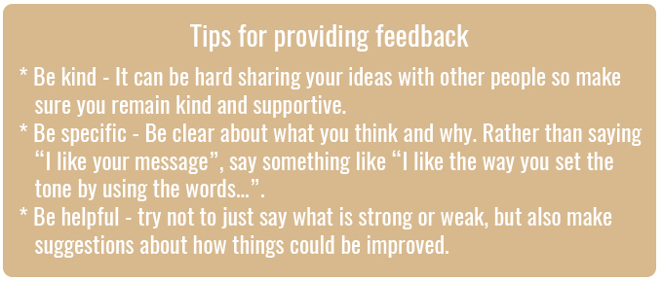

**Step 4.** After all of the groups have had the chance to present their message and incorporate feedback, they can then start planning how they will communicate this message with their school. For example, they may want to create a poster, a video, a song or a written piece.

Consider providing an opportunity for students to share their completed messages, for example, at an assembly or through the school newsletter.

## Reflection

Ask students to read over their surveys and work independently to answer the following questions (also available on the Student Worksheet):

* What kind of feedback did you receive for the message you presented to the class? Why do you think this feedback was given and what did you do to address it?
* Did your group agree, or disagree, with the opinions of your classmates (survey results)? Why do you agree/disagree?
* What tones were commonly used by your classmates? Which tended to be more effective?
* What was your favourite message presented by your classmates and why? How was tone used in this message?

## Differentiated Learning

**Extension –**Students could create a multi-modal campaign that utilises a consistent tone throughout. For example, they could make a short video, social media campaign, presentation or poster that conveys the tone of their single message.

**Provisions for Learning Support –**

* Students will have the support of their peers, ensure you consider student needs when forming groups.
* Some students may find it more appropriate to focus on just two tones throughout the lesson – perhaps, negative and positive.

## Teacher Reflection

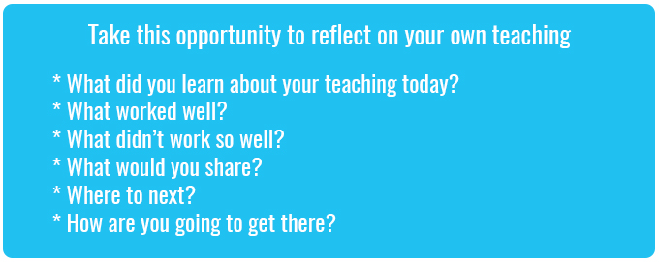

## What’s Your 2040?

Record your students’ work in their communities with the hashtag #whatsyour2040 and share their visions in the ‘2040: [The Regeneration’ Facebook Group](https://www.facebook.com/groups/2040TheRegeneration/).

The 2040 crew would love to see your class’ work.