# Finding Out About Food – Years 5 & 6 – Student Worksheet

## Thought Starter: Where does your food come from?

### **Thinking About Food**

Working in pairs spend some time looking at the image below and discussing your answers to the following questions. Record key responses to each question in note form.

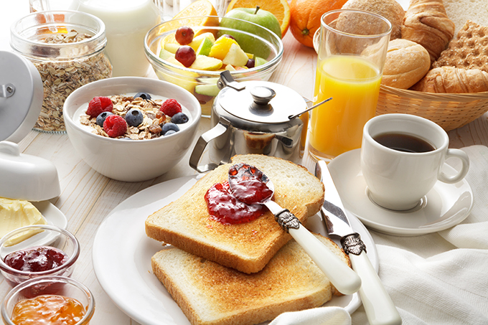

• What foods can you see in this image?

• Which foods come from an animal and which come from a plant?

• Which foods do you think came from a farm?

• How do these foods get from the farm to us?

• What kind of packaging do these foods have?

• Could you eat all this food for breakfast? What would you do with the bits you couldn’t eat or don’t like?

• Do you think these foods are healthy? Why or why not?

### **Big Issues About Food**

The big issue we are exploring:

The questions we are answering:

Research we have found and thoughts we have in response to this question (NOTE: You can discuss your thoughts in your groups, however each student is responsible for recording their own thoughts in their own words):

### **Big Solutions**

Return to the group you were in earlier (when you were researching your big issue). Each group now needs to undertake research to find out what solutions exist to help solve the problems identified in your big issue.

Each group will need to:

* Briefly describe this solution
* Share how it will address the problem
* Suggest positives and negatives of this solution.

With your research you will need to create a three-slide presentation to share your research with the class.

### **Reflection**

Work independently to answer the following question:

• What is your food 2040 (i.e. what would you like to see happening with food in the future)?

Be prepared to share your answers with the class