Finding Out About 2040 Grades 5 & 6 Teacher Worksheet
Teacher Preparation
Learning objectives and goals:
Students will…
- …understand that different people have different ideas and concerns about the future.
- …understand that solutions to the problems facing people and the planet already exist.
Students can…
- …participate in a barometer activity.
- …participate in a group mind-map exercise.
- …express their thoughts, feelings and concerns through class discussion and independent activities.
- …adhere to classroom discussion guidelines.

Make the objectives and goals visible for students throughout this lesson.
Tackling climate change requires large-scale, systemic changes across all aspects of society. Simply aiming to reduce our C02 emissions is not enough: we need to rapidly decarbonize our planet. While this might sound challenging, the good news is we already have the knowledge and tools to do it.
2040 is an innovative feature documentary that looks to the future, while focusing on what is happening now. Award-winning director Damon Gameau (director of That Sugar Film) embarks on a journey to explore what the future could look like by the year 2040 if we simply embraced the best solutions already available to us to improve our planet and shifted them into the mainstream.
The film will demonstrate to your students that we already have the solutions to climate change; we just need to take action to bring them rapidly into the mainstream. The 2040 documentary and curriculum package will support your students in turning this knowledge into positive action for a better future.
Find out how to see the film here. 2040 launched in cinemas in Nov 2019 and is now available for booking for your school. These lessons have been designed with a media library to support teachers. The film is available on video-on-demand and DVD for individual viewing.
The film is the entry point to a global impact campaign that seeks to mobilise audiences to learn about, contribute to, advocate for, and invest in regenerative solutions that improve the wellbeing of the planet, all people and all living systems. To join the Regeneration and share your vision for 2040, see the website.
Watch the 2040 trailer:
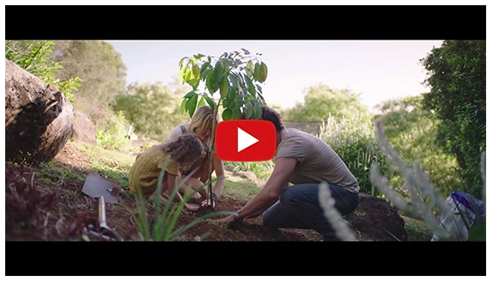
https://youtu.be/sR51ZDNSRFQ
Cool Australia, GoodThing Productions and Regen Pictures would like to acknowledge the generous contributions of Good Pitch Australia, Shark Island Institute, Documentary Australia Foundation, The Caledonia Foundation, Global Health Film and our philanthropic partners in the development of these teaching resources.
Developing classroom guidelines: In this lesson, students are asked to consider and share personal experiences and feelings, therefore it’s a good idea to set some ground rules for sharing. Consider the following:
- Own your ideas by using “I think” rather than “you should”.
- Respect each other by remembering that each person has their own beliefs and values and their own world views, experiences, and opinions.
- Each person has a right to contribute their ideas, so listen politely.
- Be brave in sharing your ideas, experiences and opinions.
- Consider the privacy of your classmates and appreciate that everyone has the right to uphold their privacy; this might mean they don’t want to share their ideas or experiences on an issue.
- Share feedback in a way that is considerate and positive.
Tips for providing feedback
- Be kind – It can be hard sharing your ideas with other people so make sure you remain kind and supportive.
- Be specific – Be clear about what you think and why. Rather than saying “I like your story”, say something like “I like the way you set the scene by describing the characters in such detail”.
Be helpful – Try not to just say what is strong or weak, but also make suggestions about how things could be improved.
Teaching sequence
Work through this resource material in the following sequence:
10 minutes – Part A: Activating Prior Knowledge
30 minutes – Part B: Exploring 2040 Challenges
20 minutes – Part C: Considering Solutions
92 mins – Part D: Watching The 2040 Documentary
10 minutes – Reflection

Part A: Activating Prior Knowledge – Defining Key Terms
Step 1. Explain to students they will be watching the trailer for a documentary film called 2040 because it explores how the world could look in the year 2040. This film was made by Damon Gameau who was concerned about how the future would look for his daughter. Specifically, he was concerned about our environment and how challenges such as energy, transport, and growing food might affect the environment in the future. He made a film to explore these challenges in more detail.
The film deals with a range of ideas that students might be unfamiliar with. To support students in their exploration of the ideas in the film they will now be watching the following clip from 2040. As students watch, invite them to record any terms or words that are new or unfamiliar.
2040 – Setting up the Journey Password: 2040_EDU (https://vimeo.com/336505203)
Once complete, invite students to share the unfamiliar terms or words with the class. Write these on the board.
Step 2. Break the class into pairs or small groups. Assign each pair or group with one or two of the terms or words identified in the clip.
Each group needs to conduct research into their assigned terms or words and then create a definition for each. Students can record their ideas on the Student Worksheet. If conducting research online, remind students of the Search Strategies for Googling.
Once complete, invite students to share their ideas with the class so that there is now a shared vocabulary that can be used to better understand the themes of the film explored in the next part of the lesson.


Part B: Exploring 2040 Challenges
Step 1. With their new understanding of these key terms in the film, students will now rewatch the clip. As they watch, invite them to record any key messages or themes they notice:
2040 – Exploring the Themes Password: 2040_EDU (https://vimeo.com/336503936)
Once complete, invite students to share their thoughts about the clip through class discussion. Consider the following questions in your discussion:
- What did you see in this clip? What was happening?
- What did you find interesting or important about this clip?
- What do you want to know more about?
Through your discussion explain to students that the filmmaker, Damon, has focused on a range of themes, or challenges, in his film – students may have already identified these. They are:
- Energy
- Transport
- Food production.
Step 2. Break the class into three, six or nine groups (depending on age and ability). The groups should be made up of students with different experiences and viewpoints. Ensure that each group has access to a web-enabled device.
Assign a theme, or challenge to each member of the group, ensuring that each challenge is assigned an equal number of times within each group.
Explain to students that each group needs to read about their assigned challenge and then share this information with other students through a jigsaw activity.
Students can start their research on information found at the following sites:
- http://whatsyour2040.com
- https://www.drawdown.org/
- https://www.climatecouncil.org.au/what-can-i-do-to-tackle-climate-change/
- https://www.climatecouncil.org.au/category/solutions/
The steps for this jigsaw activity are as follows.
- Encourage students to read and understand the information about their assigned challenge (1. Energy, 2. Transport, 3. Food production).
- Give students time to read over their information at least twice and become familiar with it. Inform students that they don’t need to memorize it, and that they could write some notes that summarize the basics of what they have read.
- Ask students to move their seats so that they form temporary ‘expert groups’. This means that one student from each jigsaw group joins other students assigned to the same challenge. Ensure that each student has a piece of paper for taking notes.
- Give students in these expert groups time to discuss the main points of their information and to rehearse how they will present what they have understood back to their original jigsaw group.
- Ask students to reform into their original jigsaw groups.
- Ask each student to present the information they have learned to the group. Encourage others in the group to ask questions for clarification and to take any notes on points they find interesting or challenging.
- Float from group to group, observing the process. If any group is having trouble (e.g. a member is dominating or disruptive), make an appropriate intervention.
Find more information about jigsaw classrooms at the Jigsaw Classroom website: https://www.jigsaw.org/
Step 3. Once the jigsaw activity is complete and all groups have had the chance to share the information they read and discussed, invite students to share what they found with the class. Invite three volunteer spokespeople for each challenge to each respond to one of the following questions:
- Describe the challenge you looked at – what is it about?
- Why is this challenge important to the future?
- What do you think is interesting or important about this challenge?

Part C: Considering Solutions
Step 1. Remind students of the 2040 clip that they watched and explain that the movie is about looking at the solutions to these challenges.
Explain to students that each group needs to brainstorm some solutions to the challenge they focused on. It isn’t necessary for students to develop the details for their ideas, but rather to think creatively and come up with a range of ideas. This brainstorm activity could be completed using a ‘50 ideas in 5 minutes’ strategy. Work through the following steps:
- Invite students to move back into the groups they were in for the jigsaw activity.
- Students will work in their groups to brainstorm as many different and varied solutions as possible in five minutes.
- The ideas can be as abstract and off-the-wall as students like.
The brainstorm could be run like this:
- Give each group a piece of butcher’s paper and each person a marker pen.
- Before starting the countdown, ask students to write their challenge on the top of their piece of paper.
- Students should stand around the tables rather than sit in their chairs as this encourages more creative thinking.
- They should:
- Write everything down as fast as possible on the butcher’s paper.
- Work fast: they only have 5 minutes and they need 50 ideas.
- Do not discuss the ideas at this stage – just record them.
- Give time markers as they progress: “Three minutes left! Two minutes! One minute left!”. You could project a countdown of 5 minutes using this website.
- Share a rough figure of how many ideas have been generated across the whole class – remind students how productive they can be in 5 minutes.
- You could offer a prize for the group that creates the most ideas within 5 minutes.
Step 2. Once groups have completed the ‘50 ideas in 5 minutes’ challenge, ask each group to spend some time viewing and discussing their list of ideas. Invite each student to nominate their favorite ideas by:
- Drawing a star next to the idea they think is the most creative
- Drawing a smiley face next to the idea that they like best.
Step 3. Invite groups to share their most creative idea and the idea they liked the best with the class.
Keep a record of student ideas: these can be referred to later in this lesson or in other lessons in this unit.


Part D: Watching The 2040 Documentary
Note: This part of the lesson involves viewing 2040 in its entirety. To find the easiest way to access 2040 visit the website; What’s Your 2040?
Step 1. Explain to students that they will now be watching the 2040 documentary. Before watching, briefly read through the information on the Critically Viewing a Documentary Film as a class. Encourage students to adopt an active approach to watching this documentary film, and to be mindful and aware of their own reactions to what they see, hear and feel.
Step 2. Ensure that students are settled and comfortable before starting the film. Close the blinds and give reminders about potential interruptions.
Step 3. To find out how to watch the documentary visit the 2040 website. If possible, allow the film to be played from start to finish, without interruption or discussion, so that your class has the opportunity to watch the documentary as the filmmaker intended.

Reflection
Invite students to complete the THINK PUZZLE EXPLORE thinking routine on the Student Worksheet to synthesize their response to 2040 and the content/topics it covers. Make time for students to debrief their reflections after watching the film.

Extension
Consider inviting students to compare the solutions they generated in the brainstorm with the solutions presented in the film:
- How are they similar?
- How are they different?

Teacher Reflection
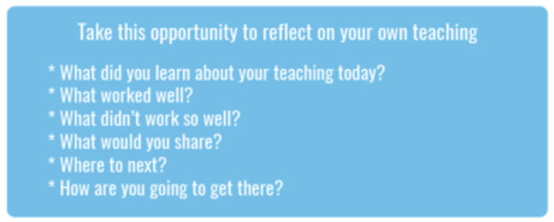
What’s Your 2040?
Record your students’ work in their communities with the hashtag #whatsyour2040 and share their visions in the ‘2040: The Regeneration’ Facebook Group.
The 2040 crew would love to see your class’ work.

