Food Security And Urban Farming Geography Years 9 & 10 Teacher Worksheet

Teacher preparation
Learning intentions: Students will …
- … understand what food security is
- … understand what urban agriculture is and how it can help address food security
Success criteria: Students can …
- … work collaboratively
- … participate in class and group discussions
- … propose and justify an urban agricultural project
- … create a proposal based upon set criteria

Teacher content information: A 2018 study by The University of Melbourne on the thoughts and concerns of young people from Generations X and Y found the number one concern across both groups was lack of action around climate change. In particular, “Generation X worries what climate change will mean for their own children, while Generation Y is concerned about the impact on future generations” (The Educator). The report indicates that young people have a serious mistrust in the Government’s ability or willingness to tackle climate change.
Tackling climate change requires large-scale, systemic changes across all aspects of society. Simply aiming to reduce our C0₂ emissions is not enough: we need to rapidly decarbonise our planet. While this might sound challenging, the good news is we already have the knowledge and tools to do it.
2040 is an innovative feature documentary that looks to the future while focusing on what is happening now. Award-winning director Damon Gameau (director of That Sugar Film) embarks on a journey to explore what the future would look like by the year 2040 if we simply embraced the best solutions already available to us to improve our planet and shifted them into the mainstream.
The film will demonstrate to your students that we already have the solutions to climate change; we just need to take action to bring them rapidly into the mainstream. The 2040 documentary and curriculum package will support your students in turning this knowledge into positive action for a better future.
Find out how to see the film here. 2040 will only be available in cinemas for the first part of 2019 and you can make a group booking for your class at your local cinema during the film’s theatrical release which starts on May 23. These lessons have been designed with a media library to support teachers. The film will be available on video-on-demand and DVD later in 2019.
The film is the entry point to a global impact campaign that seeks to mobilise audiences to learn about, contribute to, advocate for and invest in regenerative solutions that improve the wellbeing of the planet, all people and all living systems.
To join the Regeneration and share your vision for 2040, see the website.
Watch the 2040 trailer:
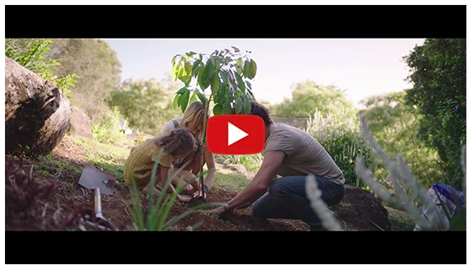
https://youtu.be/sR51ZDNSRFQ
Cool Australia, GoodThing Productions and Regen Pictures would like to acknowledge the generous contributions of Good Pitch Australia, Shark Island Institute, Documentary Australia Foundation, The Caledonia Foundation and our philanthropic partners in the development of these teaching resources.

Teaching sequence
Work through this resource material in the following sequence:
20 minutes – Part A: Activating Prior Knowledge
15 minutes – Part B: Urban Farming
60+ minutes – Part C: Urban Agriculture in Your Area
5 minutes – Reflection

Part A: Activating Prior Knowledge
Preparation:
- Cut up these parts of a lunch and place them on a table. Invite students to stand around the table and assemble the sandwich and place the banana and almonds close to the sandwich. Alternatively, students can work in groups – you will need one set of cut out lunch items per group.
- Print or access one copy of the Food Security Activity Script.
- Collect and display a range of food packaging that shows food coming from different countries around the world, for example, kidney beans from Italy, rice from Pakistan, jam from France or soy milk from Japan.
Step 1. Begin this lesson by gathering the class together around your table and printed parts of lunch.
Start reading the script out to students and following the instructions on the script.
Step 2. Once complete, explain to students that this is a scenario we might find ourselves in when faced with food insecurity. Invite students to share their thoughts about this activity before explaining that in this lesson they will be exploring the concept of future food security in more detail as well investigating some of the proposed solutions to this problem.
Step 3. Now explain to students they will participate in a guided discussion around a clip describing some of the processes and key features of food security. Play the following clip through once uninterrupted; once complete, replay the clip stopping at the suggested timings below and engaging students in a discussion around the suggested talking points:

Does Australia have ‘food security?’ (https://youtu.be/VWp5OAdqzxY)
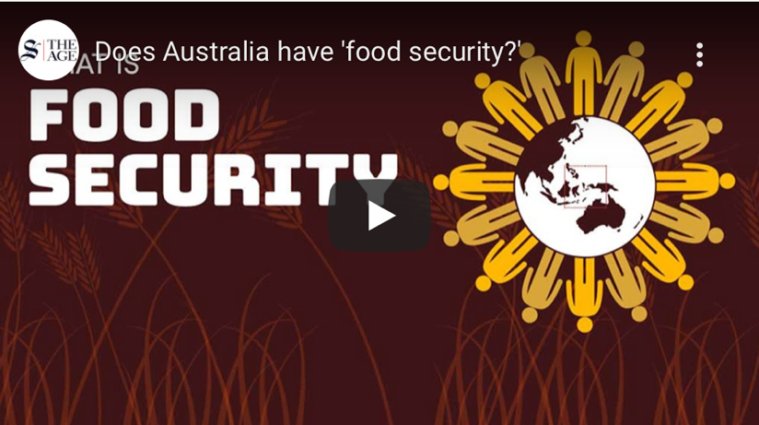
Suggested timings:
- 0:22 – What is the definition of food security provided in this clip?
- 0:43 – Where might we import food from and how much food do we import into Australia? Can students think of any foods that they eat that come from outside of Australia, for example, New Zealand, China or Thailand?
Suggested talking point: If you have bought in any food packaging invite students to identify which countries these foods have come from. In addition, the interactive map on this website may help you answer this question: https://esriaustralia.com.au/esri-australia-blog/find-out-where-australia-imports-its-food-from-blg-20
- 1:13 – Why might this create imbalances in the food system?
Suggested answers: People in wealthy communities demand greater diversity and accessibility of food which can drive food prices up, the consequences of which can be poorer communities can miss out because they don’t have access to food or they can’t afford the available food.
- 1:22 – What is food justice? What is food sovereignty?
Suggested answers: Food justice is formed of three parts: 1. Access to healthy, locally grown, fresh, culturally appropriate food. 2. Living wage jobs for all food system workers – farmers, farmworkers, restaurant, food service, processing plant etc. 3. Community control through cooperatives and organisations. Food sovereignty is defined as “the right of peoples to healthy and culturally appropriate food produced through ecologically sound and sustainable methods, and their right to define their own food and agriculture systems.”(Source: https://foodsecurecanada.org/who-we-are/what-food-sovereignty)
- 1:48 – What might a shorter food supply chain look like? For example, what might this look like in terms of the places where we grow food?
Suggested answers: It might mean growing the food we eat closer to the people who eat it. In the case of people living in cities or urban areas, this could be urban agriculture. NOTE: Students will be exploring urban agriculture in more detail later in this lesson.
- 2:00 – What do you think is meant by ‘build capacity and resilience in local food systems’?
Suggested answers: Building capacity in the context of food security refers to the ways that communities acquire, improve, and retain the skills, knowledge and tools needed to grow food for their communities. Resilience refers to ensuring that food supply chains can withstand shocks. (Source: https://www.fao.org/in-action/food-security-capacity-building/project-overview/en/)
Once complete, invite students to share any other thoughts, reflections or questions they have about this clip. You can also explain to students that if this activity made them worried, in the rest of this lesson they will be looking at some solutions to these problems that could help us find a more sustainable and delicious food future. In the next part of the lesson, students will explore and way of producing food that shortens the supply chain called urban farming.

Part B: Urban Farming
Step 1. Tell students, now that they have explored the problems our food chain and they know about the challenges we face they are going to spend the rest of the class being solutions focused.
Ask students if they have ever heard of urban farming or urban agriculture. Students may get the idea of what urban agriculture is just by the name, suggesting that it is farming in cities and towns (Food and Agriculture Organisation of the United Nations). Students may even be able to share experiences with urban farming, maybe they have heard of beehives being kept in cities, vertical farms or high tech greenhouses that can be placed in the most populous places in Australia. These are all examples of urban agriculture.
Share with the class that urban agriculture isn’t new or untested, in fact, urban agriculture is estimated by the Urban Agriculture Forum that 800 million people are involved in urban agriculture and it already provides around 20% of the world’s food needs. The Food and Agriculture Organisation of the United Nations believes that urban agriculture has advantages for both developed and developing countries.
Step 2. Challenge students to pair up and discuss what some advantages of urban agriculture might be here in Australia. Once students have discussed, invite pairs to share their thoughts. Students may suggest advantages such as lower food miles, creating more jobs in places where there are more people, more green spaces in cities and towns or providing opportunities for people to learn more about how their food is grown. You might point out that the advantages to this form of food production are economic, environmental and social. For more on the advantages of urban agriculture, check out The Ecology Center (https://www.theecologycenter.org/resources/10-ways-urban-farms-benefit-the-community/).
Step 3. Students will now watch a clip from 2040 that describes one form of urban agriculture. As they watch the clip, invite them to record anything they find interesting, inspiring or important.
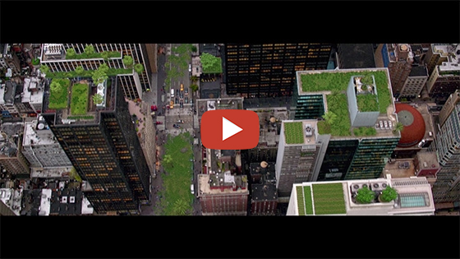
2040 – AeroFarm
Password: 2040_EDU
(https://vimeo.com/showcase/6167669/video/336498074)
Note: You can use this same password to access all clips in the 2040 education media library.
Once complete, engage students in a discussion around their thoughts about this clip and advise them that in the next part of the lesson they will be exploring opportunities for agriculture in their area.

Part C: Urban Agriculture in Your Area
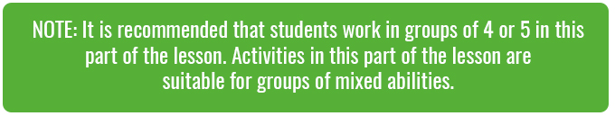
Step 1. Explain to students that in this part of the lesson they will be developing an agriculture project in their area. Distribute a copy of the Student Worksheet to each student, explaining that although they are working in groups, each student will need to complete their own copy of the Student Worksheet in their own words.
Ensure students understand that in this activity they will need to work in their groups to (information also available on the Student Worksheet):
- Identify a site this could be in their school (such as an unused part of the school) or in their community (such as vacant or under-utilised land, or unused buildings).
- Identify what form of urban agriculture would be most suitable, such as vertical farming or green walls, hydroponics, aquaponics, rooftop or backyard gardens, street landscaping, animals (e.g. chooks) or bees, or greenhouses.
- Create a report, poster, or video to share their ideas – this should include maps, diagrams, proposed forms of urban agriculture, and justification for design and site selection.
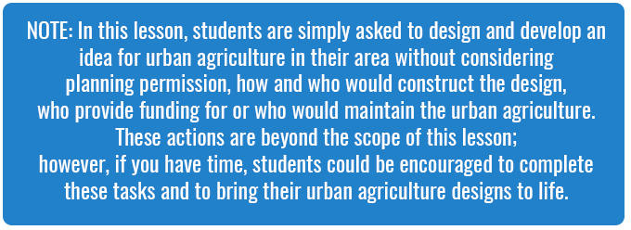
1. Site selection
The first step is to select a suitable site. Ideally, the site you select will be unused or underused, such as vacant land. The site doesn’t need to be large; one of the goals of urban agriculture is to make any space productive so small sites such as the area between the footpath and the road are suitable, or along the fence line at your school, etc.
Site selection could be done in several ways:
- The teacher could propose a site
- Students could suggest sites they have seen or are aware of around their neighbourhood
If it is close enough, you could visit the site as a class. Alternatively, you could locate the site on Google Maps or if the site is in your school grounds, on a school map. If you are visiting the site in person, remind students to take photos and to measure the site.
Students should record information about their site on the Student Worksheet.
2. Urban agriculture selection
With a site selected, students can now begin planning the form of urban agriculture that they think would be most suitable for their site. For example, if their site is adjacent to a wall, could they incorporate vertical farming or a green wall? If their site is in a location with lots of traffic, might they want to create a garden of hardy vegetables and leafy greens that can withstand small levels of disturbance? If their site is reasonably isolated, might they want to propose beehives? If they have a larger open space, might they want to be adventurous and propose and design for aquaponics?
When selecting the form of agriculture for their site, students will need to consider the parameters of their site and plan accordingly, for example (also available on the Student Worksheet:
- Size of the site – Some forms of urban agriculture require significant infrastructure; will your site be able to accommodate this infrastructure?
- Potential site disturbance – Some sites may experience regular foot traffic; how might you mitigate against site disturbance?
- Shading – Some forms of urban agriculture will require sunlight; how does your site have good access to sunlight?
- Energy and water – Some forms of urban agriculture require access to electricity and water; how can you ensure your site has access to these resources?
In some cases, students may be able to propose solutions to potential problems (e.g. fencing or water tanks), in other cases, it may be necessary for students to adjust their ideas in order to accommodate the specifics of their site.
Allow students time to discuss, sketch and develop their ideas, using the prompts on the Student Worksheet to guide them.
3. Create a proposal
Students now need to create a proposal (written, poster or video – the teacher or students could choose) for their site. This should include:
- Site selection and details of the site, including a map (including BOLTSS – Border, Orientation, Legend, Title, Scale and Source) and photos of the site (if available)
- The suggested form of urban agriculture and justification for this form of urban agriculture, including a sketch of how their design might look once complete
- Social and environmental benefits of their design
- Risks and challenges of design and proposed measures to address these
Allow students time to create their proposal.
Step 2. Invite students to share their proposals with an audience. You could do this by inviting groups to present their ideas to the rest of the class; alternatively, you could present ideas to a wider audience within or beyond the school community.
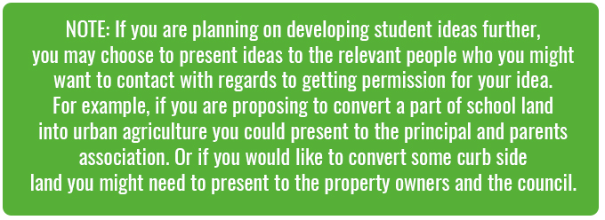

Reflection
Step 1. Invite students to work independently to suggest a response to the following question (also available on the Student Worksheet):
- Do you think we should be including urban agriculture in all future designs of urban environments? Explain your answer.
Step 2. OPTIONAL
What other ideas do you have for addressing food security in the future? As a class, watch the following clip and then invite students to work independently or in pairs to come up with their own ideas that they would like to add:
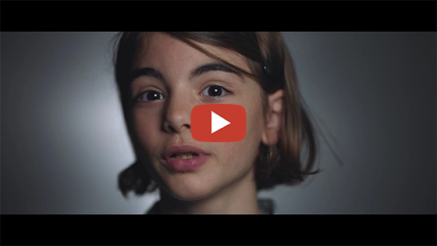
What’s Your 2040 – For Food?
Password: 2040_EDU
(https://vimeo.com/showcase/6167669/video/334803254)
Note: You can use this same password to access all clips in the 2040 education media library.

Take It Further
To expand on student learning in this lesson, consider:
- screening the following clip 2040 – A Future for Agriculture Password: 2040_EDU OR 2040 – A Future for Seaweed Password: 2040_EDU
- following up with this lesson; 2040 Vision For Your Community.
The 2040 team have created a range of clips specifically for use in geography classrooms. Access the whole package of 2040 Geography clips at the following link, Secondary GEOGRAPHY Portfolio Password: 2040_GEO

Teacher Reflection
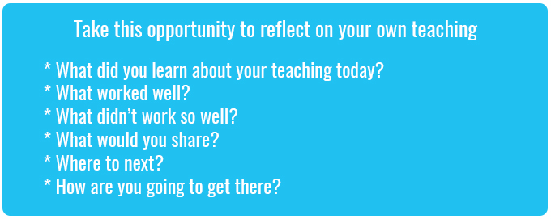

What’s Your 2040?
Record your students’ work in their communities with the hashtag #whatsyour2040 and share their visions in the ‘2040: The Regeneration’ Facebook Group.
The 2040 crew would love to see your class’ work.

