Food Security Geography Years 8 & 9 Teacher Worksheet
Teacher Preparation
Learning intentions: Students will…
- … understand what food security is
- … understand some of the key factors threatening future food security
- … recognise a range of proposed solutions to the potential future food security crisis
Success criteria: Students can …
- … work independently and collaboratively
- … participate in group and class discussions
- … conduct research
- … create a presentation
Make the learning intentions and success criteria visible for students throughout this lesson.
Tackling climate change requires large-scale, systemic changes across all aspects of society. Simply aiming to reduce our C02 emissions is not enough: we need to rapidly decarbonise our planet. While this might sound challenging, the good news is we already have the knowledge and tools to do it.
2040 is an innovative feature documentary that looks to the future, while focusing on what is happening now. Award-winning director Damon Gameau (director of That Sugar Film) embarks on a journey to explore what the future could look like by the year 2040 if we simply embraced the best solutions already available to us to improve our planet and shifted them into the mainstream.
The film will demonstrate to your students that we already have the solutions to climate change; we just need to take action to bring them rapidly into the mainstream. The 2040 documentary and curriculum package will support your students in turning this knowledge into positive action for a better future.
Find out how to see the film here. 2040 launched in cinemas in Nov 2019 and is now available for booking for your school. These lessons have been designed with a media library to support teachers. The film is available on video-on-demand and DVD for individual viewing.
The film is the entry point to a global impact campaign that seeks to mobilise audiences to learn about, contribute to, advocate for, and invest in regenerative solutions that improve the wellbeing of the planet, all people and all living systems. To join the Regeneration and share your vision for 2040, see the website.
Watch the 2040 trailer:
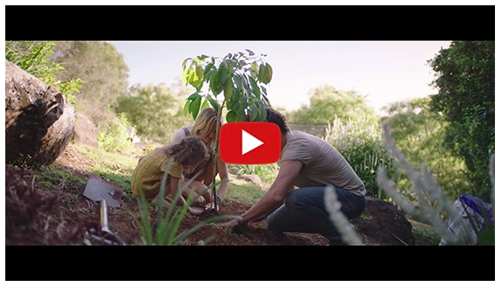
https://youtu.be/sR51ZDNSRFQ
Cool Australia, GoodThing Productions and Regen Pictures would like to acknowledge the generous contributions of Good Pitch Australia, Shark Island Institute, Documentary Australia Foundation, The Caledonia Foundation, Global Health Film and our philanthropic partners in the development of these teaching resources.
Teaching Sequence
Work through this resource material in the following sequence:
15 minutes – Part A: Activating Prior Knowledge
20 minutes – Part B: Population Growth and Food Security
20+ minutes – Part C: Solutions
5 minutes – Reflection

📚Part A: Activating Prior Knowledge
Step 1. Begin this lesson by inviting students to form a discussion circle around a table. Display the Future Food Flashcards on the table where students can see them. Invite students to suggest what these items have in common.
Explain to students that these are all suggested foods of the future. Use the explanation sheet provided with the Flashcards to describe what each food item is.
Now pose the following questions to students:
- Why are we considering these items as foods of the future? Why might we need them?
Suggested answer: With a growing population in the future, some people are concerned there might not be enough food and so are looking at other options.
- Why might insects be a good choice?
Suggested answer: Insects are high in protein, easy to breed and have a very short life cycle, meaning you can produce a lot of insects in a very short time.
- Why might we need edible water bottles?
Suggested answer: Single use plastics are a huge problem for our environment, so creating a water bottle that can either be eaten or that breaks down without causing pollution is a potential solution.
- Why might algae be an option?
Suggested answer: Algae can be used to feed both humans and animals, can be grown in the oceans so doesn’t require already scarce (in some places) fresh water to grow, and is the fastest growing plant on earth. You’re probably already eating algae as seaweed!
- Why might people be interested in this grain?
Suggested answer: Kernza was once considered a weed but its deep root system helps absorb and keep carbon in the soil and one plant produces grains for 5 years, compared to one year for wheat.
- Why might lab-grown meat be an option?
Suggested answer: Meat from livestock creates a lot of greenhouse gas as well as requiring vast amounts of water and energy. Meat grown in laboratories could help to reduce the impacts of meat consumption on our environment. Similarly, we may find more meat-replacement products sourced from plants. Would you eat lab meat? And should it be the same price as meat from a live animal?
Step 2. Now share the following clip with students, explaining that this clip comes from the documentary film 2040. The clip shows young people talking about what they hope to see happening with food now and in the future, and why:
What’s Your 2040 – For Food? Password: 2040_EDU (https://vimeo.com/showcase/6167669/video/334803254)
Once complete, engage students in a brief discussion around what they observed in this clip. Consider the following questions in your discussion:
- What was interesting or surprising about this clip?
- What do you agree with and why?
- What do you disagree with and why?
Step 3. You should then pose the following question to your class:
- What would you like to add to this clip? What other food issues can you think of?
Invite students to suggest their thoughts in response to these questions. If no one comes up with it themselves, suggest to students that one future food issue that many people are concerned about is food security.
Share this quote with the class, or direct students to read this quote from the Student Worksheet:
“The United Nations projects that the global population will increase from 7.3 billion in 2015 to 9.7 billion in 2050. This growth will be concentrated in the world’s poorest countries, where standards of living are set to rise rapidly, increasing demand for resource-intensive meat and dairy products. Together, these trends are heightening fears that the world’s cupboards may run bare in the coming decades.”
Source: The Conversation
Explain to students that in the first part of this lesson they will be exploring this quote in detail. In the second part of this lesson, they will be looking at what solutions exist for global food security challenges.
Step 4. Before students begin exploring these concepts, explain that it is first useful to clarify some of the key terms that will be used. Invite students to complete a THINK PAIR SHARE activity to develop definitions for the following terms (also available on the Student Worksheet): population, population growth, food production, food security, agriculture, food supply chain, and sustainability.
THINK PAIR SHARE is a collaborative learning strategy in which students work together to solve a problem or answer a question.
- THINK – Students independently think about an issue or question and record their thoughts.
- PAIR – Students work in pairs to discuss their ideas and record new thoughts.
- SHARE – Students share their thoughts with the whole group or with other pairs to reach consensus.
Once complete, invite student volunteers to share their definitions with the class. Use the following definitions as clarification:
- Population
Suggested definition: The whole number of people or inhabitants in a particular area.
- Population growth
Suggested definition: The increase in the numbers of people living in a particular area over time.
- Food production
Suggested definition: The process of converting raw materials into food.
- Food security
Suggested definition: Having access to a sufficient amount of affordable and nutritious food.
- Agriculture
Suggested definition: The science or practice of farming.
- Food supply chain
Suggested definition: A food supply chain describes the steps required to get food from a farm to our tables. The processes include production, processing, distribution, consumption, and disposal.
- Sustainability
Suggested definition: Making sure there is enough for our environment and for everyone on earth, both now and in the future.

Part B: Population Growth and Food Security
Step 1. Students will now start looking at population, population growth and food security. Begin by looking at population.
Break the class into pairs. Ensure each has access to a web-enabled device and a copy of the Student Worksheet. Invite students to navigate to this website and to spend several minutes exploring this website, using the following questions (also available on the Student Worksheet) to guide their exploration:
- Which countries have the largest populations?
- How does the United Kingdom’s population density compare with other countries?
- What is the projected global population for 2040 (the year the documentary is concerned with)?
- What other information do you find interesting or surprising on this website?
Invite students to share their thoughts with the class.
Step 2. Now pose the following questions to students:
- Why might food security be a problem for future populations?
Invite students to share their thoughts with the class. Through this process suggest to students that as populations grow so too will the demand for food. Explain to students that while population growth and rising demands will obviously affect the amount of food we need to produce in the future, there are a range of other factors that affect how much and what types of food we will be able to produce. These include (also available on the Student Worksheet):
- Consumption patterns – The amounts and types of food we demand will change according to the amount of money people have to spend on food, on food trends and nutritional information.
- Climate change – Climate change is expected to affect the types of food we can produce, and where and how much we can produce.
- Ecological health – Things like pollution, biodiversity degradation, and changes to marine and terrestrial environments will all affect the quantity and quality of the food we produce.
- Human influences – Issues like political disruption, trade sanctions or war can affect how food is distributed.
Step 3. Explain to students that they will now work in their groups to conduct research into one of these food security factors. They will then share the results of their research with other students.
Break the class into pairs or small groups and assign each group with a number from 1 to 4, ensuring that each number has been assigned at least once. Invite groups to access the Student Worksheet to locate the factor associated with their number.
Each group needs to conduct research to answer the following question in relation to the factor they are investigating (also available on the Student Worksheet):
- Why is this an important issue with regards to food security?
- What are the key points about this factor in relation to food security?
Once complete, invite students to form groups made up of a range of numbers (e.g. someone from a number 1 group, someone from a number 2 group, someone from a number 3 group, and someone from a number 4 group). Each student can then share the question they answered and the answer they found through their research.
Step 4. Finally, invite students to engage in a class discussion to share key issues identified through the research. Through your discussion explain to students that this is a complex subject so that if students have anything they would like to explore further or know more about they should make a note of these thoughts; you could use these ideas to guide further inquiry through homework or in a later lesson.

📚Part C: Thinking About The Solutions
Step 1. Explain to students that all around the world, people are working to come up with solutions to help address future food security. Some of these ideas involve rethinking the way we eat, the way we farm and the way the food supply chain works. They can also mean addressing underlying social and environmental issues, like poverty, access to water, and taking action for climate change.
Those working in the area of food security recognise four factors that are essential to food security. Project the Food Security Factors image below and discuss these four factors with students:
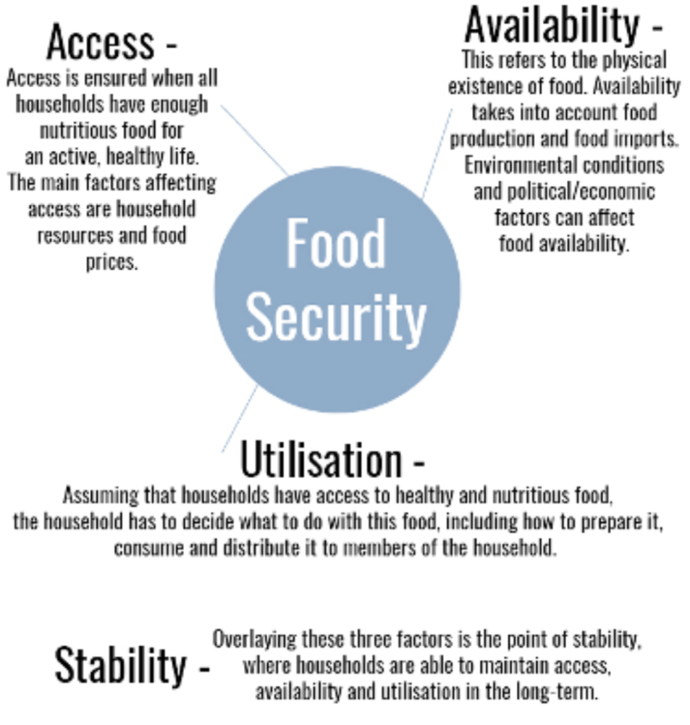
Step 2. Explain to students that people around the world are thinking about food security and working to develop solutions to meet the needs of a growing population. Students will now watch a clip from the 2040 documentary which describes one of these solutions; seaweed harvesting.
As students watch the clip, invite them to record anything they observe that relate to the four key factors of food security that they looked at earlier (i.e. consumption patterns, climate change, ecological health, and human influences).
2040 – Seaweed as Food Password: 2040_EDU (https://vimeo.com/showcase/6167669/video/304290496)
Once complete, engage the class in a brief class discussion around the following questions:
- How might seaweed harvesting help address future food security through:
  - Access
  - Availability
  - Utilisation
- What did you find interesting or inspiring about this solution?
- What did you want to know more about? What questions do you now have?
TIP: Use the questions generated in this point to guide further inquiry.
Step 2. Now explain the following to students (also available on the Student Worksheet):
There are many people in the world who are anticipating food security issues following any number of apocalyptic events. Some of these people are preparing for this situation by stocking canned and dried foods and buying water purification tablets for themselves and their families. However, this is certainly not the only way to ensure sustainable access to food in the future for all members of a community.
The task for students now is to develop a more sustainable solution to food security for their community. This may include:
- Exploring what resources are already available (e.g. what local sources of production already exist?)
- How food production could be strengthened and improved (e.g. what other opportunities for food production exist in your community?)
- How the community could get involved (e.g. how the community could ensure they are utilising resources effectively).
Break the class into groups. Each group could address all the points above, or you could divide the points above between the groups. Each group should develop one or more ideas for action, and explain how their ideas relate to at least two of the following three factors of food security:
- Access
- Availability
- Utilisation
Students may need to undertake research about what already exists in your community, and may find the Food Security Factors sheet useful in assessing their idea.
Each group needs to produce a three-slide presentation to describe their idea/s. You can give students this Presentation Assessment Rubric to describe what is expected of them.
Step 3. Invite each group to share their presentation with the class. You can use the Presentation Assessment Rubric to assess presentations or invite students to use the rubrics to assess the presentations of their peers.
Once complete, engage students in a closing discussion around what they thought were the most interesting or compelling ideas presented and why.

Reflection
Ask students to reflect on this activity using the CONNECT EXTEND CHALLENGE activity on the Student Worksheet. This activity may be completed as homework.

Take It Further
To expand on student’s learning in this lesson, consider following up with this lesson; 2040 Vision For Your Community.

Teacher Reflection
Take this opportunity to reflect on your own teaching
- What did you learn about your teaching today?
- What worked well?
- What didn’t work so well?
- What would you share?
- Where to next?
- How are you going to get there?
What’s Your 2040?
Record your students’ work in their communities with the hashtag #whatsyour2040 and share their visions in the ‘2040: The Regeneration’ Facebook Group. The 2040 crew would love to see your class’ work.

