# Girls For The Planet - High School - Teacher Worksheet US

**Teacher Preparation**

Learning objectives: Students will…

* ... locate and interpret statistics
* ... collect data directly from secondary sources
* ... use statistics to construct back-to-back stem-and-leaf plots and histograms
* ... analyse their findings and present these to their peers

Goals of Learning: Students can…

* ... locate and interpret statistics
* ... collect data directly from secondary sources
* ... use statistics to construct back-to-back stem-and-leaf plots and histograms
* ... analyse their findings and present these to their peers

**Make the learning objectives and goals of learning visible for students throughout this lesson.**

Tackling climate change requires large-scale, systemic changes across all aspects of society. Simply aiming to reduce our C02 emissions is not enough: we need to rapidly decarbonize our planet. While this might sound challenging, the good news is we already have the knowledge and tools to do it.

2040 is an innovative feature documentary that looks to the future, while focusing on what is happening now. Award-winning director Damon Gameau (director of [That Sugar Film](https://thatsugarmovement.com/film/)) embarks on a journey to explore what the future could look like by the year 2040 if we simply embraced the best solutions already available to us to improve our planet and shifted them into the mainstream.

The film will demonstrate to your students that we already have the solutions to climate change; we just need to take action to bring them rapidly into the mainstream. The 2040 documentary and curriculum package will support your students in turning this knowledge into positive action for a better future.

Find out how to see the film [here](http://www.togetherfilms.org/2040-screenings). 2040 launched in cinemas in Nov 2019 and is now available for booking for your school. These lessons have been designed with a media library to support teachers. The film is available on video-on-demand and DVD for individual viewing.

The film is the entry point to a global impact campaign that seeks to mobilise audiences to learn about, contribute to, advocate for, and invest in regenerative solutions that improve the wellbeing of the planet, all people and all living systems. To join the Regeneration and share your vision for 2040, see the [website](http://whatsyour2040.com/).

**Watch the 2040 trailer:**

](https://www.youtube.com/watch?v=sR51ZDNSRFQ&feature=emb_title)

<https://youtu.be/sR51ZDNSRFQ>

Cool Australia, GoodThing Productions and Regen Pictures would like to acknowledge the generous contributions of [Good Pitch Australia](http://goodpitch2australia.com.au/), [Shark Island Institute](http://sharkisland.com.au/shark-island-institute/), [Documentary Australia Foundation](https://www.documentaryaustralia.com.au/), [The Caledonia Foundation](https://www.caledoniafoundation.com.au/), [Global Health Film](https://www.globalhealthfilm.org/) and our philanthropic partners in the development of these teaching resources.

### A word on empowering women and girls: A lesser-known combatant to climate change is educating and empowering girls:

### Educated girls have fewer and healthier children and this controls population growth

### Educated girls have the capacity to contribute to economic growth

### The education and empowerment of girls leads to reduced incidence of disease and hence higher life expectancies

### Education equips females with the skills and knowledge to better manage the negative impact of climate change.

### How do we help? Invest in, or raise awareness, of programs that educate and empower women and girls all over the world. We can also use our consumer power to support organisations and businesses that work with women and girls who are paid fairly, such as through Fair Trade or Community Trade agreements.

### References:

### [Wired](https://www.wired.com/story/to-stop-climate-change-educate-girls-and-give-them-birth-control/) (https://www.wired.com/story/to-stop-climate-change-educate-girls-and-give-them-birth-control/)

### [FAWCO](https://www.fawco.org/global-issues/target-program/education/blog-let-s-get-schooled/3899-educating-girls-to-combat-climate-change/) (https://www.fawco.org/global-issues/target-program/education/blog-let-s-get-schooled/3899-educating-girls-to-combat-climate-change/)

### **Teaching Sequence**

**Work through this resource material in the following sequence:**

### 20 minutes – Part A: Activating Prior Knowledge

### 10 minutes – Part B: Facts and Figures About Educating Girls

### 20 minutes – Part C: Worked example 1: Back-to-Back Stem and Leaf Plot

### 20 minutes – Part D: Worked Example 2: Histogram

### 45 minutes – Part E: Statistics of Girls' Education Around The World

### 15 minutes – Part F: Take Action

### 10 minutes – Reflection

#### ****Part A: Activating Prior Knowledge****

**Note:** This lesson looks at how the empowerment and education of women and girls' has a positive impact on climate change. Before conducting this lesson it is a good idea to get an understanding of your class’ understanding of climate change as they will need to be able to draw complex links between girls' education and climate change.

If you find that your class is unsure about the causes of climate change, consider showing them this clip from the **2040** Documentary:

**2040 - Global Challenges**

Password 2040_EDU (<https://vimeo.com/showcase/6167669/video/336498352>).  
**Note: You can use this same password to access all clips in the 2040 education media library.**

**Step 1.** Lead the whole class in this 'Think, Puzzle, Explore' activity.

#### ****THINK - PUZZLE - EXPLORE****

This activity will help students connect with prior knowledge, stimulate curiosity and lay the groundwork for future inquiry:

**THINK** - What do you THINK you know about this topic?

**PUZZLE** - What questions or PUZZLES do you have?

**EXPLORE** - How can you EXPLORE this topic?

Pose the following three questions, allowing students to make notes:

* What do you think you know about climate change and how to manage it?
* What questions or puzzles do you have?
* How can we explore this topic?

Invite students to share their ideas and note these on the board. Inform the class that they will revisit their responses at the end of the lesson.

**Step 2.** Continue by asking students:

* What is the role of education in combating climate change?
* In what ways might education make a measurable impact on climate change?

Lead a brief class discussion to explore these questions.

**Step 3.** Show this 2040 clip:

**2040 - Empowering Women and Girls**

**Password**: 2040_EDU (<https://vimeo.com/showcase/6167669/video/336513493>)  
**Note: You can use this same password to access all clips in the 2040 education media library.**

**Step 4.** Give the students a chance to watch the clip again and this time ask them to record key points and write down any unfamiliar terms.

**Step 5.** Invite students to form (or assign) groups of 3 to 4. Ask students to:

* ... share their key points from the clip and form a summary
* ... collate the recorded unfamiliar terms and define them using a (print or online) dictionary

Invite some of the groups to share their responses with the class.

**Step 6.** Distribute the Student Worksheet and inform students that they will be investigating statistics through the topic of climate change and, in particular, the role of educating girls in combating climate change. Let the class know that later in the lesson, they will be choosing an action that they can undertake to inform the community about what they have learned or how they can support the empowerment and education of women and girls. Students will be using mathematical information to help convince people to take action on this issue, so invite the class to take notes on the back of their **Student Worksheet** throughout the class when they hear something that they feel is a powerful piece of information that they might be able to use.

Explain that you will not be pointing these pieces of information out during the class because you would like students to use their own judgement about what they think is powerful and persuasive mathematical information.

#### ****Part B: Facts and Figures About Educating Girls****

#### ****Step 1.**** Say to students, “Everyone make a fist and place it on their belly.”

#### Then say, “I’m going to write some statements on the board. For each one, if you know anything about the topic or have something to say, put your thumb up, like this (demonstrate the action).”

#### ****Step 2.**** Write the following on the board and read it aloud:

* "In 2016, 263 million children, adolescents, and youths were out of school, representing nearly one-fifth of the global population of this age group."

#### Look for raised thumbs, and invite any student with their thumb up to respond. Invite students to put their fist to their belly and once again to raise their thumb if they have something to say or ask about the following.

#### Display the following on the board, reading each aloud and allowing time for responses in-between:

* "Some 63 million, or 24% of the total, are children of primary school age (about 6 to 11 years old)."
* "61 million, or 23% of the total, are adolescents of lower secondary school age (about 12 to 14 years old)."
* "139 million, or 53% of the total, are youth of upper secondary school age (about 15 to 17 years old)."

#### You could also draw this [pie chart](http://whatsyour2040.com/wp-content/uploads/2020/11/pie-chart.png):

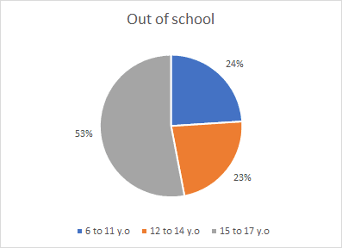

Ask students what they think about these statistics. Are they surprised? What do they think are some of the barriers to education? Later in class, students will assess whether boys and girls have differing access to education. What is their prediction for what they will find, and why? Lead a brief class discussion on the topic.

#### ****Part C: Work example 1: Back-to-Back Stem and Leaf Plot****

In this part of the lesson, students will look at rates and numbers of out-of-school young people from the UNESCO Institute for Statistics (UIS) and develop a back-to-back stem and leaf plot to compare statistics for males and females.

Note: If you, or your students, need a refresher on stem and leaf plots, check out either of these great clips; [Grouped Data](https://www.youtube.com/watch?v=a9kIVL-laYE) (<https://www.youtube.com/watch?v=a9kIVL-laYE>) and [Statistics - How to make a stem and leaf plot](https://www.youtube.com/watch?v=_7m0Q_m2ppg) (<https://www.youtube.com/watch?v=_7m0Q_m2ppg>)

**Step 1.** Explain to the class that soon they will now be looking at rates and numbers of out-of-school young people in 2016, from the UNESCO Institute for Statistics (UIS) and develop a back-to-back stem and leaf plot to help them compare statistics for males and females. But before students create their own data representations you will be working as a class to make a stem and leaf plot using some very interesting data.

**Step 2.** Recreate the table below on your whiteboard leaving space to draw a stem and leaf plot beside it or project it for all students to see. Explain to the class that this table shows the number of male and female children, adolescents and youth of primary, lower secondary and upper secondary age who are out of school:

|  |
| --- |
| **Out of school number (millions)** |
| **Region** | **Male** | **Female** |
| Europe and Northern America | 3.4 | 2.8 |
| Latin America and the Caribbean | 6.8 | 5.9 |
| Central Asia | 0.5 | 0.6 |
| Southern Asia | 49.2 | 46.5 |
| Eastern and South-Eastern Asia | 17.2 | 13.4 |
| Northern Africa and Western Asia | 8.6 | 10.0 |
| Sub-Saharan Africa | 44.7 | 52.2 |
| Oceania | 0.5 | 0.4 |

﻿

Source: <http://uis.unesco.org/sites/default/files/documents/fs48-one-five-children-adolescents-youth-out-school-2018-en.pdf>

**Step 3.** Work with the class to reorder the numbers for male and female children from smallest to largest, recording this on the board:

* Male: 0.5, 0.5, 3.4, 6.8, 6.8, 8.6, 17.6, 44.7, 49.2
* Female: 0.4, 0.6, 2.8, 5.9, 10.0, 13.4, 46.5, 52.2

**Note:** In this example, the stem will be the whole numbers (the numbers before the decimal point) and the leaves will be the numbers following the decimal point. (Hint: see the 'Key' - below)

**Step 4.** Draw a T-type shape and label the columns on the board. Don't forget to include a 'Key'. For this stem and leaf plot, we will be placing the numerals that come before the decimal point in the stem, and the numerals that are after the decimal point in the leaves. This makes the Key: Leaf = 0.1

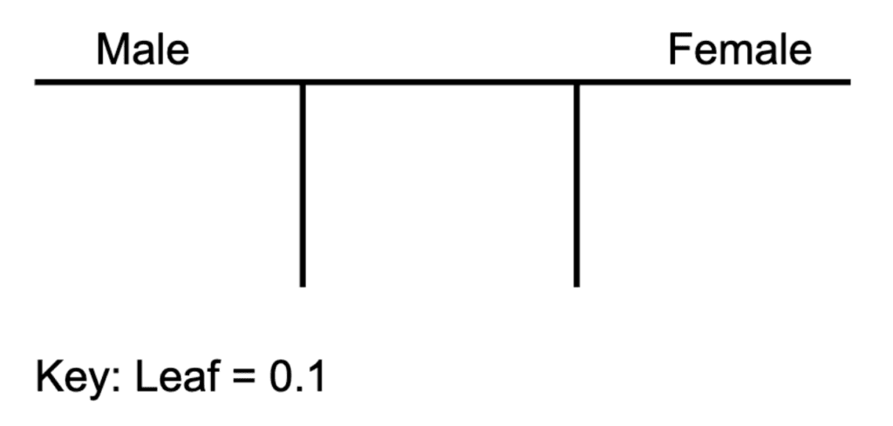

**Step 4.** Now, starting with either the male or female data, invite students to help you write the stems and leaves (in numerical order) as below:

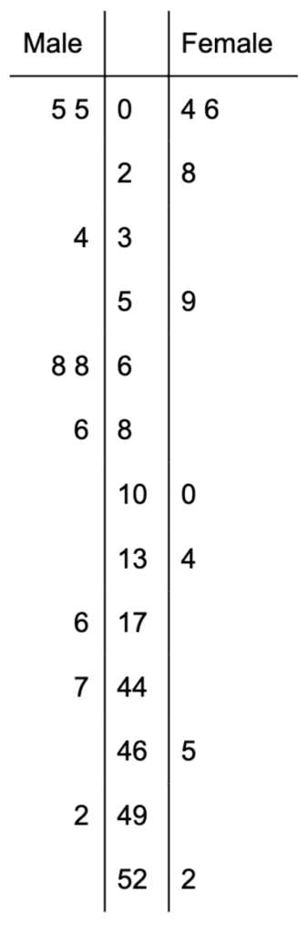

**Step 5.** Ask students to turn to the person next to them and discuss what they notice from the back-to-back stem and leaf plot you have worked together to create. Invite students to share their observations, which may include the following:

* The highest number is female at 52.2 million.
* The numbers vary widely indicating the great differences in various parts of the world.

**Step 6.** Conclude this part of the lessons by explaining that in the next part of the lesson, the class will look at a great asset to education, internet access, to see what this can add to the picture that the data is showing us.

#### ****Part D: Work Example 2: Histogram****

#### ****Step 1.**** Explain to the class that they will now look at statistics of internet use in 2017, then develop and describe two histograms to compare the statistics for males and females. Now either recreate or project the data in the table below:

|  |  |  |
| --- | --- | --- |
| **Region** | **Female Internet users as % oftotal female population 2017** | **Male Internet users as % oftotal male population 2017** |
| Australia and NZ | 53.7 | 56.9 |
| Central and Southern Asia | 41.5 | 44.6 |
| Eastern and South-eastern Asia | 27.8 | 42.0 |
| Europe and Northern America | 75.2 | 82.0 |
| Latin America and the Caribbean | 66.7 | 65.2 |
| Northern Africa and Western Asia | 55.3 | 59.5 |
| Oceania (excluding Aust. and NZ) | 53.7 | 56.7 |
| Sub-Saharan Africa | 44.7 | 50.6 |

﻿

Source: <http://www.unwomen.org/-/media/headquarters/attachments/sections/library/publications/2018/sdg-report-fact-sheet-global-en.pdf?la=en&vs=3554>

**Step 2.** Work with the class to re-order the numbers for males and females.

* Female: 27.8, 41.5, 44.7, 53.7, 53.7, 55.3, 66.7, 75.2
* Male: 42.0, 44.6, 50.6, 56.7, 56.9, 59.5, 65.2, 82.8

**Step 3.** Explain to the class that they will now be creating a frequency table using this data. If the class has not used a frequency table before explaining that it is a record of how often numbers in a set of data appears between a set range for example

Challenge students to think about the usefulness of a frequency table. You might want to invite students to pair up to discuss for a minute or two. Your class may be able to identify that a frequency table will show where data clumps.

**Step 4.** Now, construct a frequency table as below but hold off on entering that data in the first column for now. Explain to the class that first they need to determine a range (bin) for the set of numbers. We will choose the frequency range to be 10, starting at 20, so our frequency table will look like the following. Now fill out the first column as below.

|  |  |  |
| --- | --- | --- |
| **Range** | **Frequency (females)** | **Frequency (males)** |
| 20-30 |  |  |
| 30-40 |  |  |
| 40-50 |  |  |
| 50-60 |  |  |
| 60-70 |  |  |
| 70-80 |  |  |
| 80-90 |  |  |

﻿

**Step 5.** Next, begin filling out the first column with the class. You may ask students 'how many times does a number between 20-30 appear in the female data?' answer - 1. Then continue down the column inviting students to help you out as you go. The finished column should look as below:

|  |  |  |
| --- | --- | --- |
| **Range** | **Frequency (females)** | **Frequency (males)** |
| 20-30 | 1 |  |
| 30-40 | 0 |  |
| 40-50 | 2 |  |
| 50-60 | 3 |  |
| 60-70 | 1 |  |
| 70-80 | 1 |  |
| 80-90 | 0 |  |

﻿

**Step 6.** Repeat the same process in Step 5 in the male column to create this finished frequency table:

|  |  |  |
| --- | --- | --- |
| **Range** | **Frequency (females)** | **Frequency (males)** |
| 20-30 | 1 | 0 |
| 30-40 | 0 | 0 |
| 40-50 | 2 | 2 |
| 50-60 | 3 | 4 |
| 60-70 | 1 | 1 |
| 70-80 | 1 | 0 |
| 80-90 | 0 | 1 |

﻿

**Step 4:** Now, challenge students to work on either their graph paper or Excel to create a graph for male and another for female internet usage.

The histogram for females will look like this:

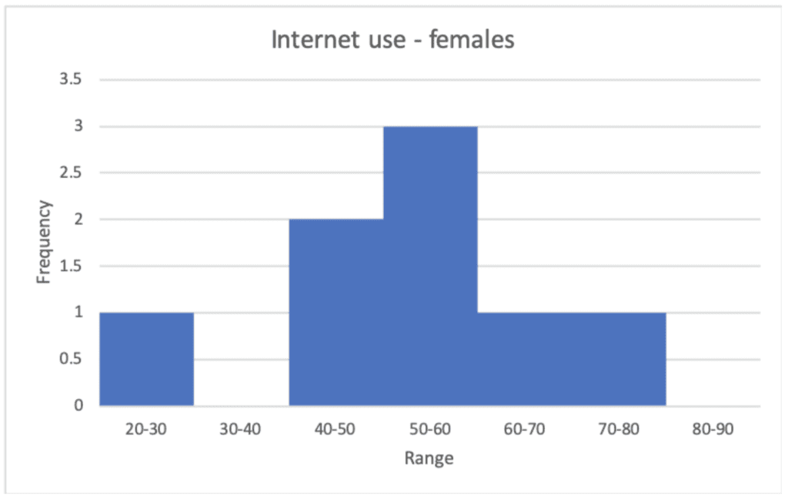

The histogram for males will look like this:

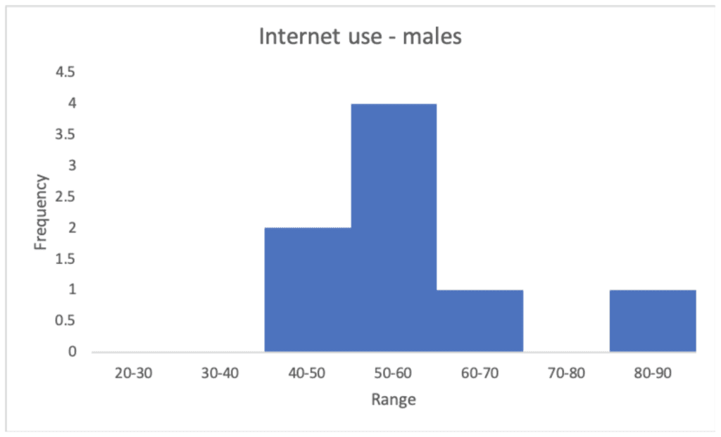

**Note:** if you would like the spreadsheet that the above histograms were made from you can download it here, [2040_HistogramEgs](https://whatsyour2040.com/worksheets/girls-for-the-planet-years-10-teacher-worksheet/).

**Step 5.** As students are working on their histograms either project or write the following information about data distribution in a histogram on the board:

Things to consider if the histograms are skewed, symmetrical or bi-modal:

* A histogram is **skewed right** if the bars towards the left are taller, and there is a tail to the right.
* A histogram is **skewed left** if the bars towards the right are taller, and there is a tail to the left.
* A histogram is **symmetrical** if it is similar (doesn’t need to be exact) on both sides.
* A histogram is **bi-modal** if it has two ‘peaks’ - that means: two values occur more frequently than others.

**Step 6.** Invite the class to discuss what the histograms are showing them. Answers may include the following:

* The histograms above are symmetrical with both clearly showing that in most regions of the world, 50-60% of the female and male populations respectively, use the Internet.
* However, it is also clear, that in some regions, only 20-30% of the female population uses the Internet, whilst the lowest percentage of males using the Internet is between 40% and 50%.
* Similarly, in one region of the world, 80-90% of the male population use the Internet, whilst the highest for women, also in one region of the world, is 70-80%.

**TIP:** Make sure that in all the excitement of this data visualisation that students have remembered to continue adding to their list of impactful mathematical information. By the end of this part of the lesson, they should hopefully have a few ideas.

#### ****Part E: Statistics of Girls' Education Around the World****

**Step 1.** Inform students that they will now be working in groups to explore information and statistics about the education of girls, then creating stem and leaf plots and histograms to display the data. Remind them that they will need to consider what action they will take to share and present their learning.

**Step 2.** Divide students into groups of 3.

NOTE: The data to be accessed consists of 189 countries. In groups, students will be assigned a set of countries to investigate. Depending on the number of students in your class, ensure that you assign groups and group numbers to investigate all the countries.

In this example, groups of 3 can be used for a class size of 27, which means that each group will manipulate data for 21 countries.

**Step 3.** Assign groups a set of countries to investigate. In this example, groups would be assigned as follows:

* Group 1 - Countries 1 to 21
* Group 2 - Countries 22 to 42
* Group 3 - Countries 43 to 63
* Group 4 - Countries 64 to 84
* Group 5 - Countries 85 to 105
* Group 6 - Countries 106 to 126
* Group 7 - Countries 127 to 147
* Group 8 - Countries 148 to 168
* Group 9 - Countries 169 to 189

**Step 4.** Ask students to complete the 'Group Activity' on the Student Worksheet where they will access The [Gender Development Index (GDI)](http://hdr.undp.org/en/composite/GDI) (http://hdr.undp.org/en/composite/GDI). Before students begin this activity you might want to inform students that:

* "The GDI measures gender gaps in human development achievements by accounting for disparities between women and men in three basic dimensions of human development - health, knowledge and living standards... The GDI shows how much women are lagging behind their male counterparts and how much women need to catch up within each dimension of human development." ([UNDP](http://hdr.undp.org/en/content/gender-development-index-gdi) - http://hdr.undp.org/en/content/gender-development-index-gdi)

The GDI shows the information in order of countries who have the 'best' gender development.

Education is measured using two indicators:

1. Female and male expected years of schooling for children (number of years of schooling that a child of school entrance age can expect to receive)
2. Female and male mean years of schooling (average number of years of education received by people ages 25 and older).

**Step 5.** Explain that, in groups, students will investigate a subset of the data and construct back-to-back stem-and-leaf plots and histograms to compare statistics of men and women. The first two steps will help students create both representations of the data (1. the back-to-back stem and leaf plot and 2. the histogram/s). Now that you have demonstrated all the skills needed to make a stem and leaf plot and a histogram, this activity has been designed is that groups can independently work through the steps at their own pace, asking for your assistance when needed.

Here are the instructions for this activity:

* Step 1. Copy the data from the GDI for 'Expected years of schooling' (for your set of countries only) into a table.
* Step 2. Re-order the numbers for males and females.

**Making a back-to-back stem and leaf plot**

* Step 3. Draw a T-type shape and label the columns. Don't forget to include a 'Key'.
* Step 4. Now write the stems and leaves (in numerical order).
* Step 5. Describe what you notice from the back-to-back stem and leaf plot.

**Making a histogram**

* Step 1. Construct a frequency table for your data.
* Step 2: Construct the histograms (one for male and another for female).
* Step 3. Now consider if the histograms are skewed, symmetrical or bi-modal:
* Step 4. Describe the histograms in writing:

Ask the students: **"What other observations do you have about the data?"** and lead a brief class discussion on this question.

#### ****Part F: Take Action****

**Optional extension** - Ask students to read the following article and summarize the main points. They can also define any unfamiliar terms: <https://www.newsecuritybeat.org/2017/09/fight-climate-change-educate-empower-girls/>

**Step 1.** Explain to the class that they will now be taking action on the issues they have been exploring. By using the impactful mathematical information that they have been collecting and/or the data visualisations that they have created students will pick a method to share the information they have found and work toward getting this learning out into your school community.

Below are a number of options that students can select (in groups). Invite students to select an option from each column and complete the activities. Students should consult with you for feedback before getting started on their action. Discuss each group's ideas with them and provide any necessary guidance.

This block contains unexpected or invalid content.

ResolveConvert to HTML

|  |  |
| --- | --- |
| **Share your learning** | **Make a stand** |
| **Develop a brief presentation** that provides information about your findings from the subset of GDI data that you investigated and the connection between climate change and the education of girls. | **Provide the ticket to education: clean water.**Did you know girls in poor communities often miss school because of a lack of clean water in their village? Instead of attending class, millions of girls and women around the world spend 200 million hours each day ([UNICEF](https://www.unicef.org/esaro/5440_2016_collecting-water.html)https://www.unicef.org/esaro/5440_2016_collecting-water.html) fetching water that is often dirty and dangerous to their health.Check out these great organizations: Charity: water: supporting community-owned water projects around the world (https://www.charitywater.org/) [Thirst Project:](https://www.thirstproject.org/)  Activating high school and higher education campuses to advocate globally for safe, clean water for all (https://www.thirstproject.org/) |
| **Write an article** for the school newsletter (or other appropriate school communication channel) that discusses information about your findings from the subset of GDI data that you investigated and the connection between climate change and the education of girls. | **Donate, raise money, or invest in micro-loans**Invite family, friends and members of your community to support you in donating to (or raising money for) charities that support the empowerment of women and girls.Check out these great organisations:- [Room to Read](https://www.roomtoread.org/literacy-girls-education/) - providing literacy education for girls. ( https://www.roomtoread.org/literacy-girls-education/)- [CamFed.org](https://camfed.org/) - African-led movement to educating girls. (https://camfed.org/) [Kiva](https://www.kiva.org/lend/women) - you can provide a small loan directly to a woman who is running or starting up her own business. (https://www.kiva.org/lend/women) |
| **Develop an infographic** that presents information about your findings from the subset of GDI data that you investigated and the connection between climate change and the education of girls. | **Become a Change Maker**Attend a Climate Reality Leadership Corps Training (<https://www.climaterealityproject.org/training>) a global community of change-makers working to solve the climate crisis and create a just and healthy future. |
| **Write a letter** to your , state, and federal elected representatives to help strengthen the voice for climate change action in the United States and around the world.Find out how to do this here. | **Join an organisation, become an ambassador or volunteer** Join [Women4Change](http://w4c.org/), offering support and mentorship to women in climate leadership around the world. (w4c.org) Volunteer or become an activist with [Amnesty International](https://www.amnesty.org.au/become-an-activist/) to stand up for women and girls. (https://www.amnesty.org/en/get-involved/ |
| **Develop a social media** **campaign** to raise public awareness about the connection between climate change and the education of girls. | **Make a pledge**Visit <https://www.malala.org/> and make a pledge to support the empowerment of women and girls. (https://www.malala.org/donate/2040) |

#### ****Reflection****

Ask students to answer the following two questions as a Think, Pair, Share activity:

* Look back at your answer to the question at the beginning of this lesson, “What is the role of education in climate change?”. What about your answer has changed? What has stayed the same?
* What is the most interesting thing that you have learned in this lesson?

**THINK PAIR SHARE is a collaborative learning strategy in which students work together to solve a problem or answer a question.**

* **THINK** - Students independently think about an issue or question and record their thoughts.
* **PAIR** - Students work in pairs to discuss their ideas and record new thoughts.
* **SHARE** - Students share their thoughts with the whole group or with other pairs to reach consensus.

#### ****Differentiated Learning****

**Extension -**

* Students may explore additional data from the GDI (http://hdr.undp.org/en/composite/GDI)  conduct further statistical analysis.
* Students can select additional options from the Take Action table or take on a whole school fundraising project.
* Some students might like to complete the 'Group Activity' individually.

**Provisions for Learning Support -**

* Some students may require further support in constructing back-to-back stem-and-leaf plots and histograms. You can refer to the worked examples and supervise them more closely during the group task.
* The information on climate change and women and girl's education contains new and unfamiliar terms to students. Encourage students to maintain a glossary of new terms discovered during the lesson. There are opportunities for this provided through the lesson already. This will benefit students of all literacy levels and improve their understanding of the topic overall.

#### ****Teacher Reflection****

Take this opportunity to reflect on your own teaching

* What did you learn about your teaching today?
* What worked well?
* What didn’t work so well?
* What would you share?
* Where to next?
* How are you going to get there?

**What's Your 2040?**

Record your students' work in their communities with the hashtag #whatsyour2040 and share their visions in the '2040: [The Regeneration' Facebook Group](https://www.facebook.com/groups/2040TheRegeneration/). The 2040 crew would love to see your class' work.