Reducing Our Carbon Footprint – Maths and Science – Years 5 & 6 – Student Worksheet

Thought starter: What is a Carbon Footprint and how is it measured?
In Lesson 1, we looked at CO₂ in the atmosphere by using the measurement ‘Parts per Million’ – or the percentage of gas in the atmosphere. Now, however, we’re going to measure CO₂ in a different way. This will allow us to look at the amount of CO₂ produced by each of us – as individuals, and within our families or our households.

The Weight of Greenhouse Gas
1. Watch as your teacher and the class measure three different substances. Record the different masses (or ‘weights’) of each of these substances, even though they are all filling up a container to the volume of exactly 1 Litre (by the way, this is the same as saying a capacity of 1000 cm³).
Substance 1: | Substance 2: | Substance 3:
What do you notice? What do you wonder?
Write down the reasons for the different masses of these three substances, even though they’re the same volume.
2. As a class, we’ll watch a second short clip from the new film ‘2040’.
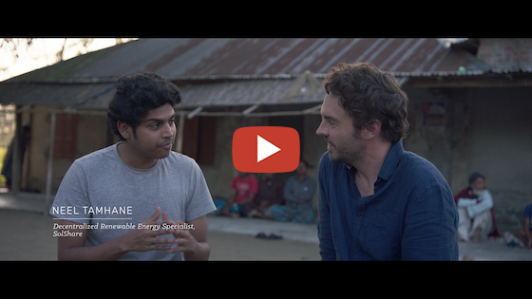
What’s Your 2040 – For Energy? Password: 2040_EDU(https://vimeo.com/showcase/6167669/video/336504721)
After you have viewed this, take a few minutes to complete the table below.
CONNECT:  What information or ideas shown in this video are connected to or remind me of what I already know about carbon dioxide? | EXTEND:  What new ideas or information presented here extend my existing knowledge about carbon dioxide? | CHALLENGE:  What problems, issues or wonderings have popped into your mind as a result of watching this video clip?
Worksheet Preview – Please click the button to Download / Print
Download / Print

Reflection
Use the space below to write in three (3) important ideas that you will take away from this lesson:
1.
2.
3.

