Renewable Energy Science Grades 7 & 8 Teacher Worksheet

Teacher preparation
Learning intentions: Students will …
- … understand what renewable and non-renewable means in terms of resources
- … recognise a range of renewable energy sources
- … understand how people can use scientific knowledge around energy to improve and empower communities through community energy programs
Success criteria: Students can …
- … work independently and collaboratively
- … participate in group discussion
- … generate scientifically relevant questions
- … conduct and share research

Teacher content information: A 2018 study by The University of Melbourne on the thoughts and concerns of young people from Generations X and Y found the number one concern across both groups was lack of action around climate change. In particular, “Generation X worries what climate change will mean for their own children, while Generation Y is concerned about the impact on future generations” (The Educator). The report indicates that young people have a serious mistrust in the Government’s ability or willingness to tackle climate change.
Tackling climate change requires large-scale, systemic changes across all aspects of society. Simply aiming to reduce our C0₂ emissions is not enough: we need to rapidly decarbonise our planet. While this might sound challenging, the good news is we already have the knowledge and tools to do it.
2040 is an innovative feature documentary that looks to the future while focusing on what is happening now. Award-winning director Damon Gameau (director of That Sugar Film) embarks on a journey to explore what the future could look like by the year 2040 if we simply embraced the best solutions already available to us to improve our planet and shifted them into the mainstream.
The film will demonstrate to your students that we already have the solutions to climate change; we just need to take action to bring them rapidly into the mainstream. The 2040 documentary and curriculum package will support your students in turning this knowledge into positive action for a better future.
Find out how to see the film here. 2040 will only be available in cinemas for the first part of 2019 and you can make a group booking for your class at your local cinema during the film’s theatrical release which starts on May 23. These lessons have been designed with a media library to support teachers. The film will be available on video-on-demand and DVD later in 2019.
The film is the entry point to a global impact campaign that seeks to mobilise audiences to learn about, contribute to, advocate for and invest in regenerative solutions that improve the wellbeing of the planet, all people and all living systems.
To join the Regeneration and share your vision for 2040, see the website.
Watch the 2040 trailer:
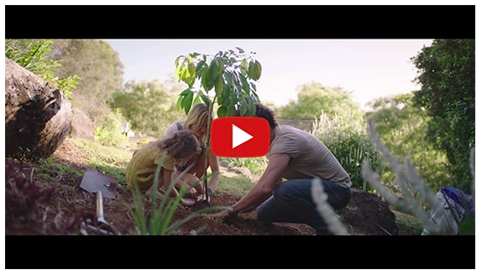
https://youtu.be/sR51ZDNSRFQ
Cool Australia, GoodThing Productions and Regen Pictures would like to acknowledge the generous contributions of Good Pitch Australia, Shark Island Institute, Documentary Australia Foundation, The Caledonia Foundation and our philanthropic partners in the development of these teaching resources.

Teaching sequence
Work through this resource material in the following sequence:
15 minutes – Part A: Activating Prior Knowledge
35 minutes – Part B: Renewable Energy
35 minutes – Part C: Beyond The Science
5 minutes – Reflection

Part A: Activating Prior Knowledge
Step 1. Begin this lesson by inviting students to participate in the following activity:
- Break students into pairs.
- Give each pair a piece of blank paper (can be scrap, printed on one side) and ensure each student has a pen or pencil.
- Set your timer for 3 minutes.
- Explain to students they have 3 minutes to write down everything they know about renewable and non-renewable resources. One person should be the scribe and the other can suggest ideas. Encourage students to build on what their partner is writing and add whatever comes into their heads, even if they’re not sure it is ‘correct’.
- Allow students three minutes to record their ideas.
Once complete, invite students to share their responses with the class, recording key points on the board.
Clarify any questions or key points raised by students, including the following:
- Natural resources – Natural resources are useful raw materials that we get from the Earth. They occur naturally, meaning humans cannot make them. Instead, humans can use and modify natural resources in ways that are beneficial to us. Some examples of natural resources are air, water, animals, minerals, plants and sunlight.
- Renewable resources – Any natural resource that can be replenished naturally over the course of a human lifespan. Examples of renewable resources include oxygen, fresh water and wood from trees.
- Non-renewable resources – Any natural resource from the Earth that exists in limited supply and cannot be replaced if it is used up, such as oil or coal.
Step 2. Now share the following clip with students. As they watch, invite students to take note of anything they think is interesting: The difference between a renewable and non-renewable resource.
Once complete, invite students to share their thoughts about this clip. You can then explain to students that in the next activity, they will be given a range of natural resources and will need to order these resources in terms of their renewability/regeneration, from fastest to the slowest.
Invite students to return to their pairs. Give each student a copy of the Student Worksheet and ask them to locate the list of resources. Students need to order the resources according to their regeneration rates by adding a number from 1 to 5 (with 1 being the fastest) next to each resource. Students then need to decide whether this is a renewable resource.Resources with answers:
- Sunlight – The sun is always shining somewhere. Renewable!
- Eggs – A chook lives for about 2 to 4 years on average. Renewable!
- Wood – Some trees can grow and be harvested within 30 years; others take 100 years to grow. Renewable!
- Water – Some water sources can be replenished with one rainfall (like a dam or lake), others – like some aquifers – can take centuries to refill. If carefully managed, water can be a renewable resource.
- Coal – Coal is formed from the remains of ancient organisms and can take millions of years to develop. Non-renewable!

Part B: Renewable Energy
Step 1. Explain to students that in the next part of this lesson students will be looking at how the term ‘renewable’ can be applied to the energy we use and why this might be important.
Pose the following question to students:
- What is renewable energy?
Explain to students that renewable energy is energy from a source that will not run out if used, such as wind or solar power.
Step 2. Now project the following image (also available on the Student Worksheet):
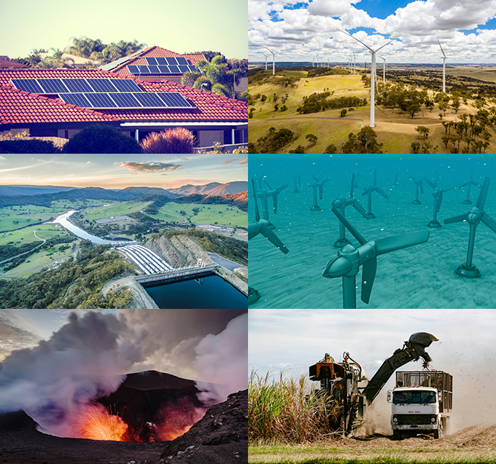
Explain to students that most of us are familiar with at least one or two forms of renewable energy. Which types of energy displayed in this picture are you familiar with and what do you know about these different types of energy? Engage students in a brief discussion around their thoughts.
NOTE: Use the following information to clarify the images in this picture:
- Top row left – Solar panels (energy generated from the sun)
- Top row right – Wind turbines (energy generated from the wind)
- Middle row left – Hydropower (Tumut Hydroelectric Power Station, NSW)
- Middle row right – Hydropower (tidal power)
- Bottom row left – Geothermal power (energy from the earth’s heat)
- Bottom row right – Bioenergy (energy derived from plants or animals e.g. sugar cane trash)
Step 3. Now explain to students that they will now work in pairs to generate a list of questions about renewable energy. Remind students that developing questions is a key component of the scientific method and defining a good research question is essential to conducting interesting and meaningful research.Students need to generate questions based on the following statement:
- What I DON’T know about renewable energy.
Each pair of students needs to generate at least five questions that are scientifically relevant (i.e. related to the topic of renewable energy) they think they could answer through online research and record these on the Student Worksheet.
Once complete, invite each student to select what they think is the most interesting question their pair generated, making sure this is a question they think they could answer. Each student should write this question down on a sticky note or small piece of paper and give it to the teacher. The teacher can then redistribute these questions to students, with one question for each student. Each student then needs to take their question and conduct research in order to answer this question (remind students of the Search Strategies for Googling when conducting research online).
When students have conducted all the research they need, they should summarise their research and record the answer to their question on an A5 sized piece of paper (you could print and cut up the Energy Answers Sheet or give students an A5 sized piece of card or paper). Students need to make sure they have added their question to this piece of paper, and any information they want to include needs to fit onto this piece of paper.
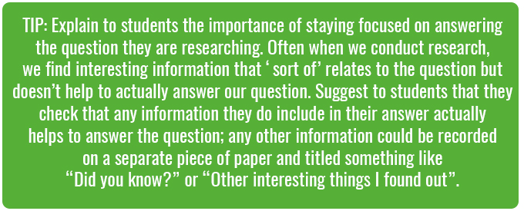
Step 4. Once students are finished their research, invite them to share the answers to their questions by creating a ‘wonder wall’ of questions and answers. If students have found extra information through their research that they think is interesting or important they could include this in the wonder wall as well.
Invite each student to present the information they found in response to the question they were given. You could also invite the authors of each question to identify themselves if they wish.
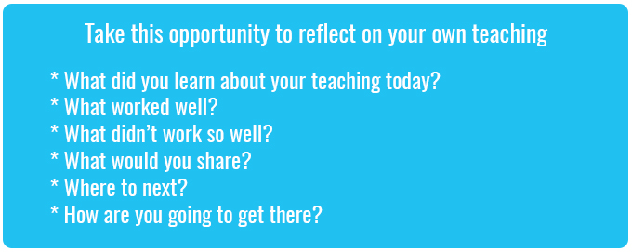

Part C: Beyond the Science
Step 1. Now read the following information to students (also available on the Student Worksheet):
The renewable energy solutions you have just looked at have been developed as a way to find more sustainable forms of energy, particularly in terms of environmental sustainability. From the time of the Industrial Revolution, most energy generation relied on fossil fuels (fossil fuels are natural fuels that were formed in the geological past from the remains of living organisms). The role that energy generation from fossil fuels has played in our modern lives should not be understated; almost all of the things we do and use have their roots in energy sourced from fossil fuels. The problem is, burning fossil fuels to power our modern lives has a range of environmental impacts, including creating greenhouse gases that contribute to climate change, and the pollution of and disruption to both terrestrial and aquatic environments. Most forms of renewable energy generally have a much lower environmental impact.
Science has had a crucial role to play in helping us to understand the environmental impacts of our energy use as well as identifying and developing alternative solutions. But these solutions rely on people like us to take them up. In the next part of this lesson you will be looking at some of these solutions.
Step 2. Students will now watch a clip from the 2040 documentary that describes a renewable energy solution involving a community:
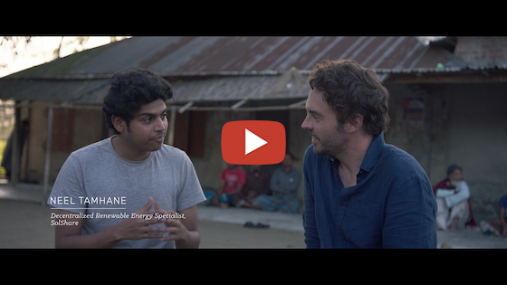
2040 – Decentralised Energy
Password: 2040_EDU
(https://vimeo.com/showcase/6167669/video/336499398)
Once complete, invite students to share their thoughts on the following:
- What did you find interesting or inspiring about this clip?
- How do you think science has influenced the decisions about energy sources in this case study?
- How does this case study demonstrate the importance of community in energy choices?
- What questions does this clip leave you with?
Step 3. Now explain to students that they will work in groups to research and present other community renewable energy projects from around Australia and the world.
Break the class into groups of 3 or 4 students. Direct students to the following examples (also available on the Student Worksheet):
- Open District Heating
- Solar gardens
- Hepburn Wind
Each group needs to research and compare these three examples, recording their results in a table like the one below (students can use the table available on the Student Worksheet):
 | Open District Heating | Solar gardens | Hepburn Wind
Is the source of energy in this case study renewable?
What information can you find about the science involved in this case study?
How are the community involved in this project?
What do you find interesting or inspiring about this case study?
Allow groups time to research these case studies and record their responses in the table.
Step 4. Once complete, invite students to share their responses with the class through a class discussion. Through your discussion suggest students return to the wonder wall and invite them to think about what information on the wall can help them understand these case studies further, or what new questions they would like to add to this wall.
Extend: If time permits you could invite students to work collaboratively to come up with their own renewable energy solution. The solution could be for their community based on local conditions (e.g. if students live near the sea it could be a hydropower project, or if many students live in apartments it could be something suited to apartment living. Students will need to explain why they think this solution will work and produce a drawing or short report that describes their idea.

Reflection
Invite students to work independently to answer the following (also available on the Student Worksheet):
- What I used to think…
- What I now think…

Take It Further
To expand on student’s learning in this lesson, consider following up with this lesson; 2040 Vision For Your Community.

Teacher Reflection

What’s Your 2040?
Record your students’ work in their communities with the hashtag #whatsyour2040 and share their visions in the ‘2040: The Regeneration’ Facebook Group.
The 2040 crew would love to see your class’ work.

