Seaweed In The Food Chain Science Year 7 Student Worksheet

Thought Starter: What do food webs have to do with sustainability?

Preparation – Flipped classroom
In preparation for the lesson on food chains and food webs, you need to watch the following two clips (in order) and answer the related questions (below):
Clip 1 – Fabulous Food Chains
Clip 2 – Home Sweet Habitat
Questions:
1. In your own words, describe a food chain.

2. In your own words, describe a food web.

3. What is the original source of all the energy in a food chain/web and why?

4. What is at the bottom of an Arctic food web and how would you describe them?

5. Why do you think we need food web models?

6. Where does our understanding of ecosystems fit with our understanding of food chains?

7. What vocabulary presented in these clips was new to you?

8. What information presented in these clips are you unclear about? What would you like to know more about?

9. Bonus question: How might studying food webs help us to understand some of the ways we can look after ecosystems?

Marine Food Webs
Take a look at these organisms that you might find in a marine habitat. Think about what these organisms might consume and add arrows to complete the flows of energy in this food web. TIP: Remember that the arrows in the food web need to indicate the direction of energy flow.
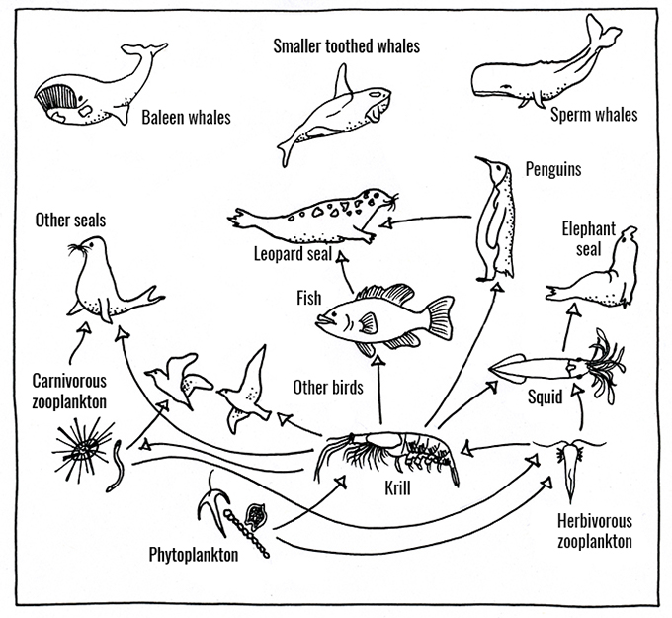

Reflection
Work independently to think about and respond to the following question:
How does thinking about ecosystems in terms of food webs and food chains help you understand how we can care for these ecosystems?

Provide an example.

