Seaweed In The Food Chain Science Year 7 Teacher Worksheet

Teacher preparation
Learning intentions: Students will …
- … understand what a food chain is and what a food web is
- … understand how marine food webs are vulnerable to human activities
- … understand actions that humans can take to improve marine food webs and habitats
Success criteria: Students can …
- … complete a flipped classroom activity in their own time
- … participate in class and group discussions
- … work independently and collaboratively
- … undertake research
- … create an infographic or poster
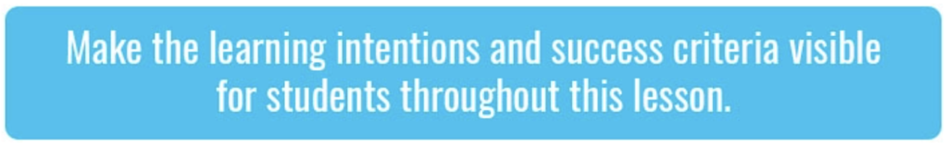
Teacher content information: A 2018 study by The University of Melbourne on the thoughts and concerns of young people from Generations X and Y found the number one concern across both groups was lack of action around climate change. In particular, “Generation X worries what climate change will mean for their own children, while Generation Y is concerned about the impact on future generations” (The Educator). The report indicates that young people have a serious mistrust in the Government’s ability or willingness to tackle climate change.
Tackling climate change requires large-scale, systemic changes across all aspects of society. Simply aiming to reduce our C0₂ emissions is not enough: we need to rapidly decarbonise our planet. While this might sound challenging, the good news is we already have the knowledge and tools to do it.
2040 is an innovative feature documentary that looks to the future while focusing on what is happening now. Award-winning director Damon Gameau (director of That Sugar Film) embarks on a journey to explore what the future could look like by the year 2040 if we simply embraced the best solutions already available to us to improve our planet and shifted them into the mainstream.
The film will demonstrate to your students that we already have the solutions to climate change; we just need to take action to bring them rapidly into the mainstream. The 2040 documentary and curriculum package will support your students in turning this knowledge into positive action for a better future.
Find out how to see the film here. 2040 will only be available in cinemas for the first part of 2019 and you can make a group booking for your class at your local cinema during the film’s theatrical release which starts on May 23. These lessons have been designed with a media library to support teachers. The film will be available on video-on-demand and DVD later in 2019.
The film is the entry point to a global impact campaign that seeks to mobilise audiences to learn about, contribute to, advocate for and invest in regenerative solutions that improve the wellbeing of the planet, all people and all living systems.
To join the Regeneration and share your vision for 2040, see the website.
Watch the 2040 trailer:
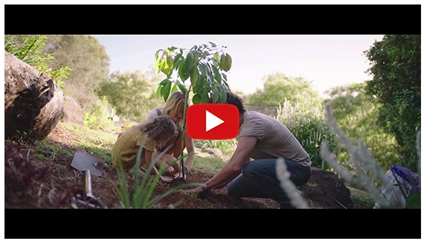
Cool Australia, GoodThing Productions and Regen Pictures would like to acknowledge the generous contributions of Good Pitch Australia, Shark Island Institute, Documentary Australia Foundation, The Caledonia Foundation, Global Health Film and our philanthropic partners in the development of these teaching resources.

Teaching sequence
Work through this resource material in the following sequence:
20 minutes – Preparation – Flipped classroom
10 minutes – Part A: Activating Prior Knowledge
15 minutes – Part B: Marine Food Webs
10 minutes – Part C: Collapsing Food Webs
30 minutes – Part D: Seaweed Solutions
5 minutes – Reflection

Preparation – Flipped classroom
Hot tip: If your class are already familiar with food web and food chains, you may choose to skip straight to Part B and allow students to spend even more time on their solutions!
Prior to participating in this lesson, students should complete the following flipped classroom activity. Students should watch the following two clips (in this order) and answer the related questions (also available on the Student Worksheet):
Clip 1 – Fabulous Food Chains
Clip 2 – Home Sweet Habitat
Questions:
- In your own words, describe a food chain.
- In your own words, describe a food web.
- What is the original source of all the energy in a food chain/web and why?
- What is at the bottom of an Arctic food web and how would you describe them?
- Why do you think we need food web models?
- Where does our understanding of ecosystems fit with our understanding of food chains?
- What vocabulary presented in these clips was new to you?
- What information presented in these clips are you unclear about? What would you like to know more about?
- Bonus question: How might studying food webs help us to understand some of the ways we can look after ecosystems?

Part A: Activating Prior Knowledge
Step 1. Begin this lesson by inviting students to share their thoughts in response to the two clips they watched and their answers to the associated questions. Explain to students that they will be using the concepts presented in these clips in this lesson, so encourage students to share when they need more information or when they are unclear about something. Below are some suggested answers to the questions they were given:
- In your own words, describe a food chain.
Suggested answer: A food chain is a model that shows how energy flows between living things in an ecosystem. Energy in a food chain starts with the sun whose rays are converted into chemical energy by plants. The energy is then transferred up the food chain when animals eat the plants and bigger animals eat those animals.
- In your own words, describe a food web.
Suggested answer: A food web is a representation of how organisms within an ecosystem receive and transfer energy. It is a more complex representation as it shows a range of living things and how they all interact with one another.
- What is the original source of all the energy in a food chain/web and why?
Suggested answer: Plants take the energy from the sun’s rays and convert it into chemical energy, such as Carbon Dioxide, water, light, sugar and oxygen.
- What is at the bottom of an Arctic food web and how would you describe them?
Suggested answer: Phytoplankton. Some are bacteria, some are protists, and most are usually single-celled plants.
- Why do you think we need food web models?
Suggested answer: Many animals within an ecosystem have multiple sources of food which may also be food sources for other animals. Food chain models are a linear representation of the flow of energy and so are limited in terms of understanding ecosystems; food web can show complexity around the flow of energy and can help us to better understand the ecosystem as a whole.
- Where does our understanding of ecosystems fit with our understanding of food chains?
Suggested answer: All living things in a habitat interact with other living and non-living things in that area, forming a system called an ecosystem. Food chains help us to understand what eats what in an ecosystem and how energy flows within an ecosystem.
- What vocabulary presented in these clips was new to you?
- What information presented in these clips are you unclear about? What would you like to know more about?
- Bonus question: How might studying food webs help us to understand some of the ways we can look after ecosystems?
Suggested answer: By studying food webs we can understand where ecosystems might be vulnerable to things like pollution or climatic changes. This means we can take action to protect the vulnerable elements of that ecosystem.
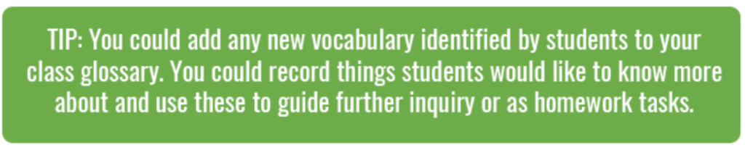
The following factsheets may also be useful here:
- Food chains and food webs
- Trophic levels

Part B: Marine Food Webs
Step 1. Explain to students that there are many different ecosystems that could be used to demonstrate food chains and food webs. In this lesson, they will be focusing on marine ecosystems.
Share the following image with students, explaining that it shows some of the organisms you might find in a marine food web (image also available on the Student Worksheet):
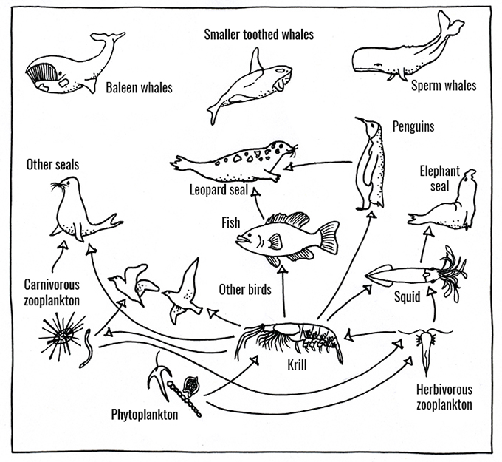
Working in pairs or as a class, invite students to add arrows to complete the flows of energy in this food web.
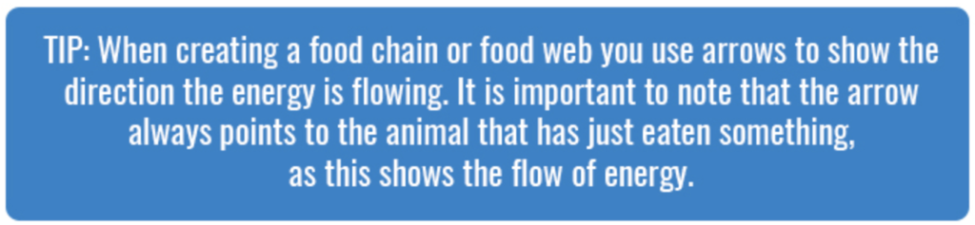
Once complete, share the following image with students, and take some time to discuss and compare student work with the answers below:
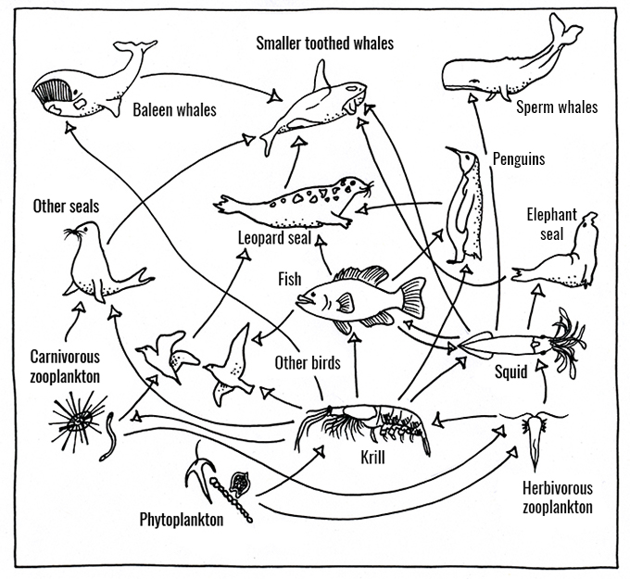
Through your discussion, invite students to suggest which organisms they believe are:
- At the top of the food web
- At the bottom of their food web.
Suggest to students that those organisms at the top of the food web are those that are not consumed by any other organisms. Those at the top are called ‘top consumers’. The organisms at the bottom of the food web are those that get their energy from the sun, not from other organisms. Those at the bottom of the food web are called ‘primary producers’.
Step 2. Project the following image, explaining that it describes the trophic levels present in food webs. A trophic level refers to the position an organism occupies in the food chain. For example, a primary producer – such as a plant – is at the bottom of the food chain. A carnivore is at the top of the food chain.
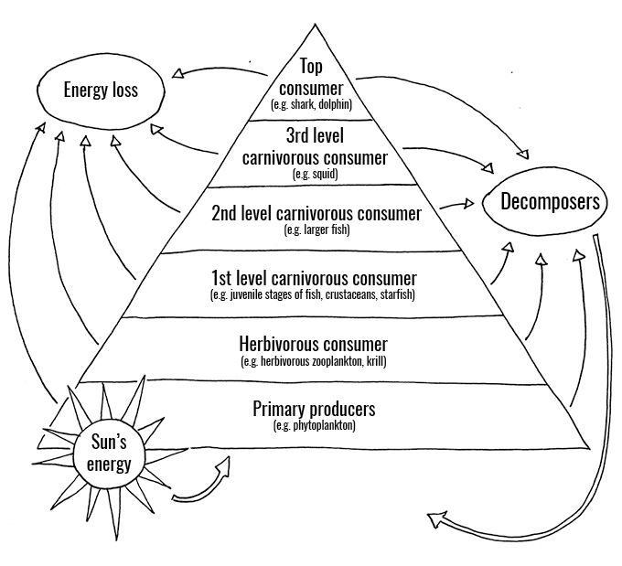
Invite students to work as a class to discuss this image.
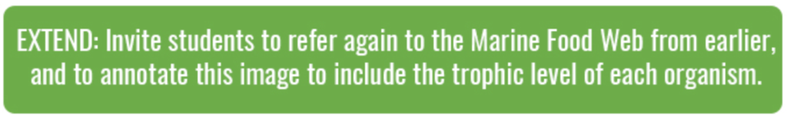

Part C: Collapsing Food Webs
Step 1. Explain to students that they will now explore the importance of the different organisms in the food chain.
Break the class into pairs and give each pair a copy of this worksheet, Marine food webs activity. Students should work in their pairs to (following instructions also available on the Marine Food Webs activity sheet):
- Cut out each of the organisms at the bottom of this sheet.
- Try to match the organisms to their position on the blank food web below. Glue or tape the organisms in place.
- Once complete, students should work in their pairs to discuss and record their responses to the following questions:
• What do you think might happen if the smaller toothed whales in this food web went extinct? How would the food web respond? Explain your answer:
• What do you think might happen if fish stocks plummeted drastically? How would the food web respond? Explain your answer:
• What would happen if algae were removed from this food web? How would the food web respond? Explain your answer:
• Based on your answers, which scenario do you think would have the biggest impact? Would it be worse if a producer or consumer disappeared?
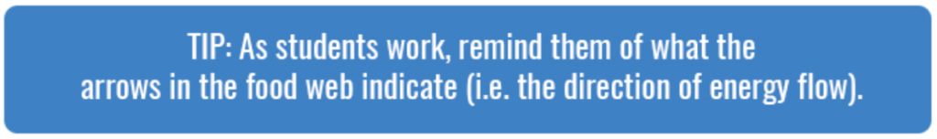
Once complete, invite pairs to share the answers to these questions with the class. The aim of this activity is to demonstrate the importance of those organisms at the bottom of the food web: without primary producers like algae and zooplankton, we would probably see animals higher up the food chain disappear.

Part D: Seaweed Solutions
Step 1. Now explain to students that marine ecosystems are increasingly under pressure from human activities, such as:
- Rising ocean temperatures – Global warming is causing temperatures to rise in the oceans.
- Ocean acidification – Human activities cause more greenhouse gases to be released into our atmosphere. One of these greenhouse gases is CO₂. Oceans absorb CO₂, causing a change in the chemical composition of the oceans. Our oceans are becoming more acidic, resulting in changes to shellfish and coral reefs. Find out more about ocean acidification here: Ocean Acidification Factsheet.
- Pollution – There are several different types of pollution that affect marine environments, including chemical pollution, plastic waste, and sediments that wash into coastal environments from terrestrial activities.
- Over-fishing – Over-fishing affects marine environments in many ways, including by removing important parts of the food chain.
NOTE: Further information about some of the human activities that can cause these issues can be found in this lesson.
However, there are some human activities that could help to improve ocean health by supplementing the bottom of marine food chains. In addition, this activity could also help humans. Explain to students that they will now watch a clip from the 2040 documentary that describes seaweed farming and the benefits to humans and our environment.
Before you watch this clip, invite students to share what they already know about seaweed. You can then explain the following:
- Seaweeds are actually algae. The term seaweed refers to several groups of multicellular algae, including red algae, green algae, and brown algae.
- Some seaweed species – such as kelp – provide essential nursery habitats for many marine species including juvenile fish and marine mammals.
- Some seaweed species are important food sources for marine animals.
- Seaweeds have two specific requirements in terms of growth;
• They need seawater (or at least brackish water) and
• They need sunlight to drive photosynthesis. Many also require a firm attachment point (like a rock) although there are some species that float freely.
- Ocean algae (from seaweeds to planktons) produce up to 90 percent of our Earth’s oxygen.
- Some species of kelp grow as much as 60cm per day and may grow to be as tall as 45 metres.
Step 2. Now watch the following clip with students. As they watch, invite students to record anything that they think relates to food chains and food webs. In addition, students should be encouraged to record anything they find interesting or important:
2040 – Seaweed as Food Password: 2040_EDU (https://vimeo.com/showcase/6167669/video/304290496)
Once complete, invite students to share their thoughts about this clip through class discussion. Consider some of the following questions in your discussion:
- What is this clip about? What happened in this clip?
- How does this clip relate to marine food chains and food webs?
- How do you think marine aquaculture and seaweed farming could help marine health?
- What did you find interesting or important about this clip?
- What would you like to know more about?
- What other actions do you think humans could take to improve marine environments, and in particular, marine food webs?
Explain to students that in the final activity they will focus on this last question.
Step 3. Invite students to work in groups to undertake research and find out what other actions humans can take to improve the health of marine environments and how these actions might benefit marine food webs. Students could create:
- A scientific poster
- An infographic – this website may be useful in creating an infographic
Students could focus on particular species, explaining what actions can be taken to improve habitat health and numbers for this species, and then describing how improving habitat health for this species will benefit other organisms in this food chain. Alternatively, students could focus on habitats – such as coastal or coral reef – and explain how improving these habitats will benefit food chains within these habitats.
Step 4. Invite students to share their work through a gallery walk:
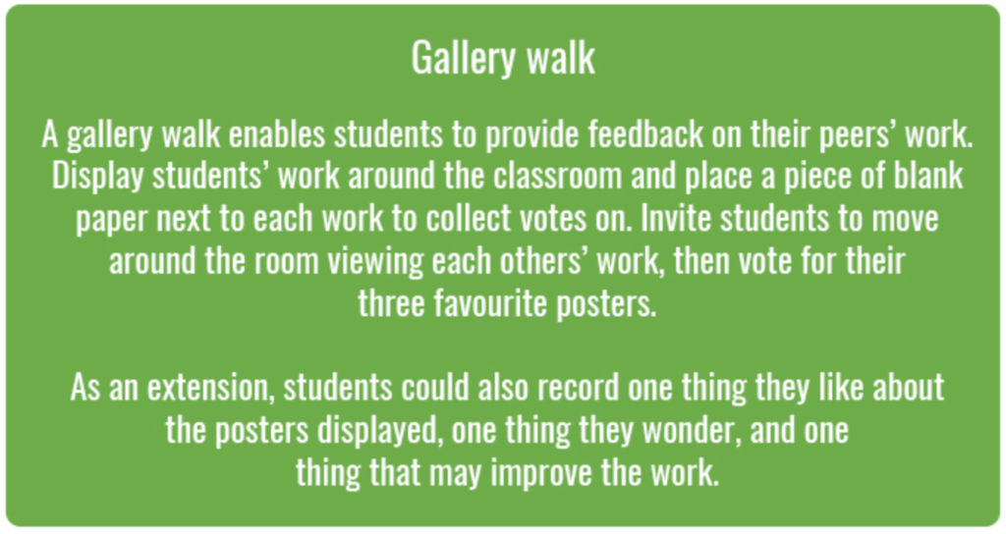

Reflection
Invite students to work independently to respond to the following question (also available on the Student Worksheet):
- How does thinking about ecosystems in terms of food webs and food chains help you understand how we can care for these ecosystems? Provide an example.

Take It Further
To expand on student’s learning in this activity, consider following up with this lesson; 2040 Vision For Your Community.

Teacher Reflection
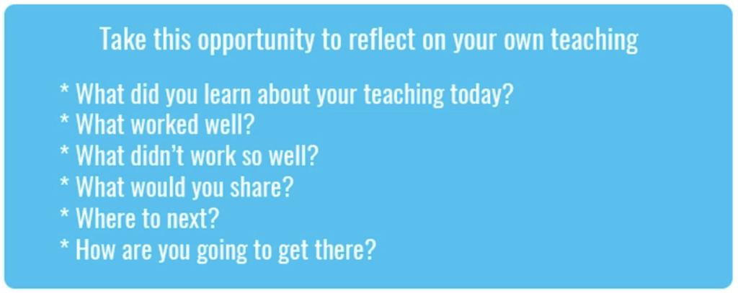

What’s Your 2040?
Record your students’ work in their communities with the hashtag #whatsyour2040 and share their visions in the ‘2040: The Regeneration’ Facebook Group.
The 2040 crew would love to see your class’ work.

