Solutions To Climate Change Science Year 10 Teacher Worksheet

Teacher preparation
Learning intentions: Students will…
- … understand key terms and processes relating to climate change
- … understand that the actions we can take for meeting the challenges of climate change broadly fall into two categories: actions for reducing carbon production and carbon sequestration
- … understand some of the natural solutions to climate change
Success criteria: Students can…
- … work independently and collaboratively
- … participate in class and group discussion
- … undertake research
- … complete a SWOT analysis

Teacher content information: A 2018 study by The University of Melbourne on the thoughts and concerns of young people from Generations X and Y found the number one concern across both groups was lack of action around climate change. In particular, “Generation X worries what climate change will mean for their own children, while Generation Y is concerned about the impact on future generations” (The Educator). The report indicates that young people have a serious mistrust in the Government’s ability or willingness to tackle climate change.
Tackling climate change requires large-scale, systemic changes across all aspects of society. Simply aiming to reduce our CO₂ emissions is not enough: we need to rapidly decarbonise our planet. While this might sound challenging, the good news is we already have the knowledge and tools to do it.
2040 is an innovative feature documentary that looks to the future, while focusing on what is happening now. Award-winning director Damon Gameau (director of That Sugar Film) embarks on a journey to explore what the future could look like by the year 2040 if we simply embraced the best solutions already available to us to improve our planet and shifted them into the mainstream.
The film will demonstrate to your students that we already have the solutions to climate change; we just need to take action to bring them rapidly into the mainstream. The 2040 documentary and curriculum package will support your students in turning this knowledge into positive action for a better future.
Find out how to see the film here. 2040 will only be available in cinemas for the first part of 2019 and you can make a group booking for your class at your local cinema during the film’s theatrical release which starts on May 23. These lessons have been designed with a media library to support teachers. The film will be available on video-on-demand and DVD later in 2019.
The film is the entry point to a global impact campaign that seeks to mobilise audiences to learn about, contribute to, advocate for and invest in regenerative solutions that improve the wellbeing of the planet, all people and all living systems.
To join the Regeneration and share your vision for 2040, see the website.
Watch the 2040 trailer:
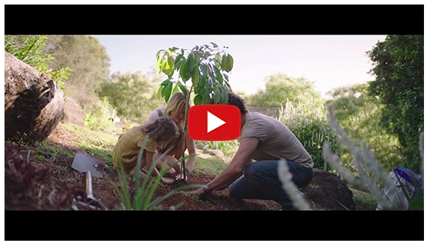
https://youtu.be/sR51ZDNSRFQ
Cool Australia, GoodThing Productions and Regen Pictures would like to acknowledge the generous contributions of Good Pitch Australia, Shark Island Institute, Documentary Australia Foundation, The Caledonia Foundation and our philanthropic partners in the development of these teaching resources.

Teaching sequence
Work through this resource material in the following sequence:
15 minutes – Part A: Activating Prior Knowledge
25 minutes – Part B: Actions for Meeting the Challenge of Climate Change
20+ minutes – Part C: Solutions to Climate Change
30+ minutes – Part D: Debate
5 minutes – Reflection

Part A: Activating Prior Knowledge
Step 1. Begin this lesson by explaining to students that they will watch a clip about climate change from the 2040 documentary and participate in a guided discussion around this clip, using the suggested timings below.

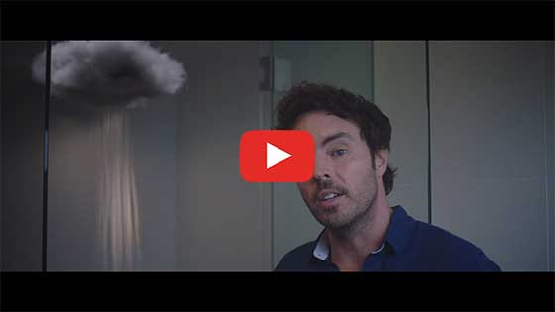
2040 – Global Challenges
Password: 2040_EDU
(https://vimeo.com/showcase/6167669/video/336498352)
Suggested timings:
- 0:14 – What do you already know about the carbon cycle? And what is carbon?
Suggested answers: Carbon is a chemical element. All living things are made of carbon, and it is also a part of the ocean, air, and even rocks. The carbon cycle is the cycle by which carbon is exchanged among the biosphere, pedosphere, lithosphere, hydrosphere, and atmosphere of the Earth.
- 0:33 – What human activities have contributed the most carbon to our atmosphere?
Suggested answers: Burning fossil fuels for energy (including for transport), landscape changes including farming and land clearing.
- 0:49 – Do you know what ‘parts per million’ in reference to our atmosphere might mean?
Suggested answer: When talking about CO₂ and parts per million (ppm), the number per million tells how many parts of CO₂ there are in one million parts of air. So, if carbon dioxide is at 380 ppm, that means in one million particles of air there are 380 particles of CO₂.
- 1:00 – What process is Damon describing here when he talks about heat being trapped in our atmosphere?
Suggested answer: The greenhouse effect. What do you already know about the greenhouse effect? Clarify with students that the greenhouse effect has been around since the formation of the planet. Naturally occurring gases – such as methane and carbon dioxide – form a blanket around the Earth, trapping heat from the sun in our atmosphere and keeping the Earth at a steady temperature where life can thrive. However, in recent years human activities – such as burning fossil fuels and deforestation – have seen an increase in the amounts of these heat- trapping gases (greenhouse gases) entering the atmosphere. This has meant that more heat from the sun is being trapped in our atmosphere. This is the greenhouse effect.
- 1:46 – What process is Damon referring to here?
Suggested answer: Climate change. What do you already know about climate change? Clarify with students that climate change is a change in the pattern of weather, and related changes in oceans, land surfaces and ice sheets, occurring over time scales of decades or longer.
- 2:30 – What do you already know about reducing emissions? What actions can we take?
Suggested answers: Use renewable energy (such as wind or solar), choose more sustainable forms of transport like public transport, ride-sharing, cycling or walking and try to stick to a plant-based diet.
- 2:42 – What do you think ‘sequestering carbon’ might look like?
Suggested answers: Carbon sequestration is a natural or artificial process where carbon dioxide is removed from the atmosphere and held in solid (such as plants or soil) or liquid form (such as the ocean).
Once complete, invite students to share any other thoughts or concerns they have about this clip and take a moment to clarify any points of confusion. Further information about climate change can be found here: Bill Nye Climate 101, Climate Council, Department of Environment and Energy and Climate Change Factsheet.

Part B: Actions for Meeting the Challenge of Climate Change
Step 1. Explain to students that there are many actions that we can take to help meet the challenges of climate change. Invite students to spend one or two minutes suggesting any personal actions that we can take and record these on the board. Leave these up for a later activity. Suggested actions could include:
- Saving energy (e.g. switching off the lights, putting on a jumper instead of the heater.)
- Eating less meat
- Using energy-efficient transport options like bike riding, public transport, etc.
- Planting trees
- Buying and wasting less
Once complete, explain to students that most of the actions that we can take fall into one of two categories:
- Actions to reduce carbon entering into our atmosphere
- Actions to sequester carbon.
In the next part of this lesson, students will explore these in more detail.

Step 2. Distribute a copy of the Student Worksheet to each student and invite them to navigate to the first activity, Actions for Meeting the Challenge of Climate Change.
Using a THINK PAIR SHARE activity invite students to create definitions for the following two actions:

- Reducing carbon production
Suggested definition – Taking action to reduce the amount of carbon (CO₂) you produce.
- Carbon sequestration
Suggested definition – Carbon sequestration is a natural or artificial process where carbon dioxide is removed from the atmosphere and held in solid (such as plants or soil) or liquid form (such as the ocean).
Once complete, invite students to share their thoughts with the class. Use the definitions above to clarify students’ understandings of these actions.
Step 3. Now, explain to students that they will watch two clips from the 2040 documentary; the first clip will show how carbon reduction activities can help us address climate change. The second clip describes the benefits of carbon sequestration.
- Option A. You could divide the class into an equal number of groups and assign each group with either a number 1 or number 2. All number 1 groups could watch the carbon reduction clip and all number 2 groups could watch the carbon sequestration clip. Once complete, each number 1 group needs to team up with a number 2 group. Groups can then share what they learned about the action they looked at.
- Option B. Alternatively, you could watch the clips as a class and reflect on the clips using the following questions:
  - What is this clip about?
  - What action does this clip describe?
  - What are the benefits of this action as described in the clip?
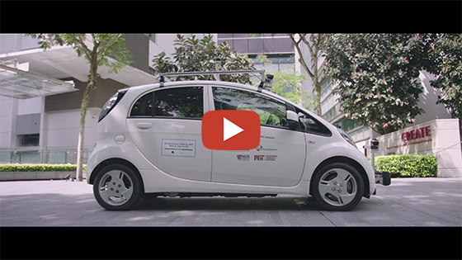
2040 – Transport Case Study
Password: 2040_EDU
(https://vimeo.com/showcase/6167669/video/336509114)
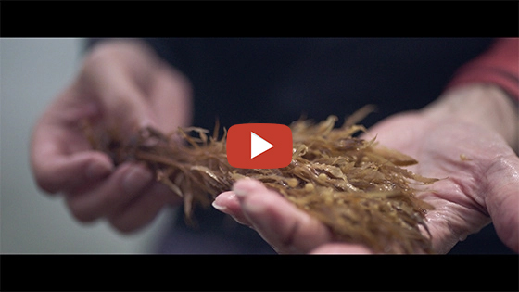
2040 – Seaweed as Food
Password: 2040_EDU
(https://vimeo.com/showcase/6167669/video/304290496)
Through this process ensure that students understand the following: successfully meeting the challenges of climate changes relies on both of these actions. We need to reduce CO₂ emissions as well as try to remove as much carbon as possible to slow the process and impacts of climate change.
Step 4. Now return to the personal actions on the board. Take a minute or two to categorise these actions as being either carbon reduction or carbon sequestration.

Part C: Solutions to Climate Change
Step 1. Invite students to respond to the following provocative statements by giving a thumbs up if they agree or a thumbs down if they disagree. If students are unsure they could also give a side thumb; there are many factors to consider with these questions and the answers are rarely black and white.
- “We are in control of the Earth”
- “Technology will solve climate change”
- “Humans should never interfere with Nature”
- “Nature has everything she needs to meet the challenges of climate change”
If students are willing, invite them to share the reasons for their responses with the class.
Step 2. Now, explain to students that the threat of climate change has meant that some people are thinking of highly creative ways of meeting the challenge of climate change. These loosely fall into two categories:
- Technological solutions – These are solutions that require human-engineered technologies to remove carbon and reduce global heating. These solutions are often described as ‘Geoengineering’ and come with a lot of feasibility questions and ethical considerations.
- Natural solutions – These are solutions that require us to work with nature, using existing resources and natural processes to sequester carbon… ‘Natural climate solutions can help address climate change in three ways:
  - Reducing greenhouse gas emissions, such as carbon dioxide (CO₂), related to land use and changes in land use
  - Capturing and storing additional carbon dioxide from the atmosphere
  - Improving resilience of ecosystems, thereby helping communities adapt to the increase in flooding and dry spells associated with climate change.’ (Source)
Explain to students that in this lesson they will focus on natural solutions as these are solutions that currently exist and that have been tested.
TIP: If students are interested in finding out more about the technological solutions, you could give them this factsheet: Geoengineering Factsheet. You could invite students to research these solutions in more detail – including any ethical considerations relating to these solutions – before participating in a debate using the Debate Guidelines.
Step 3. Share the following clip with students:
How nature can save us from climate breakdown
(https://youtu.be/J9mjbzqqA_M)
Once complete, invite them to suggest what they thought was interesting or important about this clip, before explaining that they will now explore some of these natural solutions to climate change in more detail. The solutions they will be exploring include (articles and sources to share with students included):
- Reforestation
- Avoided Deforestation
- Coastal Restoration
- Regenerative Agriculture
- Marine Permaculture
- Biochar
- Rewilding
TIP: You may wish to share with students that natural solutions can be broken down into three categories; what we can do on forest land, agricultural land, and in and around coastlines and marine environments.

Students will be reading about and analysing these solutions:
- Option A. If time allows, students could work in pairs or small groups to undertake their own research to find and analyse one or more articles about each of these natural solutions. They could then use the questions below to guide their analysis. They could then work in pairs or as a class to share the results of their research and analysis. Alternatively, each group could read and analyse all the solutions using the articles available below.
- Option B. Give each student a number from 1 to 7. Distribute copies of the natural solution articles (available below), ensuring that students assigned with the number 1 are given article 1, students assigned with the number 2 are given article 2, students assigned with the number 3 are given article 3, etc. Students read their article and analyse it using the questions below. They could then form new groups containing a student of each number (1 to 7) to share what the articles were about and what they thought and felt about the articles.
The following resources have been provided to support students in their research (also available on the Student Worksheet):
- Reforestation – Article: Massive restoration of world’s forests would cancel out a decade of CO₂ emissions, analysis suggests
- Avoided Deforestation – Book extract: Halting deforestation is essential for climate stability
- Coastal Restoration – Article: The ocean and climate change
- Regenerative Agriculture – Article: Look after the soil, save the Earth: farming in Australia’s unrelenting climate and 2040: Regenerative Agriculture
- Marine Permaculture – Article: How farming giant seaweed can feed fish and fix the climate and 2040: Marine Permaculture
- Biochar – Article: Biochar
- Rewilding – Article: In-depth: Could ‘rewilding’ help to tackle climate change?
Questions to guide article analysis and reflection (also available on the Student Worksheet):
- What points about the solution do you think are interesting, important or promising?
- What points do you think are problematic or challenging?
- What do you think is the role of science in making decisions about climate change solutions?
- What do you think about the natural solution you looked at as a solution for climate change?
- What questions do you have about this solution?

Step 4. Now invite each group to conduct a SWOT analysis of at least one of the natural solutions to climate change that they explored. Students can use this template: SWOT Analysis Template.

Once complete, each group should share their ideas with the class through a class discussion. Pose one of the following questions to students:
- Which solution to climate change inspires (or interests) you the most and why?
- What solution would contribute best to your community and why?
- Would any of these solutions be suitable for the area and community that you live in?
Step 5. You could then return to the following statements used at the start of this section:
- “We are in control of the Earth”
- “Technology will solve climate change”
- “Humans should never interfere with Nature”
- “Nature has everything she needs to meet the challenges of climate change”
Invite students to suggest if and how their thinking has changed in response to these statements.

Reflection
Invite students to complete the CONNECT EXTEND CHALLENGE thinking routine on the Student Worksheet.

Take It Further
To expand on student’s learning in this activity, consider following up with this lesson; 2040 Vision For Your Community.

Teacher Reflection



What’s Your 2040?
Record your students’ work in their communities with the hashtag #whatsyour2040 and share their visions in the ‘2040: The Regeneration’ Facebook Group.
The 2040 crew would love to see your class’ work.

