Sustainable Transport and Scatter Plots Math High School Teacher Worksheet
Teacher Preparation
Learning Objectives Students will…
- … be able to investigate statistics and examine their meaning/relevance
- … be able to construct scatter plots and examine and comment upon the relationships between variables
Goals For Learning: Students can…
- … construct scatter plots from data tables
- … examine scatter plots and comment upon the relationships between variables
- … create a visual product that uses statistics and scatter plots to persuade an audience to change their behaviour
Make the learning goals and objectives visible for students throughout this lesson.
Tackling climate change requires large-scale, systemic changes across all aspects of society. Simply aiming to reduce our C02 emissions is not enough: we need to rapidly decarbonise our planet. While this might sound challenging, the good news is we already have the knowledge and tools to do it.
2040 is an innovative feature documentary that looks to the future, while focusing on what is happening now. Award-winning director Damon Gameau (director of That Sugar Film) embarks on a journey to explore what the future could look like by the year 2040 if we simply embraced the best solutions already available to us to improve our planet and shifted them into the mainstream.
The film will demonstrate to your students that we already have the solutions to climate change; we just need to take action to bring them rapidly into the mainstream. The 2040 documentary and curriculum package will support your students in turning this knowledge into positive action for a better future.
Find out how to see the film here. 2040 launched in cinemas in Nov 2019 and is now available for booking for your school. These lessons have been designed with a media library to support teachers. The film is available on video-on-demand and DVD for individual viewing.
The film is the entry point to a global impact campaign that seeks to mobilize audiences to learn about, contribute to, advocate for, and invest in regenerative solutions that improve the wellbeing of the planet, all people and all living systems. To join the Regeneration and share your vision for 2040, see the website.
Watch the 2040 trailer:
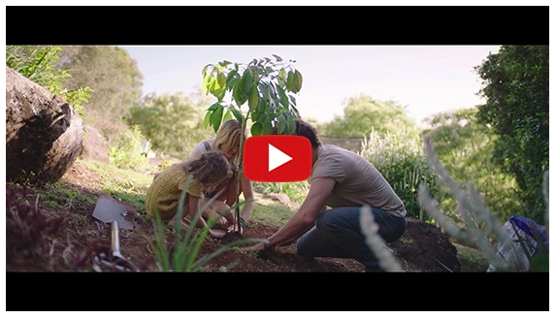
https://youtu.be/sR51ZDNSRFQ
On the issue of transport: “Transport produces 7 gigatons of carbon dioxide-equivalent greenhouse gas emissions annually, or 23 percent of energy-related emissions, which is around 14 percent of all emissions… Transport, however, is a service derived from economic growth. We find that wealthier people travel more, locally and internationally, and demand more goods and services. So, as a country develops economically, the movement of people and goods increases…
Some transport can only currently be made more efficient at using existing fossil fuels; others, however, do have alternative fuels, such as electricity for cars instead of gasoline… Other modes of transport can be avoided completely using information and communication technologies.”
Some of the most effective solutions for reducing emissions in the transport sector include:
- Using improved technologies to develop more fuel-efficient aircraft
- Increased use of hybrid cars
- Increased use of electric bikes instead of cars
- Increased ride-sharing when commuting
- Using improved technologies to develop more fuel-efficient ships
- Replacing flying for business with telepresence technologies
- Increasing the use of electric trains for freight
- Increasing the use of fuel reduction technologies for trucks
(Source: https://www.drawdown.org/solutions/transport)
Teaching Sequence
Work through this resource material in the following sequence:
25 minutes – Part A: Introduction to Climate Change and Transport
25 minutes – Part B: Your Household’s Transport
45 minutes – Part C: Statistics, Population, and Transport
75 minutes – Part D: Take Action
10 minutes – Reflection

📚Part A: Introduction to Climate Change and Transport
Step 1. This lesson looks at innovative ways of changing our consumer habits to reduce climate change. Before conducting this lesson it is a good idea to get an understanding of your class’s understanding of climate change. To begin, you might like to conduct a HEADS and TAILS activity (instruction in the green box below) using the following questions:
- Carbon dioxide is a naturally occurring gas in the atmosphere. (TRUE)
- Climate describes extreme weather events. (FALSE) Climate is the long-term changes in patterns of weather over a long period of time, such as 20 years.
- Burning fossil fuels contributes to excessive amounts of carbon dioxide in the air, which traps heat in the atmosphere. (TRUE)
- Global warming is completely out of our control. (FALSE) Humans can take action to slow global warming and can also sequester carbon dioxide out of the atmosphere by planting trees, plants, and seaweed. (See www.drawdown.org)
- There is no evidence that humans have caused climate change. (FALSE) Variations in climate have been proven to have significantly increased since the industrial revolution (which jump started the increased burning of fossil fuels: for example, the mass manufacturing of cars). There is a direct link between the serious increase in climate and human behavior/population – this has become most noticeable over the past 200 years. (See www.temperaturerecord.organd www.drawdown.org)
- Changing our transport habits can make a significant difference in reducing climate emissions. (TRUE)
HEADS and TAILS
HEADS and TAILS is a basic true or false activity.
Students stand, and when asked questions, they respond by putting both hands on their head for TRUE or both hands on their hips for FALSE. If they are unsure, they can put one hand on each.
For extra fun, (and challenge) you can run this as an elimination game.
If you notice that your students need a refresher on climate change, you can show them this informative Climate Change clip from 2040 (Password: 2040_EDU https://vimeo.com/showcase/6167669/video/336498352). Alternatively, you could distribute copies of the Climate Change Factsheet to students.
Step 2. Invite students to form pairs and use an internet enabled device to find one example of how statistics can be used to communicate a message and persuade/influence the reader/viewer.
Hint: Inform students to use Google Images and use search terms such as “infographics statistics” and “using statistics in advertising”.
Step 3. Invite some students to share their findings and explain how they think what they have found uses numbers to persuade or influence. You may wish to refer to https://thevisualcommunicationguy.com/2017/10/06/statistics-appeal-advertising/ to support facilitation of this activity.
Step 4. Explain that, soon, you will be playing a clip for the documentary 2040. Then, distribute the Student Worksheet to each student and explain that they will be writing any comments or thoughts they have on the clip using the SEE, THINK, WONDER table. Ask students to especially take note of any figures or statistics they notice.
SEE – THINK – WONDER
SEE – What did you SEE in this clip?
THINK – What did you HEAR in this clip?
WONDER – What does this clip make your WONDER about?

Step 5. Relate to students that the following clip is part of a larger documentary and is the narrator’s vision for transportation in the year 2040 based on research he has done around existing innovative technologies. He is predicting what might happen if we brought these technologies into the mainstream.
Now, view the 2040 transport clip:
2040 – Car of the Future Password 2040_EDU (https://vimeo.com/showcase/6167669/video/336510915)
Step 6. Invite students to share any statistics they noticed and any other key ideas or takeaways they made note of while viewing the clip.

📚Part B: Your Household’s Transport

Step 1. Display the following information or read it to the students:
- Transport is the largest source of greenhouse gas emissions in the United States.
- Passenger cars and light-duty trucks, including SUVs, pick-up trucks, and mini-vans, account for 59 per cent of greenhouse gas emissions from transportation.
- The United States is the second-highest emitter of greenhouse gases in the world.
- Key climate solutions for transport involve:
- Switch vehicles to those that use more efficient fuel sources, including biofuels, hydrogen, electricity, or other alternatives
- Improve fuel efficiency and reduce the need for driving within cities through urban planning, ride-sharing, and other practices-
- adopt operating and maintenance practices that reduce emissions
(Source: https://www.epa.gov/ghgemissions/sources-greenhouse-gas-emissions#land-use-and-forestry)
Conduct a group discussion using the following sentence starters:
- I used to think…
- Now I think…
Step 2. Invite students to complete Activities 2 and 3 on the Student Worksheet. For Activity 2, students will list the members of their family and their regular transport activities. By doing Activity 3, students will then use their family transport information from activity 2 and, use the EPA’s Carbon Footprint Calculator (https://www.epa.vic.gov.au/AGC/home.html), to estimate the greenhouse gas emissions (ghg) from transport in their household.
It is important to remind students that this activity is just a personal transport audit so they can plan to improve their emissions where possible. This is not a name and shame activity.
Hot tip: You can also do this activity on the board while students are working.
Step 3. Invite students to then complete another THINK, PAIR, SHARE activity on the Student Worksheet and consider how they may be able to reduce their household transport emissions.
THINK PAIR SHARE is a collaborative learning strategy in which students work together to solve a problem or answer a question.
- THINK – Students independently think about an issue or question and record their thoughts.
- PAIR – Students work in pairs to discuss their ideas and record new thoughts.
- SHARE – Students share their thoughts with the whole group or with other pairs to reach consensus.

📚Part B: Statistics, Population, and Transport
Step 1. Inform students that, because the 2040 filmmaker is Australian, they will now investigate Australia’s transport emissions and growing population and establish if there is a link (correlation) using scatterplots.
Ensure each student has access to the Scatterplot Factsheet. Go through the theory and worked example in the factsheets with the class. As you work through the factsheet ensure that students ask any clarifying questions they may have.
Step 2. Let students know that they will be completing the first unfinished data table on the Student Worksheet, labeled 'Group Task'. Draw their attention to the fact that this data is related to Australia’s projected population between 2020 and 2030 and Australia’s projected transport emissions over this time.
Step 3. Allocate students into groups of 3-4. Give each group a piece of notebook paper and ruler.
Either, recreate this data table below on your whiteboard or project it from the downloaded version of this Teacher Worksheet:
According to the Australian Bureau of Statistics, Australia’s population numbers from 2020 to 2030 will be:
Year | Projected Australian population
2020 | 25,936,500
2021 | 26,402,046
2022 | 26,873,947
2023 | 27,349,900
2024 | 27,829,520
2025 | 28,311,405
2026 | 28,796,151
2027 | 29,283,507
2028 | 29,773,492
2029 | 30,264,147
2030 | 30,755,046
Source: http://www.abs.gov.au/ausstats/abs@.nsf/latestProducts/3222.0Media%20Release12017%20(base)%20-%202066
NOTE: You may want to share with the class that these projections are not predictions, but reflect the change in population that would occur if certain beliefs about future levels of fertility, mortality, overseas migration, and internal migration were to ensue over the projection period. Read to this ABS article (http://www.abs.gov.au/AUSSTATS/abs@.nsf/mf/3222.0) for more information about the projections.
Step 4. Now either, recreate or project the table below. This table shows that according to the Australian Department of Energy and the Environment, greenhouse gas emissions from all Transport from 2020 to 2030 will be:
Year | Emissions from transport MtCO₂
2020 | 105
2021 | 106
2022 | 107
2023 | 108
2024 | 109
2025 | 110
2026 | 110
2027 | 111
2028 | 111
2029 | 111
2030 | 111
*All transport includes; Railways, Domestic navigation, Domestic aviation, Motorcycles, Articulated trucks, Rigid trucks, Buses, Light commercial vehicles, Cars and other. Source: http://www.environment.gov.au/climate-change/publications/emissions-projections-2018
NOTE: Emissions projections are estimates of Australia’s future greenhouse gas emissions. Data from a range of government agencies is used to prepare the emissions projections and includes data about the economy, energy and business. To learn more about how the emissions projections are calculated, visit Australia’s emissions projections (http://www.environment.gov.au/climate-change/climate-science-data/emissions-projections)
What is MtCO2?
MtCO2 mean Metric tons of carbon dioxide equivalent.
CO2 is the primary greenhouse gas emitted through human activities and the unit MtCO2 refers to its global warming impact.
Did you know that 1 MtCO2 is equivalent to charging 127,512 smartphones?

Step 5. Now, explain to the class that you will be using the combined data table (below) to demonstrate how to construct a scatterplot that displays the relationship between Australia’s projected population growth and Australia’s projected emissions from transport, starting from 2020 to 2030.
Year | Projected Australian population | Emissions from transport MtCO₂
2020 | 25,936,500 | 105
2021 | 26,402,046 | 106
2022 | 26,873,947 | 107
2023 | 27,349,900 | 108
2024 | 27,829,520 | 109
2025 | 28,311,405 | 110
2026 | 28,796,151 | 110
2027 | 29,283,507 | 111
2028 | 29,773,492 | 111
2029 | 30,264,147 | 111
2030 | 30,755,046 | 111
Step 6. Plot the emissions on the horizontal (x) axis and the population on the vertical (y) axis. Make sure you label your axes with equal increments that will allow all of the data to fit.
Hint: look at the worked example, to help you identify what units to use on the x and y-axes.
It is unimportant that you explain to students which axis is used for which data set, but make sure that the population axis intervals are labeled in 1 million increments between 25,000,000 and 31,000,000 at the very least. The emissions axis should be labelled with increments of 1 from 104-112 at the very least e.g.:
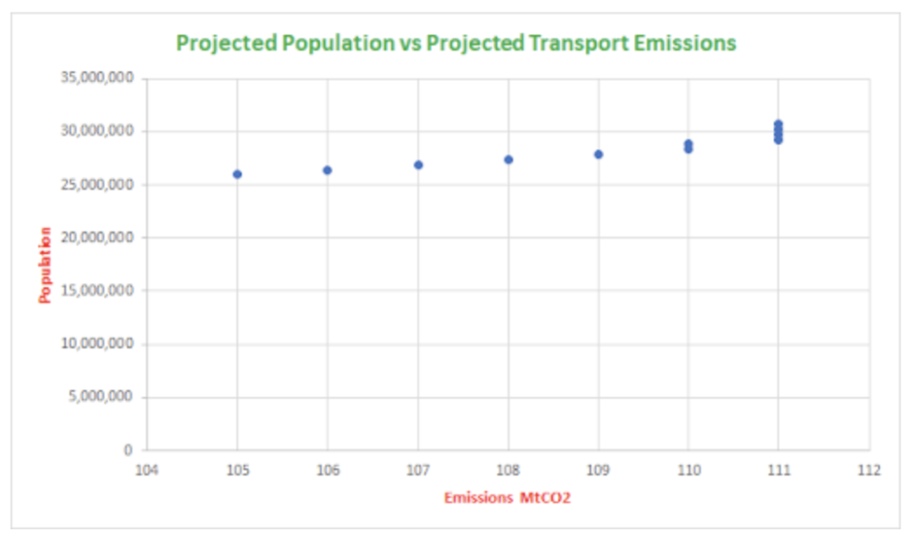
Step 7. Now, create a line of best fit that has an equal number of dots on either side of the line and best represents the trend in the data, as below:
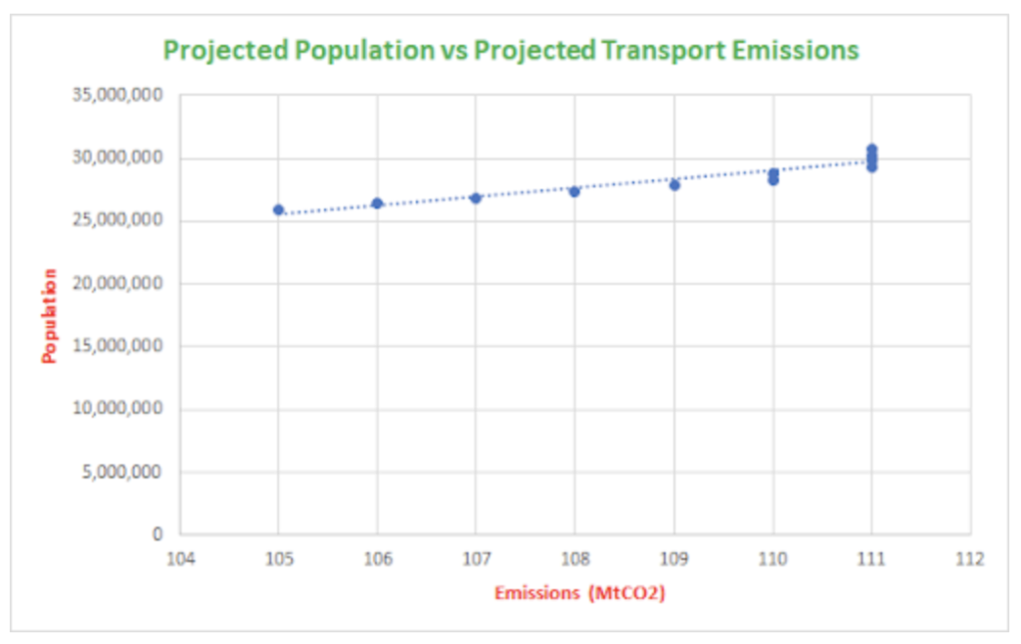
Scatter Plot with line of best fit (trend-line)
Step 8. Encourage students to discuss with the person next to them and write your own individual responses on their Worksheet to the following question; ‘What is the direction of the relationship between the two variables?’ Answer – Both of the variables increase
Step 9. Now invite students to discuss and answer the next question on the Student Worksheet:
- Question – ‘What does this suggest about our growing population and greenhouse gas emissions from transport in the future? Why do you think that this is so?’
- Possible answer – As our population increases, so will our transport emissions.
Step 10. Now, explain to the students that they will be constructing their own scatterplot to investigate Australia’s projected population between 2020 and 2030 and Australia’s projected car emissions over this time, and then compare the two scatterplots and comment on what they observe between population numbers and car emissions only versus emissions from all forms of transport.
Invites students to complete the data table and scatter plot activity on the Student Worksheet individually.
TIP: You might like to provide each group with a piece of string or cotton to help them try a few options for their lines of best fit before committing to paper.
Step 11. Observe and support students while they construct their axes and plot the data. Pay close attention to the way they are labelling increments and axes.
Here is the completed data and scatterplots for your reference.
- According to the Australian Bureau of Statistics, Australia’s population numbers from 2020 to 2030 will be: (see column 2)
- According to the Australian Department of Energy and the Environment, greenhouse gas emissions from all Transport from 2020 to 2030 will be: (see column 3)
Year | Projected Australian population | Emissions from cars MtCO₂
2020 | 25,936,500 | 45
2021 | 26,402,046 | 45
2022 | 26,873,947 | 45
2023 | 27,349,900 | 45
2024 | 27,829,520 | 46
2025 | 28,311,405 | 46
2026 | 28,796,151 | 45
2027 | 29,283,507 | 45
2028 | 29,773,492 | 45
2029 | 30,264,147 | 44
2030 | 30,755,046 | 44
Population projections from: http://www.abs.gov.au/ausstats/abs@.nsf/latestProducts/3222.0Media%20Release12017%20(base)%20-%202066
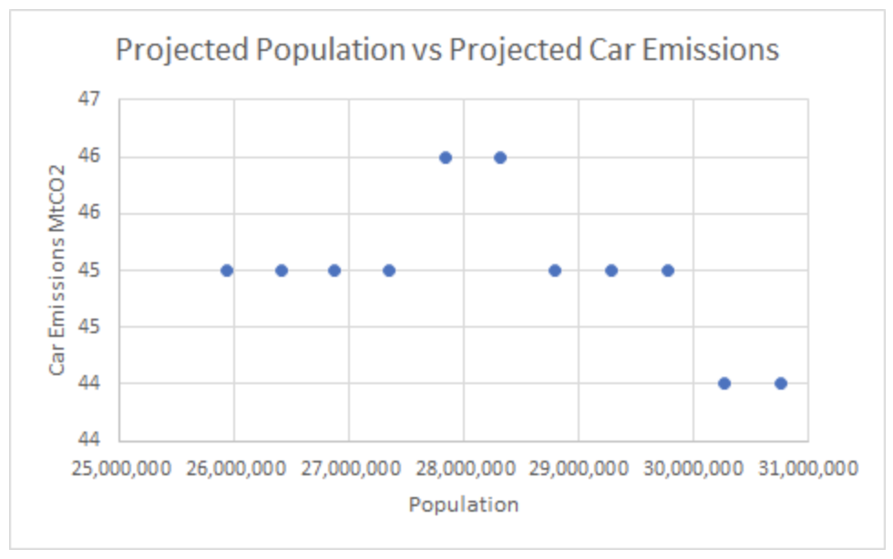
Scatterplot
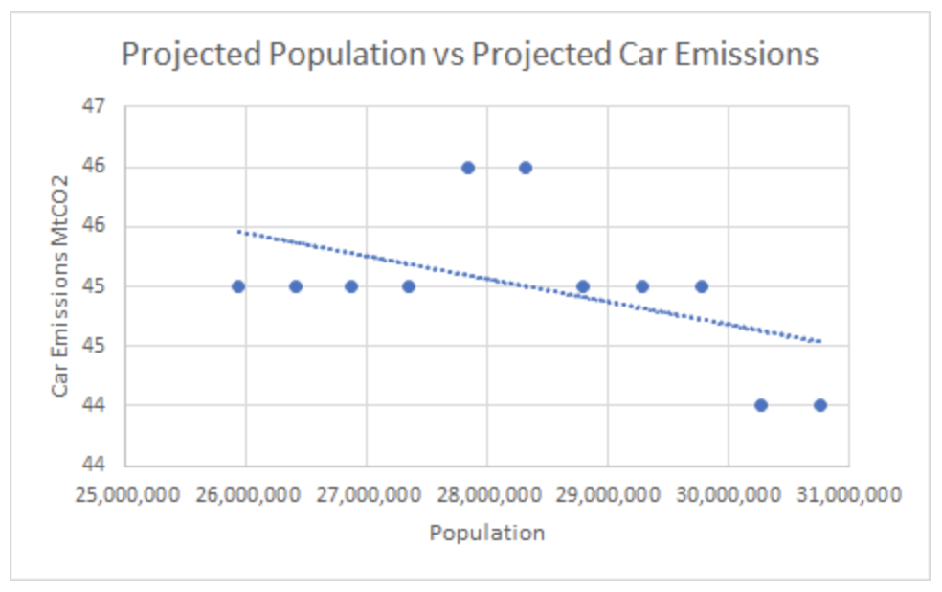
Scatterplot with line of best fit (trend-line)
Step 12. Ask students to examine their scatterplots and answer the questions in the second THINK, PAIR, SHARE table. Give them 5 minutes to complete column A before they pair up to complete column B. You might like to conduct a class discussion to collect and analyse interpretations after this activity is completed.
- Describe the scatterplot by looking for patterns. (Negative correlation, as the line is going down.)
- What does this suggest about our growing population and greenhouse gas emissions from cars in the future? Why do you think that this is so? [Think back to the video about the future of transport] (GHG emissions decrease as the population grows. This is most likely due to the production of more energy efficient cars and the increasing use of electric and hybrid vehicles.)
- Compare the two scatterplots that you have created and discuss what you observe between population numbers and car emissions only versus emissions from all forms of transport.(Transport emissions will continue to rise as the population increases, however, those produced by cars, will decrease.)

📚Part D: Take Action
Step 1. Assign students to small groups and explain the task:
Conduct some research on sustainable transport using the websites provided below and then make a poster, video or social media campaign that presents how transport of the future can be more efficient.
- https://www.climatecouncil.org.au/resources/transport-climate-change/
- https://www.drawdown.org/solutions/transport/electric-vehicles
- https://www.drawdown.org/solutions/transport/cars
- http://www.greenvehicleguide.gov.au/
RULE: You must find a way to include one of the scatterplots from this lesson in order to build a case for why we need to move towards more sustainable transport options.
- Consider your audience and their main needs, desires and obstacles
- Brainstorm what kind of information they need in order to:
  - Get their attention
  - Meet their needs and desires
  - Overcome their anticipated obstacles and resistance
- Think about what kind of data, statistics and graphs/charts you might need in order to build credibility and persuade this chosen audience.
OPTIONAL: For some inspiration on how statistics can be used to inspire and persuade, you might like to check out this TED talk from Uber founder, Travis Kalanick(https://www.ted.com/talks/travis_kalanick_uber_s_plan_to_get_more_people_into_fewer_cars)

Reflection
Have the students complete these sentences on the Students Worksheet:
- I used to think…
- But now, I think…
Prompt students to reflect on their learning, opinions or assumptions regarding climate change and consider if they think differently about transport in general. You might like to ask them to think about how they now feel about owning a car in the future and/or what type of vehicle they might like to consider.

Differentiated Learning
Extension – Students may choose to
- Use Google’s Environmental Insights Explorer to learn about the transportation emissions in your local area (https://insights.sustainability.google/)
Instructions:
- Enter name of your town, or the closest large citysuburb
- Click on the “transportation emissions” (explore and customize) to learn about your local transportation emissions.
- Use your city or state government website, or data from the US Census Bureau, to learn about population and car ownership trends in your city during the same time periods
- Create another scatterplot to see if you can determine a relationship between the transportation emissions, population, and car ownership in your area.
- If not, can you find other data that explains the trajectory of the transportation emissions where you are?
- Student then develops their own inquiry question/s and find an interesting and persuasive way to use the data uncovered about their area in relation to population and transport.
- Write an article for the school newsletter (or other appropriate school communication channel) that discusses their findings and advocates for use of EPA’s Carbon Footprint Calculator (https://www3.epa.gov/carbon-footprint-calculator/) by students and their families.
- Write a letter to their local, state, or national elected official to help strengthen the voice for climate change action at home. Encourage them to include data and statistics to make their message more persuasive. They might like to refer to: https://www.writeexpress.com/How-to-Write-a-Letter-to-Congress.html
- Research the US emission targets and work in pairs to interpret the range of graphs displayed on this international watchdog website: https://climateactiontracker.org/countries/usa/
- Write a report about which information is most helpful, and how it communicates the variables that are used to make the projections
Provisions for Learning Support –
- Help students develop a glossary of commonly used climate change terms, particularly related to transportation and new/arising forms of transport.
- Pair students that require extra help with another student for the individual graphing task.
Take It Further
To expand on student’s learning in this activity, consider following up with this lesson; 2040 Vision For Your Community.

Teacher Reflection
Take this opportunity to reflect on your own teaching
- What did you learn about your teaching today?
- What worked well?
- What didn’t work so well?
- What would you share?
- Where to next?
- How are you going to get there?
What’s Your 2040?
Record your students’ work in their communities with the hashtag #whatsyour2040 and share their visions in the ‘2040: The Regeneration’ Facebook Group. The 2040 crew would love to see your class’ work.

