# The Maths of Carbon – Science & Maths – Grades 5 & 6 – Student Worksheet

Thought starter: What’s the deal with Carbon Dioxide? Surely an invisible, tasteless and smell-less gas can’t really be such a drama? Can it?

### **The Issue of Atmospheric Carbon**

Watch this clip:

](https://vimeo.com/317186740)

[2040 – Exploring the Themes](https://vimeo.com/317186740) **Password: 2040_EDU**(https://vimeo.com/317186740)

**While** you’re watching, complete the table below.

|  |  |  |
| --- | --- | --- |
| **SEE** – What did you see as you watched this video? | **HEAR** – What did you hear the narrator talk about in the video? | **WONDER** – What questions arose as you watched? |
|  |  |  |

**After** watching, complete Column A. Then wait for further instructions.

* **Column A** – There were many ideas presented in this clip, by the narrator, about the problem we face today regarding the Earth’s atmosphere.   
  What THREE ideas did you find most interesting?
* **Column B** – Share your thoughts in column A with a partner and note down anything new.
* **Column C** – What were some ideas shared in the class discussion that you hadn’t considered before?

|  |  |  |
| --- | --- | --- |
| **Column A** | **Column B** | **Column C** |
|  | 1.  2.  3. |  |

Worksheet Preview – Please click the button to Download / Print  
[Download / Print](https://www.coolaustralia.org/worksheet-view/student_worksheet/102076/?docx=1)

### **The Air That I Breathe…**

In the table below, list each of the main gases in our atmosphere as mentioned by your teacher.

After chatting with your class, then list the amount of that gas as a proportion of the total atmosphere – first, as ‘parts per million’ (PPM) and then as a percentage:

(Remember, to calculate a percentage (%) from ‘Parts per Million’ (PPM): PPM ⁄ 1 000 000x 100 = ______ % )

|  |  |  |
| --- | --- | --- |
| **Name of Gas** | **Amount in Atmosphere – as ‘Parts per Million’ (PPM)** | **Amount in Atmosphere – as a Percentage (%)** |
|  |  | % |
|  |  | % |
|  |  | % |
|  |  | % |
|  |  | % |

**Optional** – If the Earth’s Atmosphere was a glass of frozen slushie drink, and each gas was a separate coloured ‘flavour’ draw and label the components in the glass! (Remember, in the real atmosphere, all the gases are mixed in together – not in layers!)

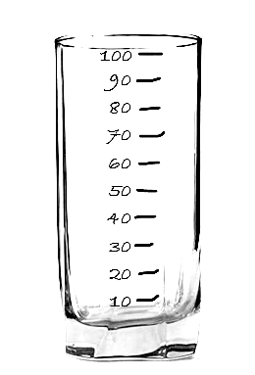

### **Reflection**

After completing the graphing activity, complete this activity.

|  |  |  |
| --- | --- | --- |
| **THINK – What are some thoughts you have about the activities and data in this lesson?** | **FEEL – How do you feel about what you have learned in this lesson?** | **WONDER – After this lesson, what are you still wondering about?** |
|  |  |  |

Write three important ideas that you will take away from this lesson:

1.

2.

3.