The Seaweed Solution Maths Grades 6 - 8 Teacher Worksheet
Teacher Preparation
Learning objectives: Students will…
- … understand what fractions, decimals and percentages are
- … understand simple ratios
- … learn how seaweed farming can help reduce CO₂ emissions and therefore help combat climate change
- … understand the relationship between seaweed farming, the health benefits of eating seaweed and climate change
Goals for Learning: Students can…
- .. solve connect fractions, decimals and percentages and carry out simple conversions
- … find percentages of quantities and express one quantity as a percentage of another, with and without digital technologies
- … recognise and solve problems involving simple ratios
- … develop an infographic that uses numbers to convince peers to eat more seaweed

Make the learning objectives and goals visible for students throughout this lesson.
Tackling climate change requires large-scale, systemic changes across all aspects of society. Simply aiming to reduce our C02 emissions is not enough: we need to rapidly decarbonize our planet. While this might sound challenging, the good news is we already have the knowledge and tools to do it.
2040 is an innovative feature documentary that looks to the future, while focusing on what is happening now. Award-winning director Damon Gameau (director of That Sugar Film) embarks on a journey to explore what the future could look like by the year 2040 if we simply embraced the best solutions already available to us to improve our planet and shifted them into the mainstream.
The film will demonstrate to your students that we already have the solutions to climate change; we just need to take action to bring them rapidly into the mainstream. The 2040 documentary and curriculum package will support your students in turning this knowledge into positive action for a better future.
Find out how to see the film here. 2040 launched in cinemas in Nov 2019 and is now available for booking for your school. These lessons have been designed with a media library to support teachers. The film is available on video-on-demand and DVD for individual viewing.
The film is the entry point to a global impact campaign that seeks to mobilize audiences to learn about, contribute to, advocate for, and invest in regenerative solutions that improve the wellbeing of the planet, all people and all living systems. To join the Regeneration and share your vision for 2040, see the website.
Watch the 2040 trailer:
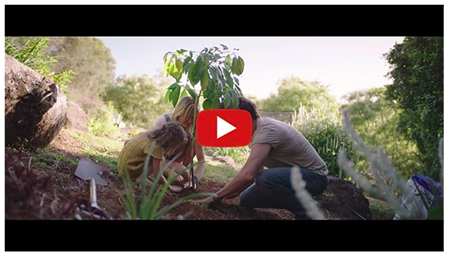
https://youtu.be/sR51ZDNSRFQ
Cool Australia, GoodThing Productions and Regen Pictures would like to acknowledge the generous contributions of Good Pitch Australia, Shark Island Institute, Documentary Australia Foundation, The Caledonia Foundation, Global Health Film and our philanthropic partners in the development of these teaching resources.

A word on seaweed and carbon pollution: The impact of carbon pollution can be seen in increased rainfall, changing and unpredictable seasons, shrinking sea ice, rising sea levels, and warmer and more acidic oceans. These changes have, and will continue to:
- destroy sensitive animal habitats (especially in the seas) – e.g. coral bleaching
- play havoc with climate-sensitive diseases which pose a threat to human health
- worsen existing health conditions due to air pollution
- affect forestry, energy, mining, and farming which in turn affect our food supply and food quality
- increase the frequency, intensity, and impact of some types of extreme weather events.
What can we do about it? Seaweed farming has been recognised as an effective way of removing carbon from the atmosphere and tackling climate change. Check out this Illustrated Guide to Seaweed Farming (https://mattersjournal.com/stories/seaweedfarming) to learn more about this – it will be used with your students in the lesson.
References:
- The Living World Canadian Geographic (http://www.canadiangeographic.com/educational_products/activities/climate_change_lesson_plans/EN/Living_World%20_Activities/Climate-Change-Lesson-Plan_Living_World_Teachers_Guide.pdf)
- What is Climate Change? National Geographic Kids (https://www.natgeokids.com/au/discover/geography/general-geography/what-is-climate-change/)
- Global Warming’s Evil Twin: Ocean Acidification The Climate Reality Project (https://www.climaterealityproject.org/blog/global-warming-ocean-acidification)
Teaching Sequence
Work through this resource material in the following sequence:
20 minutes – Part A: Activating Prior Knowledge
30 minutes – Part B: CO₂ Emissions and our Oceans
60 minutes – Part C: Seaweed Farming
30 minutes – Part D: Eat More Seaweed
10 minutes – Reflection

📚Part A: Activating Prior Knowledge
Note: This lesson looks at innovative ways of changing our consumer habits to reduce climate change. Before conducting this lesson it is a good idea to get an understanding of your class’ understanding of climate change.
To complete this lesson, students will need to know that the earth’s atmosphere contains a range of gases, some of these gases, such as CO₂ and methane, keep the earth warm by trapping the sun’s heat (super useful at night when we are not facing the sun). However, some practices like burning fossil fuels release more greenhouse gases into the atmosphere, trapping more heat, making the earth warmer.
If you find that students are unclear about these details consider showing them this clip from the 2040 Documentary: Biodiversity Sketch Password 2040_EDU (https://vimeo.com/showcase/6167669/video/311990271).
Step 1. Introduce the lesson by informing students that they will be investigating percentages and ratios through the topic of climate change and, the role of seaweed in combating climate change! You might like to let them know that later, they will be required to develop an infographic that shows their learning and also presents important information to others about climate change and seaweed.
Step 2. Lead the whole class in this ‘Think, Puzzle, Explore’ activity.

THINK – PUZZLE – EXPLORE
This activity will help students connect with prior knowledge, stimulate curiosity and lay the groundwork for future inquiry:
THINK – What do you THINK you know about this topic?
PUZZLE – What questions or PUZZLES do you have?
EXPLORE – How can you EXPLORE this topic?
- On the board write: Did you know that seaweed can reduce climate change?
- On poster paper write: What do you think you know about climate change? What do you know about seaweed? Invite students to form pairs and write their responses on sticky notes. Ask them to stick their responses to the poster paper.
- On another piece of poster paper write: What questions do you have, or what puzzles you? In their pairs, invite students to write their responses and then stick these to the poster paper.
- Lastly, on another piece of poster paper write: How can we explore this topic? Once again inviting pairs of students to write their responses and stick these to the poster paper.
Hot tip: You might prefer to use a large window and liquid chalk instead!
Keep a record of responses so that connections can be readily made when relevant, throughout the lesson.
Step 3. Show this 2040 clip:
2040 – Marine Permaculture Password: 2040_EDU (https://vimeo.com/showcase/6167669/video/336507628)
Step 4. Give the students a chance to watch the clip again. This time ask students to record key points and write down any unfamiliar terms.
Step 5. Invite students to form (or assign) groups of 3 to 4. Ask students to:
- … share their key points from the video clip and form a summary
- … collate the recorded unfamiliar terms and define them using an online search engine such as Google
Hot tip: If you would like a safer browsing environment, look out for search engines designed especially for kids, such as www.kidzsearch.com.
Invite some of the groups to share their responses with the class.
Step 6. Write ‘Glossary’ on poster paper and invite students to stick their unfamiliar terms and meanings on this. Collate the like terms together and review these. Invite some students to read out the terms and their meanings.
Hot tip: You might like to use this Marine Permaculture diagram to provide a summary and points for reflection:
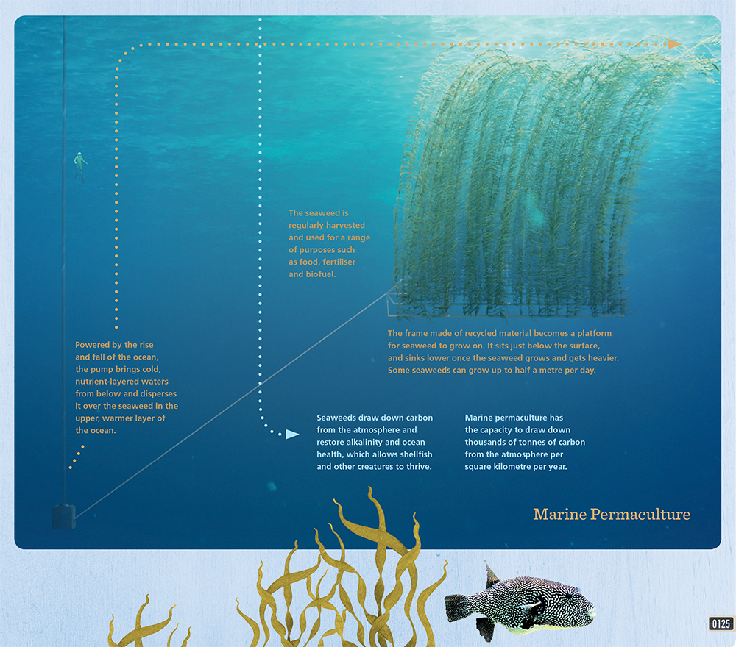
To save on printing, you could project this image on the board. Click here to download a high-resolution version suitable for projecting. We have also included a transcript of the text from the image:
- Powered by the rise and fall of the ocean, the pump brings cold, nutrient-layered waters from below and disperses it over the seaweed in the upper, warmer layer of the ocean.
- The seaweed is regularly harvested and used for a range of purposes such as food, fertilzer and biofuel.
- The frame made of recycled material becomes a platform for seaweed to grow on. It sits just below the surface, and sinks lower once the seaweed grows and gets heavier. Some seaweeds can grow up to half a meter per day.
- Seaweeds draw down carbon from the atmosphere and restore alkalinity and ocean health, which allows shellfish and other creatures to thrive.
- Marine permaculture has the capacity to draw down thousands of tons of carbon from the atmosphere per square kilometer per year.

📚Part B: CO2 Emissions And Our Oceans
In this next part of the lesson, students will need to search online in small groups. You may decide to begin this part of the lesson with students in their groups in front of their devices or you can do this at step 2.
Step 1. Read to students:
‘We know that CO2 emissions in our atmosphere have been increasing due to actions such as burning fossil fuels. But increased CO2 doesn’t just affect temperature it is also detrimental to our oceans. 25 percent of all CO2 emissions are absorbed by our oceans and this is destroying our sea life. Because of this absorption (which is a natural part of the carbon cycle), CO2 emissions are destroying sea life by decreasing the oxygen levels in the ocean and creating ocean acidification. Increasing acidity will make it harder for corals to build skeletons and for shellfish to build the shells they need for protection. Corals are particularly important because they provide homes for many other sea creatures.’
Sources: https://www.theguardian.com/environment/2017/oct/23/ocean-acidification-deadly-threat-to-marine-life-finds-eight-year-study,
https://archive.epa.gov/climatechange/kids/impacts/signs/index.html
Step 2. Distribute Student Worksheet and ask students to complete the first activity on the Student Worksheet, as follows:
Go to http://www.globalcarbonatlas.org/en/CO2-emissions and click on ‘Chart View‘ on the right-hand side. Find the United Sates by looking at the bar chart or entering ‘United States in the ‘Countries’ text box on the left.
Once students have navigated to this part of the site invite them to answer the first question on the Student Worksheet:
How many MtCO2 did the United States emit in 2017? Answer: 379
Step 3. Read the following statement on the Student Worksheet and check for understanding.
What is MtCO2?
MtCO2 means Metric tons of carbon dioxide equivalent.
CO2 is the primary greenhouse gas emitted through human activities and the unit MtCO2 refers to its global warming impact.
Did you know that 1 MtCO2 is equivalent to charging 127,512 smartphones?
Step 4. Now, challenge students to work out how much of the United State’s emissions went into the ocean without using their calculators.
Hint: 25 percent of all CO2 emissions are absorbed by our oceans.
Students should be able to recall that 25 percent = ¼ and use this fraction to calculate the answer.
¼ of 379 = 379/4 = 94.75 = 94 ¼
Note: Some key terms, such as ‘CO2’ and ‘greenhouse gas’ can be explored here: https://ecometrica.com/white-papers/greenhouse-gases-co2-co2e-and-carbon-what-do-all-these-terms-mean

📚Part C: Seaweed Farming
Step 1. Explain to students that now that they know one of the big issues facing our ocean they are going to be looking at a possible solution. Then show this 2040 clip:
2040 – Seaweed as Food Password: 2040_EDU (https://vimeo.com/showcase/6167669/video/304290496)
Step 2. Read An Illustrated Guide to Seaweed Farming (https://mattersjournal.com/stories/seaweedfarming) as a class, and check for understanding. Ask students to identify any unfamiliar terms and find their meanings and record this on post-it notes. These can then be added to the Glossary poster.
Step 3. Ask students to re-read An Illustrated Guide to Seaweed Farming and complete the graphic organiser on their worksheet by writing the topic of the article in the circle and the main ideas in the surrounding rectangles. The graphic organiser (below) enables students to identify and record the topic of the article and its main points.
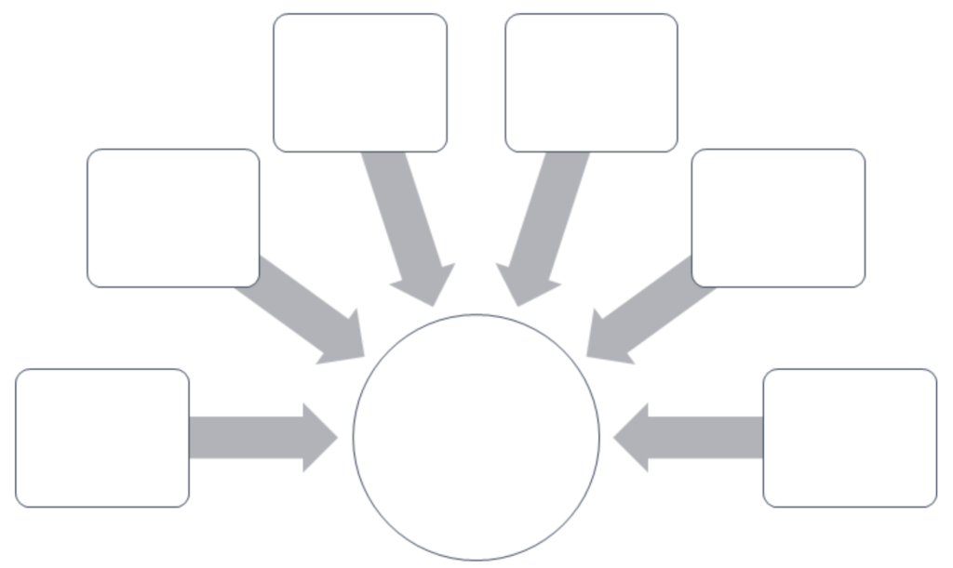
Step 4. Invite students to complete the following questions on the Student Worksheet. Here students will get practice working with ratios, percentages and fractions to answer the questions asked. They will then need to determine which of the information and numbers are important and assign them to key points that they have recorded on the graphic organiser.
By how much has the acidity of oceans risen over the past 150 years?
Answer: 30 percent
Express this as a fraction in its simplest terms.
Answer: 30 ⁄ 100 = 3 ⁄ 10
What has been the decrease in marine biological activity because of global warming?
Answer: 4 to 8 percent per year
Express this as decimal.
Answer: 0.04 to 0.08
How many phytoplankton can fit in one cup of seawater?
Answer: 0.25 billion
Express this as a whole number and in words.
Answer: 0.25 billion = 25% of a billion = ¼ of 1,000,000,000 = 250,000,000 = 250 million
The Director of the film is from Australia. According to the article, Nine percent of our ocean is as big as 4.5 Australia’s. Express this as a ratio.
First, we need to convert nine percent to a decimal. Nine percent = 9/100 = 0.09
4.5 is already a decimal so we have: 0.09:4.5
Multiply both sides by 100 such that, 0.09 x 100 : 4.5 x 100 = 9:450 =
Answer: 1:50 (simplifying by dividing both sides by 9)
How many Australia’s would fit into all of the ocean?
9% = 4.5, so 1% = 0.5 (dividing both sides by 9), therefore 100% = 50 (multiplying both sides by 100)
Answer: 50 Australia’s would fit into all of the ocean.
Fill in the blank: Methane emissions from cattle in Australia account for around 10 percent of total greenhouse gas (GHG) emissions.
Express this as a fraction and a decimal.
Answer: 10 percent = 10 ⁄ 100 = 1 ⁄ 10 = 0.1
Using the Global Carbon Atlas, calculate the methane emissions from cattle in Australia in 2017. Express this as a decimal and a fraction.
Answer: 10% of 413 = 41.3 = 41 3 ⁄ 10
Step 5. Discuss what students have written in the graphic organizer and the facts from the mathematical calculations above that they have included in their diagrams.

📚Part D: Eat More Seaweed
Step 1. You will now guide students to undertake a Jigsaw activity to explore the link between eating seaweed, seaweed farming and climate change. (https://www.jigsaw.org/)
Note: If you want to learn more about jigsaw activities see, https://www.jigsaw.org/#steps.
Read this paragraph (also on the Student Worksheet):
“Seaweed is not only good for the oceans and therefore our planet, but it is also a healthy food source and it’s likely that you have already eaten seaweed, even if you didn’t know it. If you’ve eaten sushi, then you’ve probably eaten a seaweed known as nori – the sheet that wraps the sushi. By eating more seaweed we are actively contributing to our health and the health of the planet as we are supporting seaweed farming.”
Step 2. Assist students to create ‘Home’ groups (maximum six students per group). Note: This lesson is written for a class of 30 students.
Step 3. Number each student in the ‘Home’ groups from #1 – 5. Lay out five sets of the 5 seaweed articles. Each ‘Home’ group should collect 5 matching articles, so each person in the group has their own copy to read, but are all reading the same content.
Step 4. Appoint one student from each group as the leader and invite all students to read their assigned article and list the main points.
Step 5. After 10 minutes, invite all the #1s, #2s, etc. to form ‘Expert’ groups and to discuss the main points of each of their articles and clarify any unfamiliar information or words. As a group, students will then decide what information to bring back to their ‘Home’ group.
Step 6. Ask students to return to their ‘Home’ groups where they will present the information formed in their ‘Expert’ group to their ‘Home’ group.
Step 7. Invite students to create an infographic that aims to convince other students to eat more seaweed. The infographic must make use of numbers and information that they have accessed throughout the lesson. The following videos are also provided to support students in understanding the topic further.
- Kelp: It’s What’s For Dinner (https://www.youtube.com/watch?v=0BHfHkOoDGA)
- 3 (Actually Safe) Ways to Fight Climate Change (first 2 min only) (https://www.youtube.com/watch?v=X9mNgvdsncE)
- How Kelp Could Help Combat Climate Change | This New World (https://www.youtube.com/watch?v=F5KL4TdMcFk)
You may wish to refer to https://creativeeducator.tech4learning.com/2013/lessons/Infographics to support you in guiding students in developing an infographic; or https://www.creativebloq.com/infographic/tools-2131971, which provides online infographic making tools, many of which are free.

Reflection
Have the students complete these sentences on the Students Worksheet:
- I used to think…
- But now, I think…
When introducing this activity, encourage students to reflect back to their ‘Think, Puzzle, Explore‘ responses from the beginning of the lesson.

Differentiated Learning
Extension –
- Students can conduct further research on the benefits of ocean farming.
- Students could publish their infographic on social media or through in-school communication channels and collect ratings, feedback and/or votes.
- For students who may be interested in greenhouse gas emissions, they can further explore the global carbon atlas http://www.globalcarbonatlas.org/en/CO2-emissions to determine the emissions of countries around the world. Here is a suggested activity:
Go to http://www.globalcarbonatlas.org/en/CO2-emissions and in pairs, calculate the following, without using your calculator:
- MtCO2 emissions by the top 5 ranking countries.
- MtCO2 emissions by the top 10 ranking countries. (Hint: for a and b above, click on Ranking on the left-hand side to help you)
- MtCO2 that is absorbed in the oceans from the top 5 ranking countries.
- MtCO2 that is absorbed in the oceans from the top 10 ranking countries.
- Express your answers to c and d above as a mixed fraction and a decimal.
Here are the answers for your reference:
- Top 5 ranking countries are: China, USA, India, Russian Federation and Japan. Their MtCO2 emissions respectively are: 9839, 5270, 2467, 1693, 1205. To find their total emissions, students will need to add the figures manually: 9839 + 5270 + 2467 + 1693 + 1205 = 20474 MtCO2
- Top 10 ranking countries are: China, USA, India, Russian Federation, Japan, Germany, Iran, Saudi Arabia, South Korea and Canada. Their total emissions are: 20474 (from a above) + 799 + 672 + 635 + 616 + 573 = 23769 MtCO2
- ¼ of 20474 = 5118.5 = 5118 ½ MtCO2
- ¼ of 23769 = 5942.25 = 5942 ¼ MtCO2
Provisions for Learning Support –
- The information on climate change and seaweed farming contain new and unfamiliar terms to students. The poster glossary, that the students created, of key terms used, will benefit all students and improve their understanding overall.
- Students can pair up to complete any non-group activities.
Take It Further
To expand on student’s learning in this activity, consider following up with this lesson; 2040 Vision For Your Community.

Teacher Reflection
Take this opportunity to reflect on your own teaching
- What did you learn about your teaching today?
- What worked well?
- What didn’t work so well?
- What would you share?
- Where to next?
- How are you going to get there?
What’s Your 2040?Record your students’ work in their communities with the hashtag #whatsyour2040 and share their visions in the ‘2040: The Regeneration’ Facebook Group. The 2040 crew would love to see your class’ work.

