The Seaweed Solution Maths Years 8 & 9 Student Worksheet
Name: …………………………………….. Class: …………..

Thought starter: What’s so great about seaweed?
“Most of the world’s oxygen, about 70%, comes from seaweeds and algae. It is estimated that there are about 9 times more seaweeds in the oceans than there are plants on land.”
(Seaweed Enterprises Australia, https://www.seaweedenterprisesaustralia.com.au/blog/post/3658/9-amazing-facts-about-Seaweed/)
1. Watch this clip:
Marine Permaculture Password: 2040_EDU (https://vimeo.com/showcase/6167669/video/336507628)
Note down any unfamiliar words or phrases you hear in the clip.

2. Go to http://www.globalcarbonatlas.org/en/CO2-emissions and click on ‘Chart View’.
Find the United Kingdom by looking on the bar chart or entering ‘United Kingdom’ in the ‘Countries’ text box on the left.
How many MtCO2 did the United Kingdom emit in 2017?

What is MtCO2?
MtCO2 mean Metric tons of carbon dioxide equivalent.
CO2 is the primary greenhouse gas emitted through human activities and the unit MtCO2 refers to its global warming impact.
Did you know that 1 MtCO2 is equivalent to charging 127,512 smartphones?
Now work out how much of the United Kingdom’s emissions went into the ocean without using your calculator.
(Hint, 25 percent of all CO2 emissions are absorbed by our oceans.)
Express your answer as a mixed fraction and a decimal.

3. Watch this 2040 clip:
2040 – Seaweed as Food
Password: 2040_EDU (https://vimeo.com/304290496)
If there are any more terms or words you haven’t heard before, or need to find out more about, list them here:

4. Read An Illustrated Guide to Seaweed Farming and fill in the diagram below. Write the topic of the article in the circle and the main ideas in the surrounding rectangles.

Now answer the following questions and add any relevant information to your diagram. This information and calculations will help you develop your infographic later in the lesson.
- By how much has the acidity of oceans risen over the past 150 years?:
- Express this as a fraction in its simplest terms:
- What has been the decrease in marine biological activity because of global warming?:
- Express this as decimal:
- How many phytoplankton can fit in one cup of seawater?:
- Express this as a whole number and in words:
- According to the article, nine percent of our ocean is as big as 4.5 Australia’s. Express this as a ratio:
- How many Australia’s would fit into all of the ocean?:
- Fill in the blank: Methane emissions from cattle in Australia account for around _____ percent of total greenhouse gas (GHG) emissions.
- Express this as a fraction and a decimal:
- Using the Global Carbon Atlas, calculate the methane emissions from cattle in Australia in 2017. Express this as a decimal and a fraction:

5. Read as a class:
“Seaweed is not only good for the oceans and therefore our planet, it is also a healthy food source and it’s likely that you have already eaten seaweed, even if you didn’t know it. If you’ve eaten sushi, then you’ve probably eaten a seaweed known as nori – the sheet that wraps the sushi.
By eating more seaweed we are actively contributing to our health and the health of the planet as we are supporting seaweed farming.”
6. In your ‘Home’ group, read your assigned article on seaweed. What are the main points? Write these down in the space below.

In your ‘Expert’ group, discuss the main points of the article and clarify any information or words that you’re not sure of. As a group, decide what information you will each bring back to your respective ‘Home’ groups. Write your summary down in the space below.

Back in your ‘Home’ group, present the information that you wrote above and when others are speaking, listen and ask questions to improve your understanding.
7. Create an infographic that aims to convince your peers to eat more seaweed. Your infographic must include numbers (refer to An Illustrated Guide to Seaweed Farming and the source documents from the previous activity to help you!)
You can also check out these videos for more information.
- Kelp: It’s What’s For Dinner (https://www.youtube.com/watch?v=0BHfHkOoDGA)
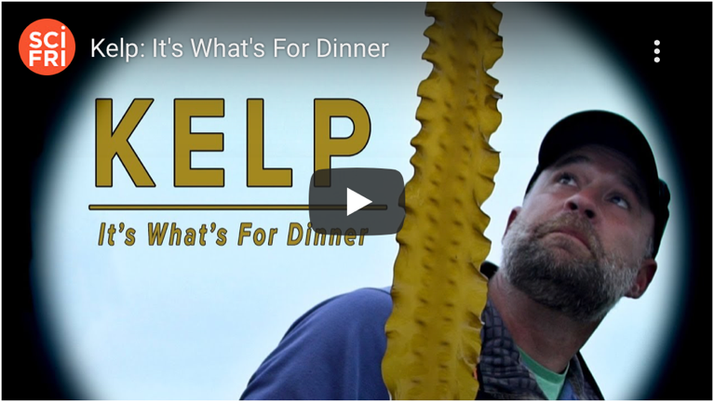
- 3 (Actually Safe) Ways to Fight Climate Change (first 2 min only) (https://www.youtube.com/watch?v=X9mNgvdsncE)
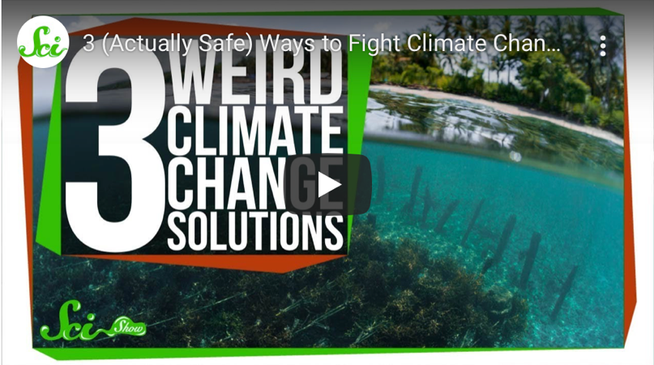
- How Kelp Could Help Combat Climate Change | This New World (https://www.youtube.com/watch?v=F5KL4TdMcFk)
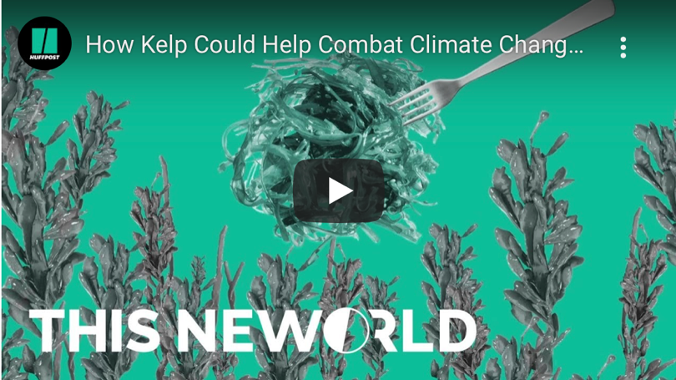
Reflection
I used to think…

But now I think…

