Transport And Liveability Geography Years 7 & 8 Teacher Worksheet

Teacher preparation
Learning intentions: Students grasp …
- … what liveability is.
- … how transport affects our environment.
- … the relationship between transport choices and liveability.
Success criteria: Students can …
- … participate in a role-play activity.
- … participate in group and class discussions.
- … work collaboratively and independently.
Teacher content information: A 2018 study by The University of Melbourne on the thoughts and concerns of young people from Generations X and Y found the number one concern across both groups was lack of action around climate change. In particular, “Generation X worries what climate change will mean for their own children, while Generation Y is concerned about the impact on future generations” (The Educator).
The report indicates that young people have a serious mistrust in the Government’s ability or willingness to tackle climate change.
Tackling climate change requires large-scale, systemic changes across all aspects of society. Simply aiming to reduce our C0₂ emissions is not enough: we need to rapidly decarbonise our planet. While this might sound challenging, the good news is we already have the knowledge and tools to do it.
2040 is an innovative feature documentary that looks to the future while focusing on what is happening now. Award-winning director Damon Gameau (director of That Sugar Film) embarks on a journey to explore what the future would look like by the year 2040 if we simply embraced the best solutions already available to us to improve our planet and shifted them into the mainstream.
The film will demonstrate to your students that we already have the solutions to climate change; we just need to take action to bring them rapidly into the mainstream. The 2040 documentary and curriculum package will support your students in turning this knowledge into positive action for a better future.
Find out how to see the film here. 2040 will only be available in cinemas for the first part of 2019 and you can make a group booking for your class at your local cinema during the film’s theatrical release which starts on May 23. These lessons have been designed with a media library to support teachers. The film will be available on video-on-demand and DVD later in 2019.
The film is the entry point to a global impact campaign that seeks to mobilise audiences to learn about, contribute to, advocate for and invest in regenerative solutions that improve the wellbeing of the planet, all people and all living systems.
To join the Regeneration and share your vision for 2040, see the website.
Watch the 2040 trailer:
Cool Australia, GoodThing Productions and Regen Pictures would like to acknowledge the generous contributions of Good Pitch Australia, Shark Island Institute, Documentary Australia Foundation, The Caledonia Foundation and our philanthropic partners in the development of these teaching resources.

Teaching sequence
Work through this resource material in the following sequence:
15 minutes – Part A: Activating Prior Knowledge
5 minutes – Part B: Transport and Liveability
25 minutes – Part C: Thinking Hats Role Play
10 minutes – Part D: Future Transport Now
5 minutes – Reflection

Part A: Activating Prior Knowledge
Step 1. Begin this lesson by inviting students to participate in a short warm-up activity around their personal transport use. Move students to an open space (this could be an area cleared of desks in the classroom or could be outside) and invite students to work collaboratively to form groups based on:
- The type of transport they used to get to school today (e.g. car, bus, train, bike, walking, etc.).
- The number of days in the last week you DIDN’T travel in a car.
- The number of cars they have at home.
- The type of transport they enjoy the most.
- Whether they know what liveability is or not.
Students will need to move around the space and negotiate the groups they are forming with each other. In addition, if students want to discuss or share anything about the groups they form throughout this activity you can encourage them to do so, however, this is not necessary.
Once complete, invite students to return to their desks and explain that in this lesson they will be exploring the relationship between transport and liveability. They will begin by looking at liveability.
Step 2. Explain to students that when considering opportunities for urban development, town planners and decision makers don’t just think about appearance; they also need to consider making the area liveable. We can assess the liveability of a place using a range of factors. What makes a place liveable is different for different people. People have different criteria or even a different ranking of the same criteria of what makes a place liveable for them.
Break the class into small groups and give each group around 10 sticky notes (or scrap pieces of paper – A4 cut into six or eight pieces is fine). Invite the groups to brainstorm the things that they do not want in the places where they live, explaining that it is often easier for people to say what they don’t like, rather than what they do like. Invite students to add their ideas to the sticky notes, ensuring that they have only one idea per sticky note.
After several minutes, invite students to share their thoughts with the class by adding their sticky notes to the board (use sticky tape if using scrap paper or arrange on a table instead of the board). When all groups have had the chance to share their responses, invite students to:
- Share some of the reasons why these things have been named.
- Try to group the things in the list into one of the following three categories: cultural, social and physical. Move the sticky notes around as you need. You can also use this image to guide you (this image comes from this clip – consider sharing the clip with students if they need more detail about the concept of liveability).
Step 3. Next, encourage students to flip their thinking. Suggest students refer to the list on the board to make a new list of things of importance to them that make places liveable. Give groups several minutes to come up with some ideas, again recording them on sticky notes or scrap paper.

Once complete, you can again invite students to:
- Share some of the reasons why these things have been named.
- Try to group the things in the list into one of the three categories: cultural, social and physical. Move the sticky notes around as you need.
Step 4. Finally, encourage students to think forward to the year 2040. Explain that the importance of liveability factors vary between individuals, such as older people, and regions such as city/country.
Invite students to suggest which liveability criteria might change for them in the year 2040 and why. What about the year 2060 or 2080? Students can share their ideas in pairs or through class discussion and record these ideas on the board.
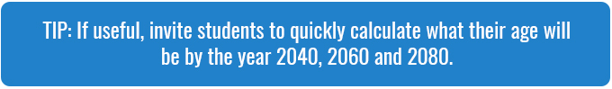

Part B: Transport and Liveability
Step 1. Pose the following questions to your class and invite them to respond through class discussion:
- When thinking about the factors of liveability in your area, did you think of transport? Why or why not?
Through your discussion suggest to students that transport affects liveability in a number of ways, including allowing us to connect with our friends, family, and community. In addition, we need transport to access goods and services and to bring goods and services to us.
Step 2. Distribute a copy of the Student Worksheet to each student. Break the class into pairs and invite them to complete a THINK PAIR SHARE routine around the following questions (also available on the Student Worksheet):
- When thinking about the factors of liveability in your area, did you think of our environment? Why or why not?
- What relationship do you think might exist between transport and our environment in terms of liveability?
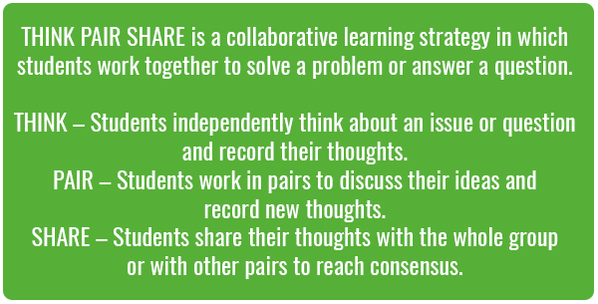
Allow students time to discuss their thoughts in pairs before inviting them to share their ideas with the class. Ensure that students are aware of the following:
- Humans have become increasingly reliant on transport options that can cause harm to our environment. One of the main environmental impacts of transport is its contribution to climate change.
NOTE: This lesson doesn’t require deep background knowledge of climate change; however, if students are unfamiliar with the concept of climate change and want to know more, consider sharing this clip with students:
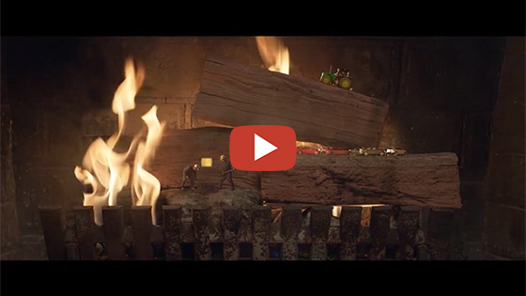
2040 – Biodiversity Sketch
Password: 2040_EDU
(https://vimeo.com/showcase/6167669/video/336498352)
Alternatively, you could distribute copies of the Climate Change Factsheet to students.

Part C: Thinking Hats Role Play
Step 1. Now, explain to students that they will be exploring the ways transport can affect our environment and our liveability. They will be doing this by participating in a role-play activity. This activity is designed to help students think critically and creatively about the issues associated with transport and liveability. Students will explore issues and potential solutions from a range of different perspectives using a 2040 version of de Bono’s Thinking Hats.
Students are asked to imagine they are characters in a community meeting about transport and liveability in their community. Students will work in groups to play the following roles:
- Teenagers
- Parents of teenagers
- Elderly couple
- Young couple
- Single professional
- Parents of young children
The topic they will be discussing is:
- How can our transport choices improve liveability?
Step 2. Divide the class into six groups. Give each group one printed copy of the Thinking Hats Worksheet and assign them ONE of the profiles on the sheet.

Each profile requires students to practice a thinking style using one of Edward de Bono’s Thinking Hats. The table below shows each profile and the Thinking Hat to be used by students as they adopt that profile. Project and explain this table to the class, using the information provided on the Thinking Hats Worksheet to provide further details about each hat:
Thinking hat | Profile | Focus/Way of thinking
Red | Parents of young children | Intuition and emotion
Green | Parents of teenagers | Creativity and alternatives
Yellow | Teenagers | Positives and benefits
Blue | Single professional | Process and control
White | Young couple | Facts and figures
Black | Elderly couple | Negatives and caution
Once complete, invite students to access the Thinking Hats activity on the Student Worksheet. Using the questions provided, allow 10 minutes of research, reading, discussion and note-making time in groups. Each student should note their group’s answers and ideas on their own worksheet.
Step 3. Reconvene the class and have each group share their answers and ideas through role-play. Each group member may speak, or there may be one spokesperson per group. Facilitate a discussion based on the ideas and viewpoints presented. Encourage debate and rebuttal between groups but emphasise the importance of finding solutions and compromises. As a class, think about specific scenarios that will keep the discussion flowing.
- Example: By removing parking spaces in town we could improve bike lanes.
- Possible discussion points for this scenario: This might mean that businesses struggle to attract customers. Empty shops don’t make for happy towns!


Step 4. Once complete, invite each group to work together to briefly discuss the notes or thoughts they had in response to the role-play and to again consider the question:
- How can our transport choices improve liveability?
Through their discussion invite students to consider:
- What ideas have changed?
- What new ideas have we had?

Part D: Future Transport Now
Step 1. Explain to students that they will now explore different types of transport and will think about which types of transport provide the best liveability and why.
Break the class into groups of 3 or 4 students. Each group needs to create a mind-map based on the following three points:
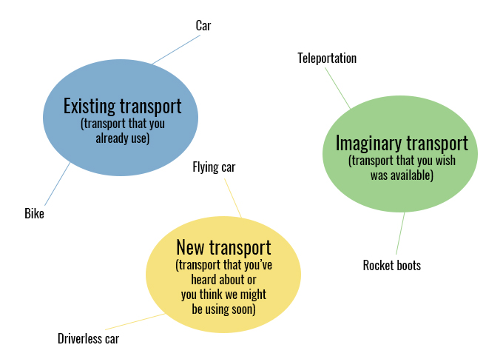
Each group should then select the type of transport that they think provides the best liveability. Working together they need to discuss the reasons for this selection and record their responses (in bullet points).
Invite students to share their ideas with the class, stating their case for the type of transport they selected.
Step 2. Now, invite students to think about what changes could we make to the types of transport that we currently use to improve liveability. This might mean that we think about new forms of transport or even futuristic types of transport. These forms of transport might look quite different from what we have now.
Hot tip: If your class need a little help thinking about a better transport future consider showing them this clip of some younger students from around the world, 2040 Children Transport Password: 2040_EDU
Share the following clip with students, explaining that it comes from the 2040 documentary.
As they watch invite students to record anything they observe that relates to liveability or sustainability.
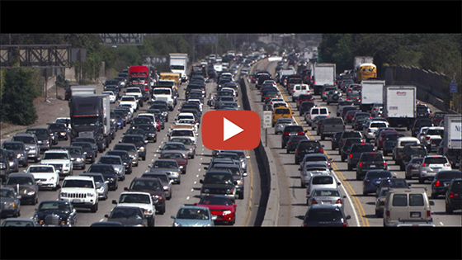
2040 – Future Transport
Password: 2040_EDU
(https://vimeo.com/showcase/6167669/video/336508862)
Step 3. Invite students to move back into the groups they were in for the previous activity (Part C). Explain that each group now needs to assess the transport featured in the 2040 clip using the same liveability factors they used earlier. Using the Student Worksheet, students should rate each factor on a scale of 1 to 10, where 1 = poor and 10 = excellent. Students should also provide a justification for each rating.

Reflection
Invite students to work independently to consider the following (also available on the Student Worksheet):
- How do your own transport choices relate to how you experience the liveability of your area?
Students should write one or two paragraphs describing their response to this question.

Take It Further
To expand on student’s learning in this lesson, consider following up with this lesson; 2040 Vision For Your Community. The class could also explore solutions to transport issues (https://whatsyour2040.com/transport/) in more detail using the 2040 website.
The 2040 team have created a range of clips specifically for use in geography classrooms. Access the whole package of 2040 Geography clips at the following link, Secondary GEOGRAPHY Portfolio Password: 2040_GEO

Extension – Field Work
Explain to students that many ‘futuristic’ transport options are already up and running in Australia. Students could plan, carry out, analyse, present and draw conclusions about the transport options that are already available in their community. If these transport options were widely adopted, how might these affect liveability?

Teacher Reflection

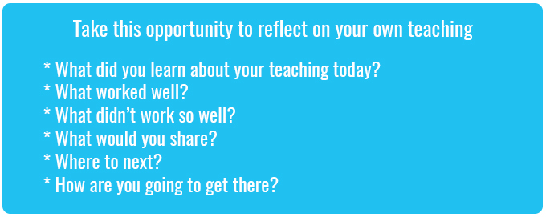

What’s Your 2040?
Record your students’ work in their communities with the hashtag #whatsyour2040 and share their visions in the ‘2040: The Regeneration’ Facebook Group.
The 2040 crew would love to see your class’ work.

