# Tuning in to the documentary Years 5 & 6 Teacher Worksheet (UK)

**Teacher Preparation**

Learning intentions: Students will…

* …understand that different people have different ideas and concerns about the future.
* …understand that solutions to the problems facing people and the planet already exist.

Success criteria: Students can…

* …participate in a barometer activity.
* …participate in a group mind-map exercise.
* …express their thoughts, feelings and concerns through class discussion and independent activities.
* …adhere to classroom discussion guidelines.

**Make the learning intentions and success criteria visible for students throughout this lesson.**

Tackling climate change requires large-scale, systemic changes across all aspects of society. Simply aiming to reduce our C02 emissions is not enough: we need to rapidly decarbonise our planet. While this might sound challenging, the good news is we already have the knowledge and tools to do it.

2040 is an innovative feature documentary that looks to the future, while focusing on what is happening now. Award-winning director Damon Gameau (director of [That Sugar Film](https://thatsugarmovement.com/film/)) embarks on a journey to explore what the future could look like by the year 2040 if we simply embraced the best solutions already available to us to improve our planet and shifted them into the mainstream.

The film will demonstrate to your students that we already have the solutions to climate change; we just need to take action to bring them rapidly into the mainstream. The 2040 documentary and curriculum package will support your students in turning this knowledge into positive action for a better future.

Find out how to see the film [here](http://www.togetherfilms.org/2040-screenings). 2040 launched in cinemas in Nov 2019 and is now available for booking for your school. These lessons have been designed with a media library to support teachers. The film is available on video-on-demand and DVD for individual viewing.

The film is the entry point to a global impact campaign that seeks to mobilise audiences to learn about, contribute to, advocate for, and invest in regenerative solutions that improve the wellbeing of the planet, all people and all living systems. To join the Regeneration and share your vision for 2040, see the [website](http://whatsyour2040.com/).

**Watch the 2040 trailer:**

[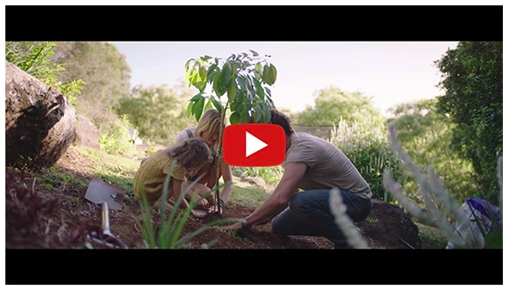](https://www.youtube.com/watch?v=sR51ZDNSRFQ&feature=emb_title)

<https://youtu.be/sR51ZDNSRFQ>

Cool Australia, GoodThing Productions and Regen Pictures would like to acknowledge the generous contributions of [Good Pitch Australia](http://goodpitch2australia.com.au/), [Shark Island Institute](http://sharkisland.com.au/shark-island-institute/), [Documentary Australia Foundation](https://www.documentaryaustralia.com.au/), [The Caledonia Foundation](https://www.caledoniafoundation.com.au/), [Global Health Film](https://www.globalhealthfilm.org/) and our philanthropic partners in the development of these teaching resources.

**Developing classroom guidelines:** In this lesson, students are asked to consider and share personal experiences and feelings, therefore it’s a good idea to set some ground rules for sharing. Consider the following:

* Own your ideas by using “I think” rather than “you should”.
* Respect each other by remembering that each person has their own beliefs and values and their own world views, experiences, and opinions.
* Each person has a right to contribute their ideas, so listen politely.
* Be brave in sharing your ideas, experiences and opinions.
* Consider the privacy of your classmates and appreciate that everyone has the right to uphold their privacy; this might mean they don’t want to share their ideas or experiences on an issue.
* Share feedback in a way that is considerate and positive.

**Tips for providing feedback**

* **Be kind** – It can be hard sharing your ideas with other people so make sure you remain kind and supportive.
* **Be specific**– Be clear about what you think and why. Rather than saying “I like your story”, say something like “I like the way you set the scene by describing the characters in such detail”.
* **Be helpful** – Try not to just say what is strong or weak, but also make suggestions about how things could be improved.

**Teaching Sequence**

Work through this resource material in the following sequence:

10 minutes – Part A: Activating Prior Knowledge – OPTIONAL

20 minutes – Part B: Concerns For The Future – Barometer Activity

15 minutes – Part C: Thinking About The Solutions

25 minutes – Reflection

#### 

## Part A: Activating Prior Knowledge – OPTIONAL

**Step 1.** Explain to students that in this lesson they will be watching clips from the 2040 documentary. This documentary explores what the future would look like by the year 2040 if we simply embraced the best solutions already available to us to improve our planet and shifted them into the mainstream. Assist students in clarifying key concepts discussed in the film by inviting them to complete the following activity, or move onto Part B if students are already familiar with these concepts.

Break the class into pairs and invite each pair to participate in a THINK PAIR SHARE activity to discuss and develop definitions for the following terms (also available on the Student Worksheet):

* Climate change
* Greenhouse gas
* Carbon dioxide
* Carbon sequestration
* Sustainability

**THINK PAIR SHARE is a collaborative learning strategy in which students work together to solve a problem or answer a question.**

* **THINK**– Students independently think about an issue or question and record their thoughts.
* **PAIR**– Students work in pairs to discuss their ideas and record new thoughts.
* **SHARE**– Students share their thoughts with the whole group or with other pairs to reach consensus.

Students can conduct research on the internet to help create their own definitions. Students can use the table on the Student Worksheet to guide them through the THINK PAIR SHARE process. Remind students of the Search Strategies for Googling when working online.



**Step 2.** Once complete, you can invite pairs of students to share their ideas with the class. Use the following definitions to clarify the concepts:

* **Climate change** – Suggested definition: Climate change is a change in the pattern of weather, and related changes in oceans, land surfaces and ice sheets, occurring over time scales of decades or longer.
* **Greenhouse gas** – Suggested definition: A gas that contributes to the greenhouse effect.
* **Carbon dioxide** – Suggested definition: Carbon dioxide (CO2) is generally a minor, yet very important, component of the atmosphere. CO2 is released through natural processes like respiration and volcano eruptions, but also through human activities such as deforestation and burning fossil fuels. Since the beginning of the Industrial Revolution, humans have increased atmospheric CO2 concentration by more than a third.
* **Carbon sequestration** – Suggested definition: Carbon sequestration is a natural or artificial process where CO2 is removed from the atmosphere and held in solid or liquid form, such as in forests, in the soil or in the sea.
* **Sustainability** – Suggested definition: Sustainability is about making sure there are enough resources for our environment and for everyone on Earth, both now and in the future.

**TIP:**For more information about climate change, the greenhouse effect and global warming, access the Climate Change Factsheet.

#### ****📚Part B: Concerns For The Future – Barometer Activity****

**Step 1.** Begin by watching one of the following clips from the 2040 documentary with students. Explain to students that this documentary explores what the future would look like by the year 2040 if we simply embraced the best solutions already available to us to improve our planet and shifted them into the mainstream.

As they watch one of the clips below, invite students to record anything they find interesting or important:

**Watch the 2040 trailer:**

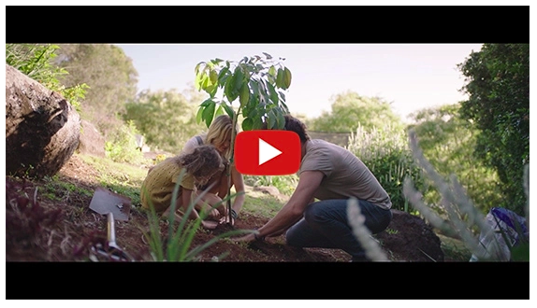

(<https://youtu.be/sR51ZDNSRFQ>)

**Exploring the Themes:**

[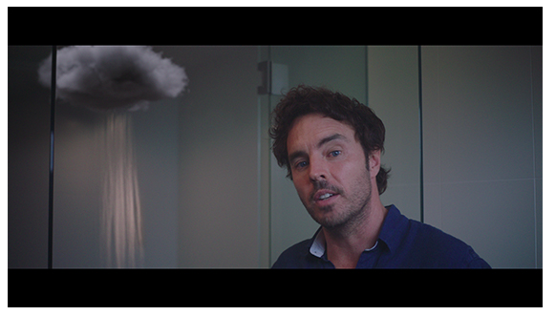](https://vimeo.com/showcase/6167669/video/336503936)

[2040 – Exploring the Themes](https://vimeo.com/showcase/6167669/video/336503936)  
**Password: 2040_EDU**(<https://vimeo.com/showcase/6167669/video/336503936>) *Note: You can use this same password to access all clips in the 2040 education media library.*

Once complete, engage students in a class discussion about their thoughts in response to this clip. Consider using the following questions in your discussion:

* What happened in this clip? What was this clip about?
* What did you find interesting or important about this clip?
* How does this clip make you feel?
* What does this clip make you think about?
* What does it make you wonder?

**Step 2.** You can then invite students to participate in a barometer activity with the aim of helping them to identify their feelings about the future.

**Stand on the Line**

* Using string, masking tape or chalk (this activity could be done outside!), create a line on the floor/ground, long enough for all students to place themselves along.
* Explain to students that one end of the line means ‘strongly agree’ and the other end means ‘strongly disagree’, while the halfway point means ‘neither agree nor disagree’ (consider adding small signs with these titles along the line).
* Invite students to respond to a range of statements by positioning themselves along the line, according to whether they agree or disagree with the statement.
* With each statement, engage students in a brief discussion, highlighting some of the key points identified in each statement.

Read the following statements one at a time and invite students to position themselves along the line in response to each statement. Explain to students that it is likely that there will be a wide range of responses to these; therefore, it is important to remember your classroom guidelines for discussions. Once students have settled into position, invite student volunteers to share why they have chosen their position.

* I often think about the future.
* I know what the future might look like.
* I am hopeful about the future.
* I am concerned about the future. (In response to this final statement, you should also invite students to share what they are concerned about, reminding students that others will have different concerns and that this is ok; all concerns are important and valid. The concern may include things like biodiversity loss, finishing school, making money, having and keeping friends, getting a job, playing sports, climate change, mental health issues, etc.)

Work with students to group concerns generated in the final statement into categories, such as the environment, family, friends, education, work, health, etc. Record these categories on the board.

**TIP:** You could use these AGREE/DISAGREE signs for this activity.



#### ****📚Part C: Thinking About The Solutions****

**Step 1.** Referring to the categories of concerns recorded on the board, explain to students that they will now work in groups to brainstorm some solutions to the concerns they have identified by creating a group mind-map.

Explain that students don’t need to develop a detailed plan for the solution; instead, the aim is for them to explore any ideas that could help address their concerns as well as listing some solutions that already exist.

Break the class into five or six groups and assign one of the categories of concern raised by the class in the previous activity. Alternatively, invite students to form groups based on the concern that is most important or interesting to them.

Give each group a piece of craft paper and some markers. Each group should write the category of concern they are focusing on in the middle of their craft paper.

Groups should then be given five to ten minutes to share and discuss ideas for addressing their concern and adding these ideas to the paper to make a mind-map.

Remind students of your classroom guidelines for discussion. You should also encourage students to be inspired by the suggestions of other students in their groups and to build upon these ideas in their mind-map.

**Step 2.** Once complete, invite groups to share some of their favourite ideas generated in the mind-map with the class through a class discussion.

Keep a record of student mind-maps – these can be referred to if you are planning on completing further lessons in the 2040 curriculum unit.

**TIP:**Explain to students that the filmmaker of the 2040 documentary – Damon Gameau – followed a process similar to the mind-mapping activity students just completed when he was looking to create his film.

However, instead of trying to create solutions to the concerns he was having about the future – particularly concerns about the environment – he decided to look for solutions that already existed for these concerns. And he found them.

#### ****Reflection****

Explain to students that they will be selecting one thing they personally are concerned about for the future and thinking about why this is a concern and what might be the solution.

Students can create either:

* A written piece.
* An image or graphic.
* An audio or video recording.

Alternatively, students could work from this worksheet, Concerns and Solutions.

In their piece they need to answer the following:

* What is my concern?
* Why is this a concern for me?
* What is one possible solution?
* Who is responsible for this solution and why?

#### ****Teacher Reflection****

Take this opportunity to reflect on your own teaching

* What did you learn about your teaching today?
* What worked well?
* What didn’t work so well?
* What would you share?
* Where to next?
* How are you going to get there?

**What’s Your 2040?**

Record your students’ work in their communities with the hashtag #whatsyour2040 and share their visions in the ‘2040:[The Regeneration’ Facebook Group](https://www.facebook.com/groups/2040TheRegeneration/). The 2040 crew would love to see your class’ work.