Writing The Future English Grades 10 & 11 Teacher Worksheet

Teacher Preparation
Learning intentions: Students will…
- … understand that solutions to climate change already exist
- … consider how these solutions might affect their lives and the lives of others
- … use facts as creative prompts for imaginative writing
Success criteria: Students can…
- … identify solutions explored in a video
- … undertake research to explore solutions
- … elaborate on facts provided to create an imaginative futuristic text

Teacher content information: A 2018 study by The University of Melbourne on the thoughts and concerns of young people from Generations X and Y found the number one concern across both groups was lack of action around climate change. In particular, “Generation X worries what climate change will mean for their own children, while Generation Y is concerned about the impact on future generations” (The Educator). The report indicates that young people have a serious mistrust in the Government’s ability or willingness to tackle climate change.
Tackling climate change requires large-scale, systemic changes across all aspects of society. Simply aiming to reduce our C0₂ emissions is not enough: we need to rapidly decarbonise our planet. While this might sound challenging, the good news is we already have the knowledge and tools to do it.
2040 is an innovative feature documentary that looks to the future while focusing on what is happening now. Award-winning director Damon Gameau (director of That Sugar Film) embarks on a journey to explore what the future could look like by the year 2040 if we simply embraced the best solutions already available to us to improve our planet and shifted them into the mainstream.
The film will demonstrate to your students that we already have the solutions to climate change; we just need to take action to bring them rapidly into the mainstream. The 2040 documentary and curriculum package will support your students in turning this knowledge into positive action for a better future.
Find out how to see the film here. 2040 will only be available in cinemas for the first part of 2019 and you can make a group booking for your class at your local cinema during the film’s theatrical release which starts on May 23. These lessons have been designed with a media library to support teachers. The film will be available on video-on-demand and DVD later in 2019.
The film is the entry point to a global impact campaign that seeks to mobilise audiences to learn about, contribute to, advocate for and invest in regenerative solutions that improve the wellbeing of the planet, all people and all living systems.
To join the Regeneration and share your vision for 2040, see the website.
Watch the 2040 trailer:
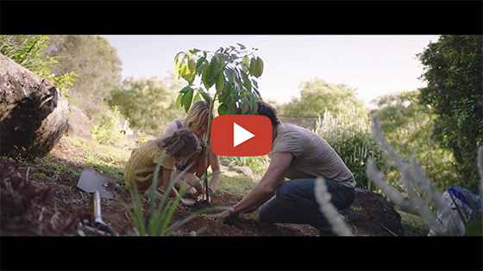
2040 – Official Trailer
Password: 2040_EDU
(https://vimeo.com/showcase/6167669/video/325372102)
Cool Australia, GoodThing Productions and Regen Pictures would like to acknowledge the generous contributions of Good Pitch Australia, Shark Island Institute, Documentary Australia Foundation, The Caledonia Foundation and our philanthropic partners in the development of these teaching resources.

Teaching Sequence
Work through this resource material in the following sequence:
5 minutes – Part A: Climate Change Solutions
20 minutes – Part B: Visions of 2040
25 minutes – Part C: Fact-based Dreaming
10 minutes – Reflection

Part A: Climate Change Solutions
Step 1. Begin by explaining to students that although climate change is a huge problem, there are many solutions that can help us meet the challenges posed by a changing climate. Explain to students that in this activity they will explore some of these solutions:
- Invite students to stand around the classroom tables and form small groups
- Provide groups with some A3 paper or butcher’s paper and markers
- Tell them that as a group they will have 5 minutes to write down 50 solutions to climate change (let them know that the small steps/actions are just as important as the big ones)
- Invite them to write Climate Change Solutions at the top of the paper and then divide the paper into two categories – “I know this exists” and “I wish this existed”. You might like to provide additional support to students by helping them to quickly brainstorm some of the key challenges of climate change and listing them on the board – eg rising water levels, pollution, etc.
- Say “Ready, Set, Go!’ and start the 5-minute timer. You could use this online timer and display it on the board

Step 2. Once complete, invite students to share how many solutions they came up with. Encourage them to share a few that they think are most creative, unexpected or funny.

Part B: Visions of 2040
Step 1. Now tell students they will be watching two clips that describe exciting visions of 2040. These come from a documentary called 2040. Explain to students that this film imagines what the future might look like if we apply currently existing solutions and technologies to help meet the challenges of climate change.
Provide each student with a copy of the Student Worksheet. Students can use this to record any ideas, innovations or solutions that they like about the shared visions presented in the clips from 2040.
Watch the following two clips as a class:
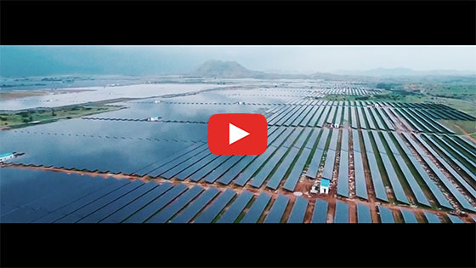
2040 – Decentralised Energy in Bangladesh
Password: 2040_EDU
(https://vimeo.com/showcase/6167669/video/336505664)
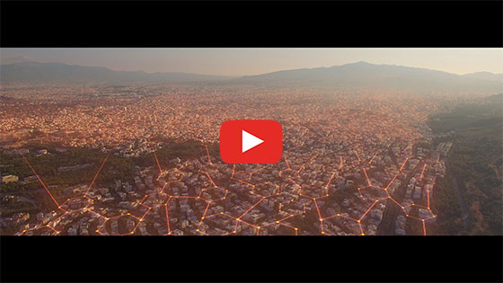
What’s Your 2040 – Renee
Password: 2040_EDU
(https://vimeo.com/showcase/6167669/video/348080817)
Step 2. Once complete, invite students to team up with a partner to share and discuss the solutions they noticed in the clips. The table on the Student Worksheet provides them with space to write down any ideas they and their partner found interesting.
Step 3. You could then lead a class discussion around their observations. Consider using the following questions to guide your discussion:
- What visions for 2040 were explored that you found interesting?
- Did the clip mention any solutions you had generated with your group earlier?
- How was the balance between fact and imagination?
- What do you imagine your life will be like in 2040?

Part C: Fact-based Dreaming
In this part of the lesson, students will synthesise what they saw in the clips with their own 2040 visions and will conduct research to plan a creative text.
Step 1. Remind students of the two clips from 2040 they just watched, and explain that Damon – the creator and narrator of the film – describes the film as “an exercise in fact-based dreaming”. Ask students to share some ideas about what they think the term ‘fact-based dreaming’ might mean.
Then explain to students that to Damon, fact-based dreaming is a process that involves a significant amount of research and investigation. To make his film he explored the best climate change solutions that already existed (or were being trialled) and then imagined a future where these solutions had become widely adopted.
Tell students that they will now have an opportunity to apply the same process to develop their own creative text – their own vision of 2040. They will be conducting some research and then imagining what life will be like in 2040 if the solutions they find were to be adopted.
Step 2. The first step in this process is for students to pick an everyday experience and transform it. They could choose one of the following experiences or come up with their own:
- Entertainment – A day out with friends (what technologies will exist, how will people get around, what will they do for fun?)
- Journeys – getting somewhere (work, uni, overseas)
- Eating – cooking dinner, eating out or growing food
- Education / Future Jobs – what will they look like, how will people get to them, what will they learn about/focus on
Once students have chosen an experience, invite them to research existing climate change solutions related to this experience. For example, if they chose Entertainment as their experience, they might research what kind of climate friendly entertainment options exist, or are likely to exist in the near future. Perhaps local communities are building gaming centres in parks or town squares to allow people to play outdoors and enjoy the fresh air, or perhaps dance floors will be developed that can create electricity when used. Encourage them to find out what already exists or is in the process of being prototyped or implemented.
Invite students to collect images, links, and descriptions of inventions or ideas that could be included in their stories.
If students are struggling to find information, they can use the below keywords, in addition to the experience they chose.
- Climate friendly
- Climate change solutions
- Future climate
Hot tip: The Drawdown website might be a useful source of climate change solutions if students get stuck.
Step 3. Now that students know a little bit about their chosen experience and various existing or likely climate-friendly solutions, it is time to extend these ideas by using their imagination. Invite students to think about their research and then brainstorm how these solutions might be improved upon, or what it would be like if they were widely adopted, in 2040.
If students are struggling to think of ideas, they might find the following stems helpful:
- How would it be different if…
- Suppose that…
- What would change if…
- How would it look differently if…
Step 4. Inform students that they will start to turn their ideas into a creative text. The next step is to develop a storyboard.
Their storyboard should have at least 6 squares that lay out the premise of their text. You might like to provide them with this Storyboard Template.
This storyboard should show the ideas and visions for 2040 that they are going to explore in their text. You can adapt this task for any type of text you want students to create, or you could give them free choice. For example, students could storyboard narratives, graphic novels, scripts, videos, advertisements or other texts.
Step 5. Once students have completed a storyboard, it is a good time to get feedback from their peers.
Ask students to either walk around to read or view others’ work or pass it around. Students should use sticky notes, or Google Comments (if you use online docs) to share with their feedback. They might wish to use sentence stems such as:
- I want to know more about…
- I am confused about…
- I am interested in…
- It worked well when you…
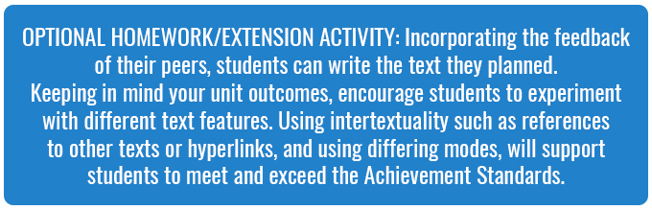

Reflection
Invite students to work independently to respond to the following questions (also available on the Student Worksheet):
- Fact-based dreaming is interesting because…
- Fact-based dreaming has limitations because…
- I would be interested in further exploring…

Differentiated Learning
Extension – Students could use multi-modal features in their text such as hyperlinks to research, footnotes, images, sound effects or narration.
Provisions for Learning Support –
- Students could work together on the solutions table.
- Students could use the prompts provided.
- Students could storyboard ideas about energy or 2040 in general from the videos. They could use this Storyboard Template.

Teacher Reflection
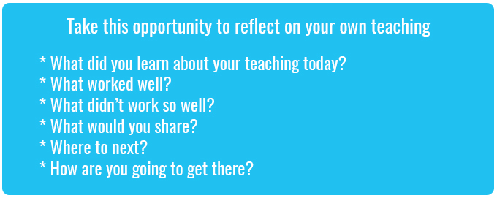

What’s Your 2040?
Record your students’ work in their communities with the hashtag #whatsyour2040 and share their visions in the ‘2040: The Regeneration’ Facebook Group.
The 2040 crew would love to see your class’ work.

