Writing The Future English Years 9 & 10 Student Worksheet
Name: …………………………………. Class: …………..

Thought starter: What is fact-based dreaming?

Climate Change Solutions
Although climate change is a huge problem, there are many solutions that can help us with meeting the challenges posed by a changing climate. How many solutions to climate change can you come up with in 5 minutes? List them below in the two columns provided.
I know this solution exists | I hope this solution exists/I wish it existed

Visions of 2040
You will now be watching two clips that describe exciting visions of the year 2040. These come from a documentary called 2040. This film imagines what the future might look like if we applied currently existing solutions and technologies to help meet the challenges of climate change.
Watch the following two videos and while you watch, record any interesting innovations, solutions or aspects of the visions of 2040 presented in the film in Column A of the table below.
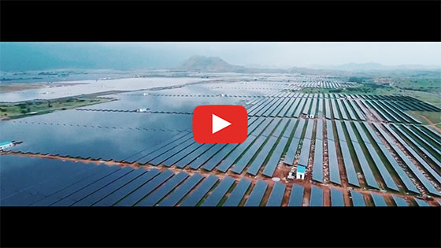
Energy Case Study – Future
Password: 2040_EDU
(https://vimeo.com/336505664)
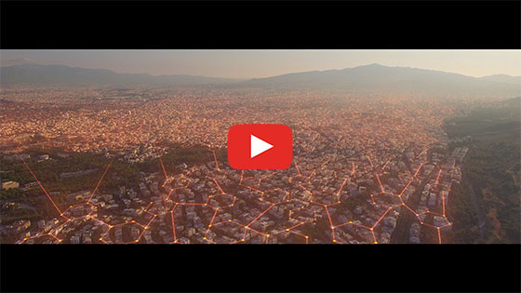
What’s Your 2040 – Renee
Password: 2040_EDU
(https://vimeo.com/348080817)
Column A. Ideas I found interesting from the clips | Column B. Ideas my partner/group found interesting from the clips
Once complete, team up with a partner to share your ideas. Following this, add any new ideas raised in your discussion in Column B of the table above.

Fact-based Dreaming
In this part of the lesson, you will plan and produce a creative text around your 2040 vision. You will need to synthesise what you saw in the clips with research and with your own ideas about what the future might look like. Follow the steps below:
1. Pick an everyday experience and transform it. You could pick one of the below experiences, or come up with your own:
- Entertainment – a day out with friends
- Journeys – getting somewhere (work, uni, overseas)
- Eating – cooking dinner, eating out or growing food
- Education / Future Jobs – what will they look like, how will people get to them, what will they learn about/focus on.
2. Research climate change solutions related to the experience you chose.
Struggling to find information? Use these keywords + your experience
- Climate-friendly
- Climate change solutions
- Future climate
- Environmental change
- Rising sea levels
Collect images, links and write short descriptions of inventions or ideas that may be included in your story.
3. Finish at least three of these questions to help guide your writing. The first is done as an example for you. You should focus on possible changes related to the solutions you have researched.
Example: What would it be like if we ate bugs instead of beef?
- What would it be like if…
- How would it be different if…
- Suppose that…
- What would change if…
- How would it look differently if…
4. Complete the storyboard template. Your storyboard should have at least 6 squares that lay out the premise of your text. Your storyboard should show what the world of your story will look like – what ideas and inventions will the reader come across? What is different about the world in 2040? How do you want the reader to feel?
5. Create your text using the planning you have completed. Your final text should reflect the research you have completed, the texts you have seen and your own ideas. Bring to life your vision of 2040! Try to use elements of intertextuality – such as links to other texts and/or differing modes such as written, audio and visual elements. This will help you to be more creative and to meet the standards.

Reflection
Work independently to answer the following questions:
• Fact-based dreaming is interesting because…

• Fact-based dreaming has limitations because…

• I would be interested in further exploring…

